**Queue & Stack**

Introduction

We may access a random element by index in [Array](https://leetcode.com/explore/learn/card/array-and-string/). However, we might want to restrict the processing order in some cases.

In this card, we introduce two different processing orders, First-in-First-out and Last-in-First-out and its two corresponding linear data structures, Queue and Stack.

We go through the definition, implementation and built-in functions for each data structure. Then, we focus more on the practical applications of these two data structures.

By completing this card, you should be able to:

1. Understand the principle of the processing orders of FIFO and LIFO;
2. Implement these two data structures;
3. Be familiar with the built-in queue and stack structure;
4. Solve basic queue-related problems, especially BFS;
5. Solve basic stack-related problems;
6. Understand how system stack helps you when you solve problems using DFS and other recursion algorithms;

Queue: First-in-first-out Data Structure

 First-in-first-out Data Structure

 Queue - Implementation

 Circular Queue

 Design Circular Queue

 Circular Queue - Implementation

 Queue - Usage

 Moving Average from Data Stream

Queue and BFS

 Queue and BFS

 BFS - Template

 Walls and Gates

 Number of Islands

 Open the Lock

 Perfect Squares

Stack: Last-in-first-out Data Structure

 Last-in-first-out Data Structure

 Stack - Usage

 Min Stack

 Valid Parentheses

 Daily Temperatures

 Evaluate Reverse Polish Notation

Stack and DFS

 Stack and DFS

 DFS - Template I

 Number of Islands

 Clone Graph

 Target Sum

 DFS - Template II

 Binary Tree Inorder Traversal

Conclusion

 Implement Queue using Stacks

 Implement Stack using Queues

 Decode String

 Flood Fill

 01 Matrix

 Keys and Rooms

## Queue: First-in-first-out Data Structure

In this chapter, we will first introduce First-in-first-out (FIFO) and how it works in a queue.

The goal of this chapter is to help you:

1. Understand the definition of FIFO and queue;
2. Be able to implement a queue by yourself;
3. Be familiar with the built-in queue structure;
4. Use queue to solve simple problems.

**First-in-first-out Data Structure**

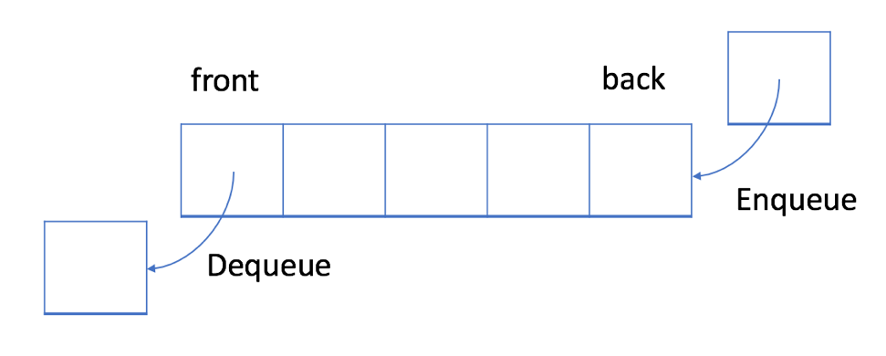

In a FIFO data structure, the first element added to the queue will be processed first.

As shown in the picture above, the queue is a typical FIFO data stucture. The insert operation is also called enqueue and the new element is always added at the end of the queue. The delete operation is called dequeue. You are only allowed to remove the first element.

### ***Example - Queue***

1. Enqueue: you can click Enqueue below to see how a new element 6 is added to the queue.

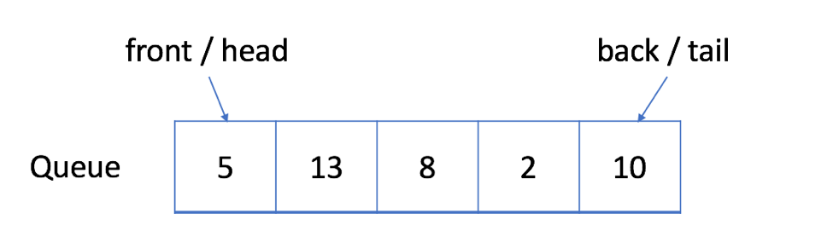    **Enqueue**

2. Dequeue: you can click Dequeue below to see which element will be removed.

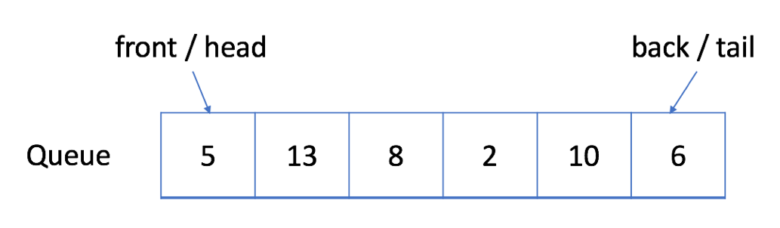    **Dequeue**

**Queue - Implementation**

To implement a queue, we may use a dynamic array and an index pointing to the head of the queue.

As mentioned, a queue should support two operations: enqueue and dequeue. Enqueue appends a new element to the queue while dequeue removes the first element. So we need an index to indicate the starting point.

Here is an implementation for your reference:

|  |
| --- |
| // "static void main" must be defined in a public class.  class MyQueue {  // store elements  private List<Integer> data;  // a pointer to indicate the start position  private int p_start;  public MyQueue() {  data = new ArrayList<Integer>();  p_start = 0;  }  /** Insert an element into the queue. Return true if the operation is successful. */  public boolean enQueue(int x) {  data.add(x);  return true;  };  /** Delete an element from the queue. Return true if the operation is successful. */  public boolean deQueue() {  if (isEmpty() == true) {  return false;  }  p_start++;  return true;  }  /** Get the front item from the queue. */  public int Front() {  return data.get(p_start);  }  /** Checks whether the queue is empty or not. */  public boolean isEmpty() {  return p_start >= data.size();  }  };  public class Main {  public static void main(String[] args) {  MyQueue q = new MyQueue();  q.enQueue(5);  q.enQueue(3);  if (q.isEmpty() == false) {  System.out.println(q.Front());  }  q.deQueue();  if (q.isEmpty() == false) {  System.out.println(q.Front());  }  q.deQueue();  if (q.isEmpty() == false) {  System.out.println(q.Front());  }  }  } |

### ***Drawback***

The implementation above is straightforward but is inefficient in some cases. With the movement of the start pointer, more and more space is wasted. And it will be unacceptable when we only have a space limitation.

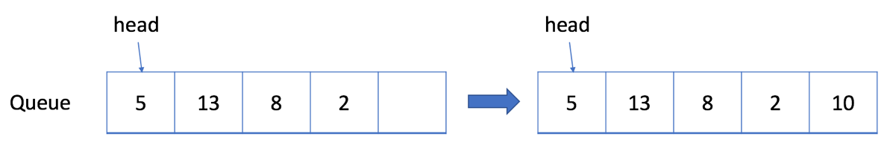

Let's consider a situation when we are only able to allocate an array whose maximum length is 5. Our solution works well when we have only added less than 5 elements. For example, if we only called the enqueue function four times and we want to enqueue an element 10, we will succeed.

And it is reasonable that we cannot accept more enqueue request because the queue is full now. But what if we dequeue an element?

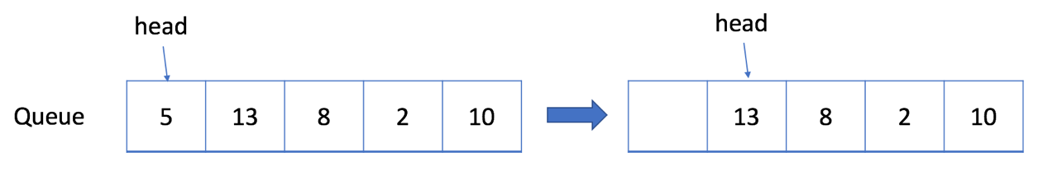

Actually, we should be able to accept one more element in this case.

**Circular Queue**

Previously, we have provided a straightforward but inefficient implementation of queue.

A more efficient way is to use a circular queue. Specifically, we may use a fixed-size array and two pointers to indicate the starting position and the ending position. And the goal is to reuse the wasted storage we mentioned previously.

Let's take a look at an example to see how a circular queue works. You should pay attention to the strategy we use to enqueue or dequeue an element.

Review the animation carefully to figure out the strategy we use to check if a queue is empty or full.

For the next exercise, we will let you try to implement the circular queue by yourself and provide a solution later.

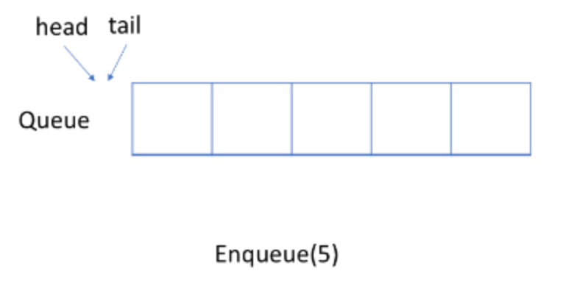

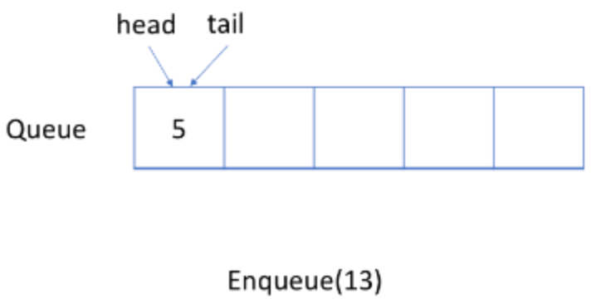

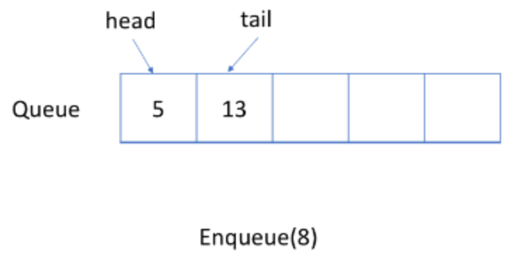  
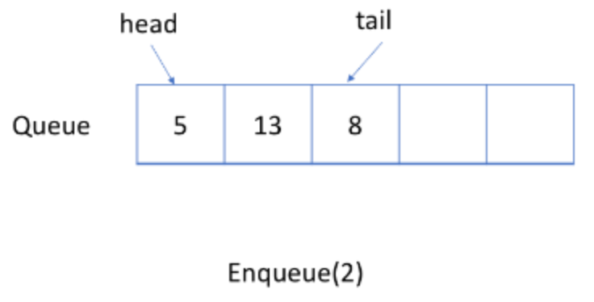  
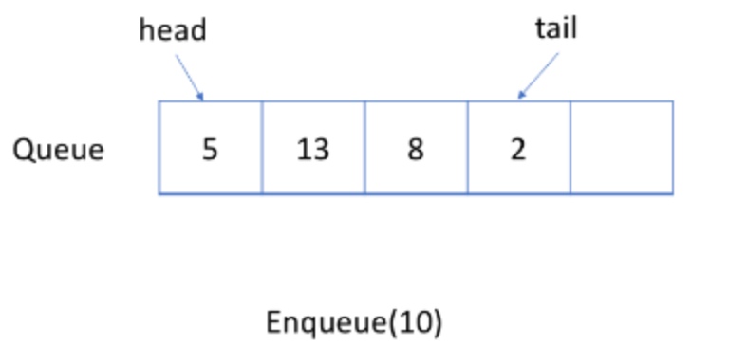

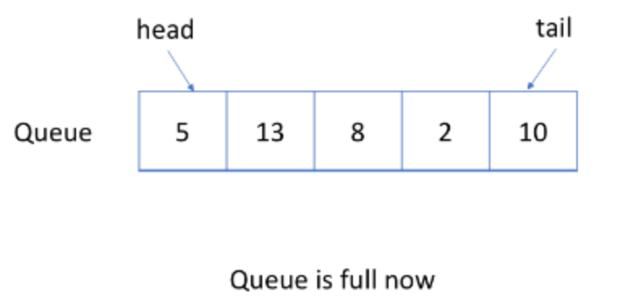  
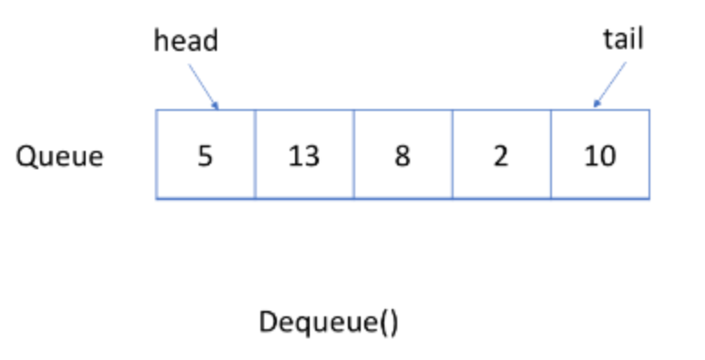  
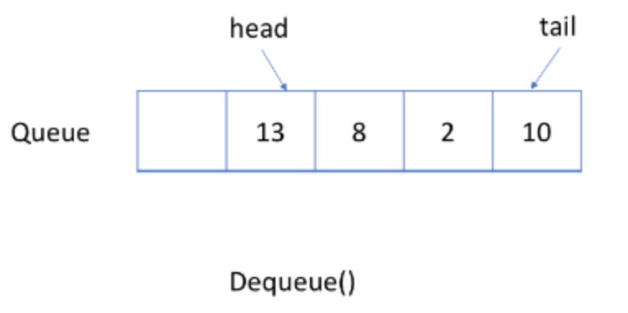  
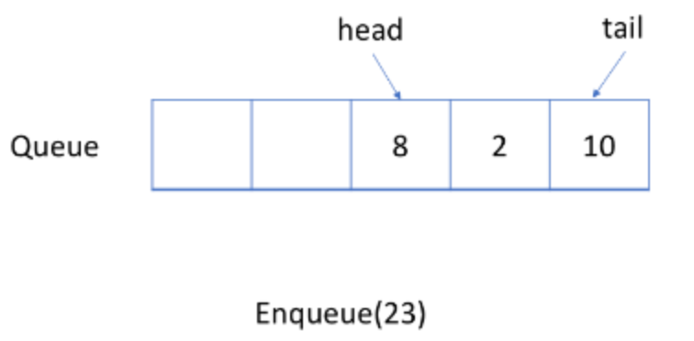  
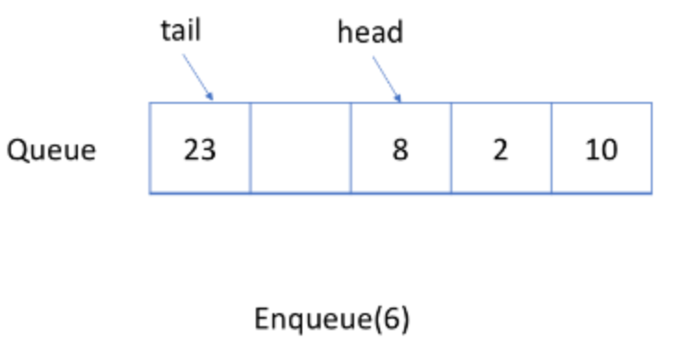  
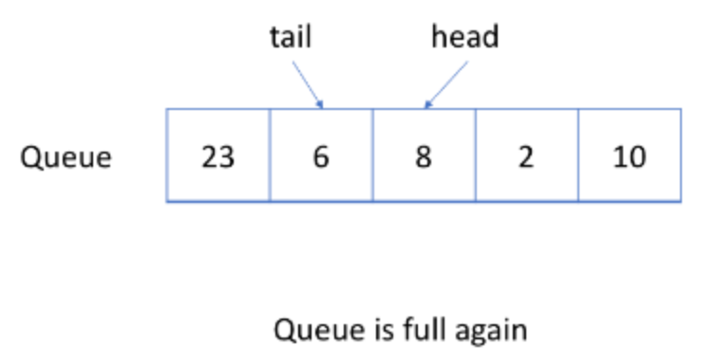  
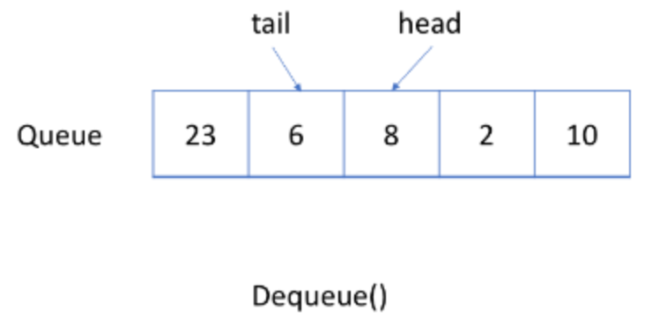  
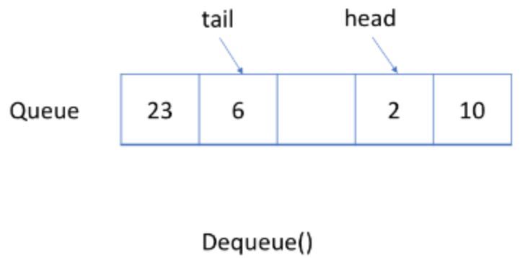  
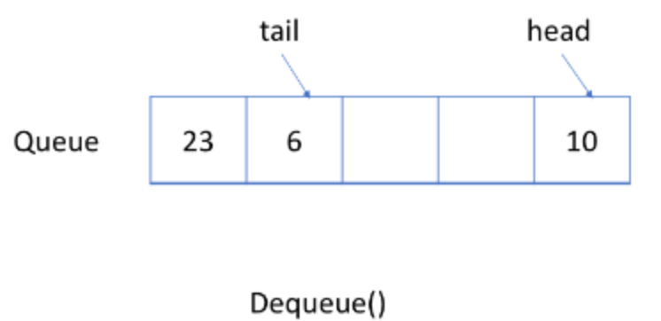  
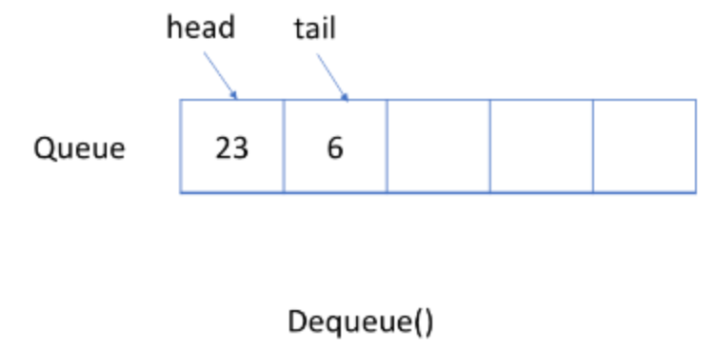  
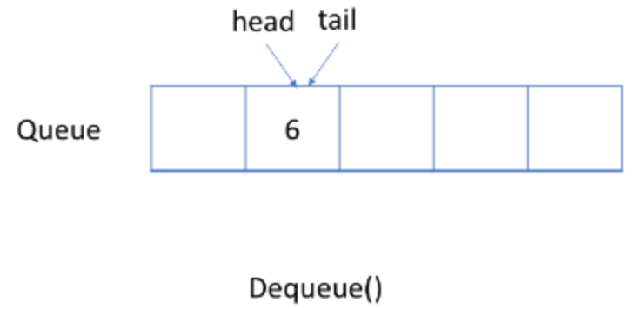  
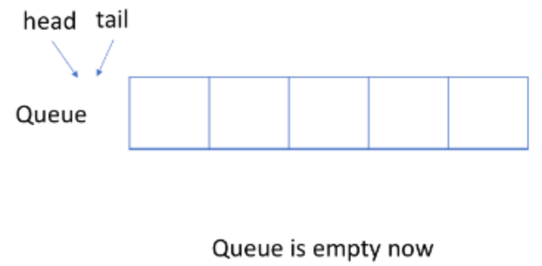

**Design Circular Queue**

Design your implementation of the circular queue. The circular queue is a linear data structure in which the operations are performed based on FIFO (First In First Out) principle and the last position is connected back to the first position to make a circle. It is also called "Ring Buffer".

One of the benefits of the circular queue is that we can make use of the spaces in front of the queue. In a normal queue, once the queue becomes full, we cannot insert the next element even if there is a space in front of the queue. But using the circular queue, we can use the space to store new values.

Implementation the MyCircularQueue class:

* MyCircularQueue(k) Initializes the object with the size of the queue to be k.
* int Front() Gets the front item from the queue. If the queue is empty, return -1.
* int Rear() Gets the last item from the queue. If the queue is empty, return -1.
* boolean enQueue(int value) Inserts an element into the circular queue. Return true if the operation is successful.
* boolean deQueue() Deletes an element from the circular queue. Return true if the operation is successful.
* boolean isEmpty() Checks whether the circular queue is empty or not.
* boolean isFull() Checks whether the circular queue is full or not.

**Example 1:**

**Input**

["MyCircularQueue", "enQueue", "enQueue", "enQueue", "enQueue", "Rear", "isFull", "deQueue", "enQueue", "Rear"]

[[3], [1], [2], [3], [4], [], [], [], [4], []]

**Output**

[null, true, true, true, false, 3, true, true, true, 4]

**Explanation**

MyCircularQueue myCircularQueue = new MyCircularQueue(3);

myCircularQueue.enQueue(1); // return True

myCircularQueue.enQueue(2); // return True

myCircularQueue.enQueue(3); // return True

myCircularQueue.enQueue(4); // return False

myCircularQueue.Rear(); // return 3

myCircularQueue.isFull(); // return True

myCircularQueue.deQueue(); // return True

myCircularQueue.enQueue(4); // return True

myCircularQueue.Rear(); // return 4

**Constraints:**

* 1 <= k <= 1000
* 0 <= value <= 1000
* At most 3000 calls will be made to enQueue, deQueue, Front, Rear, isEmpty, and isFull.

**Follow up:** Could you solve the problem without using the built-in queue?

## Solution

#### **Approach 1: Array**

**Intuition**

Based on the description of the problem, an intuitive data structure that meets all the requirements would be a **ring** where the head and the tail are adjacent to each other.

However, there does not exist a ring data structure in any programming language. A similar data structure at our disposal is the one called **Array** which is a collection of elements that reside continuously in one dimensional space.

The essence of many design problems, is how one can build more advanced data structures with the basic building blocks such as Array.

In this case, to build a circular queue, we could form a virtual ring structure with the Array, via the manipulation of index.

Given a fixed size array, any of the elements could be considered as a head in a queue. As long as we know the length of the queue, we then can instantly locate its tail, based on the following formula:

tailIndex=(headIndex+count−1) mod capacity

where the variable capacity is the size of the array, the count is the length of the queue and the headIndex and tailIndex are the indice of head and tail elements respectively in the array. Here we showcase a few examples how a circular queue could reside in a fixed size array.

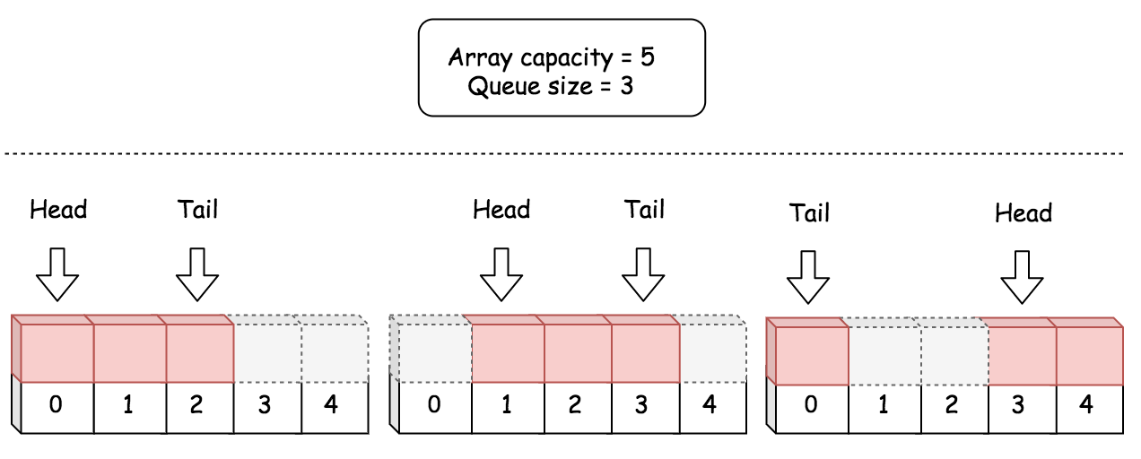

**Algorithm**

The procedure to design a data structure lies essentially on how we design the attributes within the data structure.

One of the traits of a good design is to have as less attributes as possible, which arguably could bring several benefits.

* Less attributes usually implies little or no redundancy among the attributes.
* The less redundant the attributes are, the simpler the manipulation logic, which eventually could be less error-prone.
* Less attributes also requires less space and therefore it could also bring efficiency to the runtime performance.

However, it is not advisable to seek for the minimum set of attributes. Sometimes, a bit of redundancy could help with the time complexity. After all, like many other problems, we are trying to strike a balance between the space and the time.

Following the above principles, here we give a list of attributes and the thoughts behind each attribute.

* queue: a fixed size array to hold the elements for the circular queue.
* headIndex: an integer which indicates the current head element in the circular queue.
* count: the current length of the circular queue, i.e. the number of elements in the circular queue. Together with the headIndex, we could locate the current tail element in the circular queue, based on the formula we gave previously. Therefore, we choose not to add another attribute for the index of tail.
* capacity: the capacity of the circular queue, i.e. the maximum number of elements that can be hold in the queue. One might argument that it is not absolutely necessary to add this attribute, since we could obtain the capacity from the queue attribute. It is true. Yet, since we would frequently use this capacity in our algorithm, we choose to keep it as an attribute, instead of invoking function len(queue) in Python at every occasion. Though in other programming languages such as Java, it might be more efficient to omit this attribute, since it is part of the attributes (queue.length) in Java array. Note: for the sake of consistency, we keep this attribute for all implementations.

|  |
| --- |
| class MyCircularQueue {  private int[] queue;  private int headIndex;  private int count;  private int capacity;  /** Initialize your data structure here. Set the size of the queue to be k. */  public MyCircularQueue(int k) {  this.capacity = k;  this.queue = new int[k];  this.headIndex = 0;  this.count = 0;  }  /** Insert an element into the circular queue. Return true if the operation is successful. */  public boolean enQueue(int value) {  if (this.count == this.capacity)  return false;  this.queue[(this.headIndex + this.count) % this.capacity] = value;  this.count += 1;  return true;  }  /** Delete an element from the circular queue. Return true if the operation is successful. */  public boolean deQueue() {  if (this.count == 0)  return false;  this.headIndex = (this.headIndex + 1) % this.capacity;  this.count -= 1;  return true;  }  /** Get the front item from the queue. */  public int Front() {  if (this.count == 0)  return -1;  return this.queue[this.headIndex];  }  /** Get the last item from the queue. */  public int Rear() {  if (this.count == 0)  return -1;  int tailIndex = (this.headIndex + this.count - 1) % this.capacity;  return this.queue[tailIndex];  }  /** Checks whether the circular queue is empty or not. */  public boolean isEmpty() {  return (this.count == 0);  }  /** Checks whether the circular queue is full or not. */  public boolean isFull() {  return (this.count == this.capacity);  }  } |

**Complexity**

* Time complexity: O(1). All of the methods in our circular data structure is of constant time complexity.
* Space Complexity: O(*N*). The overall space complexity of the data structure is linear, where *N* is the pre-assigned capacity of the queue. *However, it is worth mentioning that the memory consumption of the data structure remains as its pre-assigned capacity during its entire life cycle.*

**Improvement: Thread-Safe**

One might be happy with the above implementation, after all it meets all the requirements of the problem.

As a followup question though, an interviewer might ask one to point out a *potential defect* about the implementation and the solution.

This time, it is not about the space or time complexity, but ***concurrency***. Our circular queue is NOT *thread-safe*. One could end up with *corrupting* our data structure in a multi-threaded environment.

For example, here is an execution sequence where we exceed the designed capacity of the queue and overwrite the tail element undesirably.

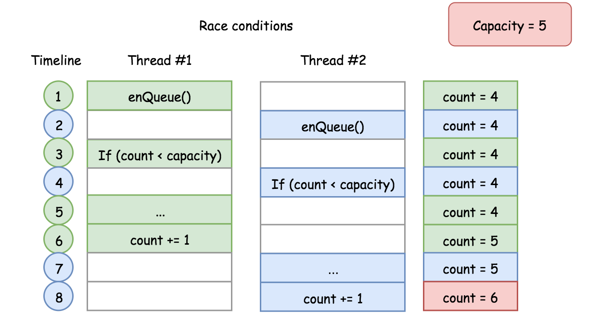

The above scenario is called race conditions as described in the problem of [Print in Order](https://leetcode.com/problems/print-in-order/solution/). One can find more [concurrency problems](https://leetcode.com/problemset/concurrency/) to practice on LeetCode.

There are several ways to mitigate the above concurrency problem. Take the function enQueue(int value) as an example, we show how we can make the function thread-safe in the following implementation:

|  |
| --- |
| class MyCircularQueue {  private Node head, tail;  private int count;  private int capacity;  // Additional variable to secure the access of our queue  private ReentrantLock queueLock = new ReentrantLock();  /** Initialize your data structure here. Set the size of the queue to be k. */  public MyCircularQueue(int k) {  this.capacity = k;  }  /** Insert an element into the circular queue. Return true if the operation is successful. */  public boolean enQueue(int value) {  // ensure the exclusive access for the following block.  queueLock.lock();  try {  if (this.count == this.capacity)  return false;  Node newNode = new Node(value);  if (this.count == 0) {  head = tail = newNode;  } else {  tail.nextNode = newNode;  tail = newNode;  }  this.count += 1;  } finally {  queueLock.unlock();  }  return true;  }  } |

With the protection of locks, we now feel more confident to apply our circular queue in critical scenarios.

The above improvement does not alter the time and space complexity of the original data structure, though overall the thread-safe measures do incur some extra costs.

#### **Approach 2: Singly-Linked List**

**Intuition**

Similar with Array, the Linked List is another common building block for more advanced data structures.

Different than a fixed size Array, a linked list could be more memory efficient, since it does not pre-allocate memory for unused capacity.

With a singly-linked list, we could design a circular queue with the same time and space complexity as the approach with Array. But we could gain some memory efficiency, since we don't need to pre-allocate the memory upfront.

In the following graph, we show how the operations of enQueue() and deQueue() can be done via singly-linked list.

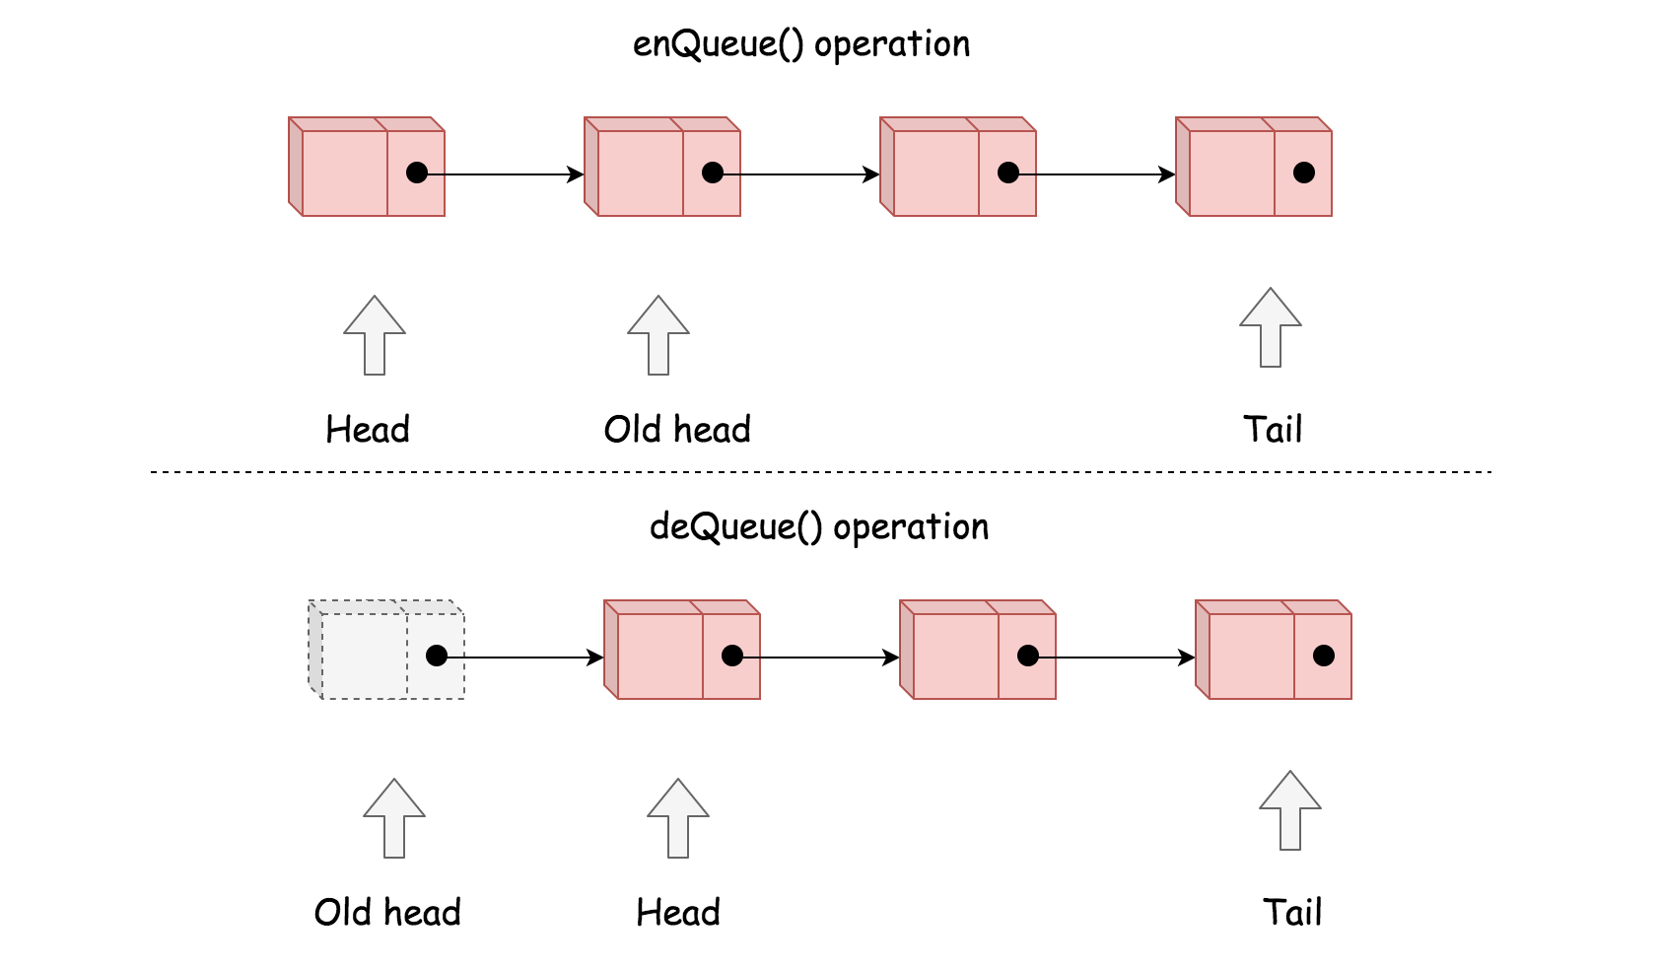

**Algorithm**

Here we give a list of attributes in our circular queue data structure and the thoughts behind each attribute.

* capacity: the maximum number of elements that the circular queue will hold.
* head: the reference to the head element in the queue.
* count: the current length of the queue. This is a critical attribute that helps us to do the boundary check in each method.
* tail: the reference to the tail element in the queue. Unlike the Array approach, we need to explicitly keep the reference to the tail element. Without this attribute, it would take us O(*N*) time complexity to locate the tail element from the head element.

|  |
| --- |
| class Node {  public int value;  public Node nextNode;  public Node(int value) {  this.value = value;  this.nextNode = null;  }  }  class MyCircularQueue {  private Node head, tail;  private int count;  private int capacity;  /** Initialize your data structure here. Set the size of the queue to be k. */  public MyCircularQueue(int k) {  this.capacity = k;  }  /** Insert an element into the circular queue. Return true if the operation is successful. */  public boolean enQueue(int value) {  if (this.count == this.capacity)  return false;  Node newNode = new Node(value);  if (this.count == 0) {  head = tail = newNode;  } else {  tail.nextNode = newNode;  tail = newNode;  }  this.count += 1;  return true;  }  /** Delete an element from the circular queue. Return true if the operation is successful. */  public boolean deQueue() {  if (this.count == 0)  return false;  this.head = this.head.nextNode;  this.count -= 1;  return true;  }  /** Get the front item from the queue. */  public int Front() {  if (this.count == 0)  return -1;  else  return this.head.value;  }  /** Get the last item from the queue. */  public int Rear() {  if (this.count == 0)  return -1;  else  return this.tail.value;  }  /** Checks whether the circular queue is empty or not. */  public boolean isEmpty() {  return (this.count == 0);  }  /** Checks whether the circular queue is full or not. */  public boolean isFull() {  return (this.count == this.capacity);  }  } |

**Complexity**

* Time complexity: O(1) for each method in our circular queue.
* Space Complexity: The upper bound of the memory consumption for our circular queue would be O(*N*), same as the Array approach. However, it should be more memory efficient as we discussed in the intuition section.

**Circular Queue - Implementation**

In a circular queue, we use an array and two pointers, head and tail. head indicates the start position of the queue while tail indicates the ending position of the queue.

Here we provide the code for your reference:

|  |
| --- |
| class MyCircularQueue {    private int[] data;  private int head;  private int tail;  private int size;  /** Initialize your data structure here. Set the size of the queue to be k. */  public MyCircularQueue(int k) {  data = new int[k];  head = -1;  tail = -1;  size = k;  }    /** Insert an element into the circular queue. Return true if the operation is successful. */  public boolean enQueue(int value) {  if (isFull() == true) {  return false;  }  if (isEmpty() == true) {  head = 0;  }  tail = (tail + 1) % size;  data[tail] = value;  return true;  }    /** Delete an element from the circular queue. Return true if the operation is successful. */  public boolean deQueue() {  if (isEmpty() == true) {  return false;  }  if (head == tail) {  head = -1;  tail = -1;  return true;  }  head = (head + 1) % size;  return true;  }    /** Get the front item from the queue. */  public int Front() {  if (isEmpty() == true) {  return -1;  }  return data[head];  }    /** Get the last item from the queue. */  public int Rear() {  if (isEmpty() == true) {  return -1;  }  return data[tail];  }    /** Checks whether the circular queue is empty or not. */  public boolean isEmpty() {  return head == -1;  }    /** Checks whether the circular queue is full or not. */  public boolean isFull() {  return ((tail + 1) % size) == head;  }  }  /**  * Your MyCircularQueue object will be instantiated and called as such:  * MyCircularQueue obj = new MyCircularQueue(k);  * boolean param_1 = obj.enQueue(value);  * boolean param_2 = obj.deQueue();  * int param_3 = obj.Front();  * int param_4 = obj.Rear();  * boolean param_5 = obj.isEmpty();  * boolean param_6 = obj.isFull();  */ |

**Queue - Usage**

Most popular languages provide built-in Queue library so you don't have to reinvent the wheel.

As mentioned before, the queue has two important operations, enqueue and dequeue. Besides, we should be able to get the first element in a queue since the first element should be processed first.

Below are some examples of using the built-in Queue library and its common operations:

|  |
| --- |
| // "static void main" must be defined in a public class.  public class Main {  public static void main(String[] args) {  // 1. Initialize a queue.  Queue<Integer> q = new LinkedList();  // 2. Get the first element - return null if queue is empty.  System.out.println("The first element is: " + q.peek());  // 3. Push new element.  q.offer(5);  q.offer(13);  q.offer(8);  q.offer(6);  // 4. Pop an element.  q.poll();  // 5. Get the first element.  System.out.println("The first element is: " + q.peek());  // 7. Get the size of the queue.  System.out.println("The size is: " + q.size());  }  } |

We provide exercise after this article to help you familiarize with these operations. And remember when you want to process the elements in order, using a queue might be a good choice.

**Moving Average from Data Stream**

Given a stream of integers and a window size, calculate the moving average of all integers in the sliding window.

Implement the MovingAverage class:

* MovingAverage(int size) Initializes the object with the size of the window size.
* double next(int val) Returns the moving average of the last size values of the stream

**Example 1:**

**Input**

["MovingAverage", "next", "next", "next", "next"]

[[3], [1], [10], [3], [5]]

**Output**

[null, 1.0, 5.5, 4.66667, 6.0]

**Explanation**

MovingAverage movingAverage = new MovingAverage(3);

movingAverage.next(1); // return 1.0 = 1 / 1

movingAverage.next(10); // return 5.5 = (1 + 10) / 2

movingAverage.next(3); // return 4.66667 = (1 + 10 + 3) / 3

movingAverage.next(5); // return 6.0 = (10 + 3 + 5) / 3

**Constraints:**

* 1 <= size <= 1000
* -105 <= val <= 105
* At most 104 calls will be made to next.

## Solution

#### **Approach 1: Array or List**

**Intuition**

Following the description of the problem, we could simply keep track of all the incoming values with the data structure of Array or List. Then from the data structure, later we retrieve the necessary elements to calculate the average.

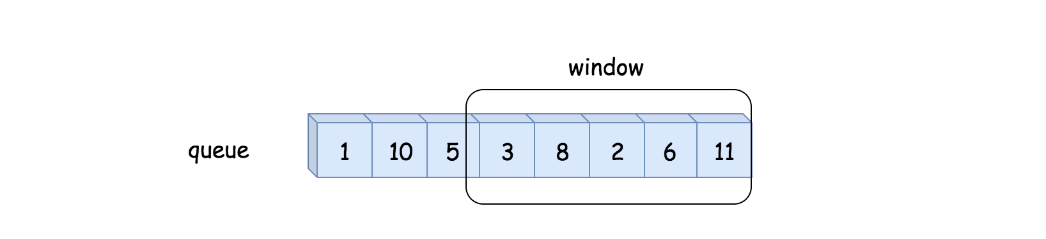

**Algorithm**

* First, we initialize a variable queue to store the values from the data stream, and the variable n for the size of the moving window.
* At each invocation of next(val), we first append the value to the queue. We then retrieve the last n values from the queue, in order to calculate the average.

|  |
| --- |
| class MovingAverage {  int size;  List queue = new ArrayList<Integer>();  public MovingAverage(int size) {  this.size = size;  }  public double next(int val) {  queue.add(val);  // calculate the sum of the moving window  int windowSum = 0;  for(int i = Math.max(0, queue.size() - size); i < queue.size(); ++i)  windowSum += (int)queue.get(i);  return windowSum * 1.0 / Math.min(queue.size(), size);  }  } |

**Complexity**

* Time Complexity: O(*N*) where *N* is the size of the moving window, since we need to retrieve *N* elements from the queue at each invocation of next(val) function.
* Space Complexity: O(*M*), where *M* is the length of the queue which would grow at each invocation of the next(val) function.

#### **Approach 2: Double-ended Queue**

**Intuition**

We could do better than the first approach in both time and space complexity.

First of all, one might notice that we do not need to keep all values from the data stream, but rather the last n values which falls into the moving window.

By definition of the moving window, at each step, we add a new element to the window, and at the same time we remove the oldest element from the window. Here, we could apply a data structure called *double-ended queue* (*a.k.a* deque) to implement the moving window, which would have the constant time complexity (O(1)) to add or remove an element from both its ends. With the deque, we could reduce the space complexity down to O(*N*) where N*N* is the size of the moving window.

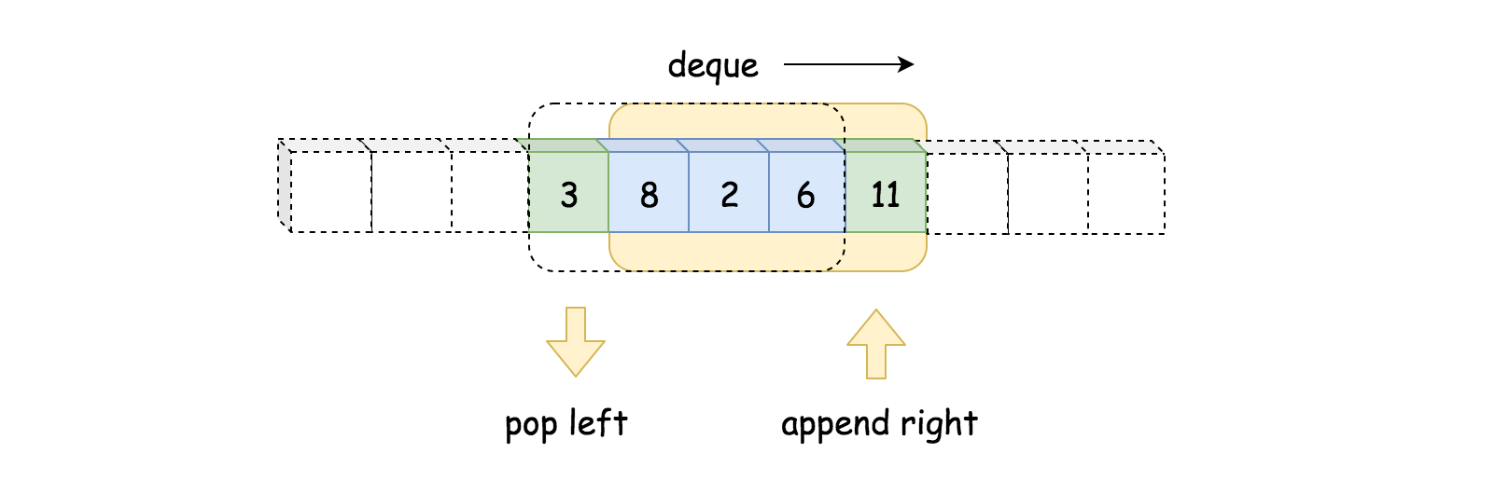

Secondly, to calculate the sum, we do not need to reiterate the elements in the moving window.

We could keep the sum of the previous moving window, then in order to obtain the sum of the new moving window, we simply add the new element and deduce the oldest element. With this measure, we then can reduce the time complexity to constant.

**Algorithm**

Here is the definition of the *deque* from Python. We have similar implementation of deque in other programming languages such as Java.

Deques are a generalization of stacks and queues (the name is pronounced deck and is short for double-ended queue). Deques support thread-safe, memory efficient appends and pops from either side of the deque with approximately the same O(1) performance in either direction.

Follow the intuition, we replace the queue with the *deque* and add a new variable window_sum in order to calculate the sum of moving window in constant time.

|  |
| --- |
| class MovingAverage {  int size, windowSum = 0, count = 0;  Deque queue = new ArrayDeque<Integer>();  public MovingAverage(int size) {  this.size = size;  }  public double next(int val) {  ++count;  // calculate the new sum by shifting the window  queue.add(val);  int tail = count > size ? (int)queue.poll() : 0;  windowSum = windowSum - tail + val;  return windowSum * 1.0 / Math.min(size, count);  }  } |

**Complexity**

* Time Complexity: O(1), as we explained in intuition.
* Space Complexity: O(*N*), where *N* is the size of the moving window.

#### **Approach 3: Circular Queue with Array**

**Intuition**

Other than the deque data structure, one could also apply another fun data structure called circular queue, which is basically a queue with the circular shape.

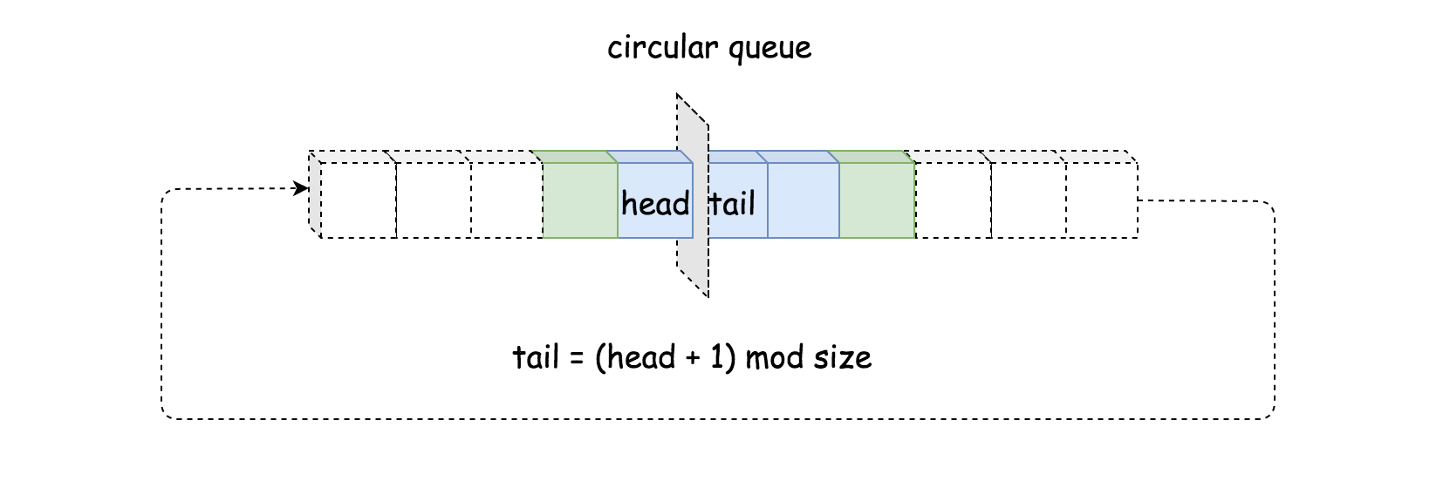

* The major advantage of circular queue is that by adding a new element to a full circular queue, it automatically discards the oldest element. Unlike deque, we do not need to explicitly remove the oldest element.
* Another advantage of circular queue is that a single index suffices to keep track of both ends of the queue, unlike deque where we have to keep a pointer for each end.

**Algorithm**

No need to resort to any library, one could easily implement a circular queue with a fixed-size array. The key to the implementation is the correlation between the index of head and tail elements, which we could summarize in the following formula:

tail=(head+1) mod size

In other words, the tail element is right next to the head element. Once we move the head forward, we would overwrite the previous tail element.

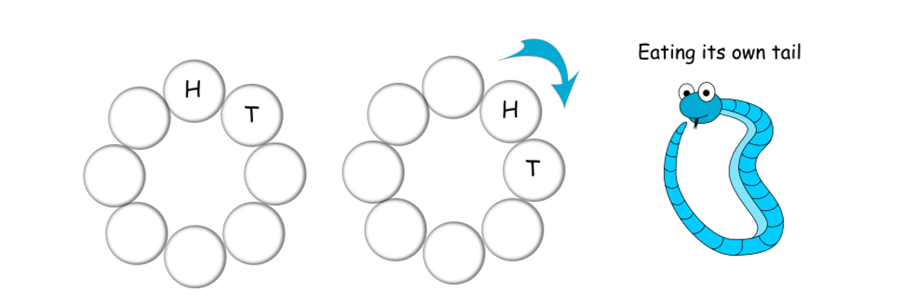

|  |
| --- |
| class MovingAverage {  int size, head = 0, windowSum = 0, count = 0;  int[] queue;  public MovingAverage(int size) {  this.size = size;  queue = new int[size];  }  public double next(int val) {  ++count;  // calculate the new sum by shifting the window  int tail = (head + 1) % size;  windowSum = windowSum - queue[tail] + val;  // move on to the next head  head = (head + 1) % size;  queue[head] = val;  return windowSum * 1.0 / Math.min(size, count);  }  } |

**Complexity**

* Time Complexity: O(1), as we can see that there is no loop in the next(val) function.
* Space Complexity: O(*N*), where *N* is the size of the circular queue.

## Queue and BFS

Prerequisite: [Tree Level-order Traversal](https://leetcode.com/explore/learn/card/data-structure-tree/134/traverse-a-tree/990/)

Breadth-first search (BFS) is an algorithm to traverse or search in data structures like a tree or a graph.

As we mentioned, we can use BFS to do level-order traversal in a tree.

We can also use BFS to traverse a graph. For example, we can use BFS to find a path, especially the shortest path, from a start node to a target node.

We can use BFS, in even more abstract scenarios, to traverse all the possible statuses. In this case, we can regard the statuses as the nodes in the graph while the legal transition paths as the edges in the graph.

In this chapter, we will briefly review how BFS works and focus more on how a queue helps us implement the BFS algorithm. We will also provide some exercise for you to design and implement BFS by yourself.

**Queue and BFS**

One common application of Breadth-first Search (BFS) is to find the shortest path from the root node to the target node. In this article, we provide an example to explain how queue is applied in a BFS algorithm step by step.

### **An Example**

Here we provide an example to show how BFS is used to find the shortest path between the root node A and the target node G.

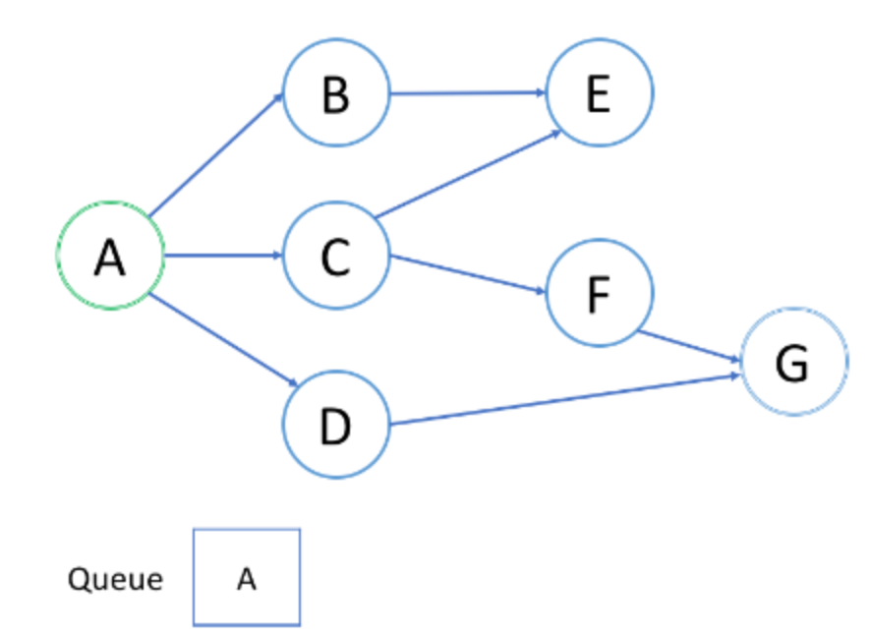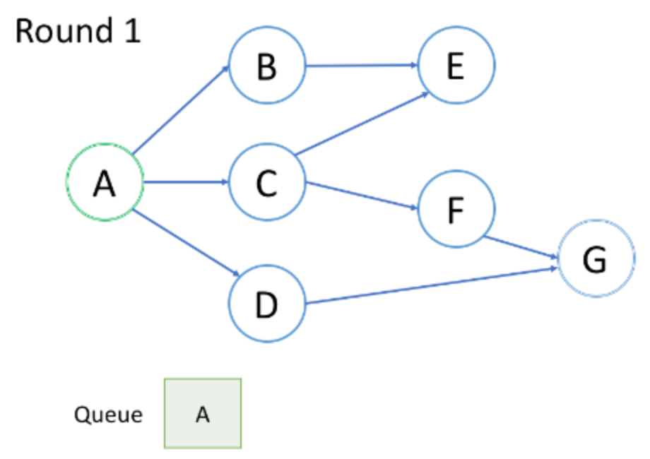

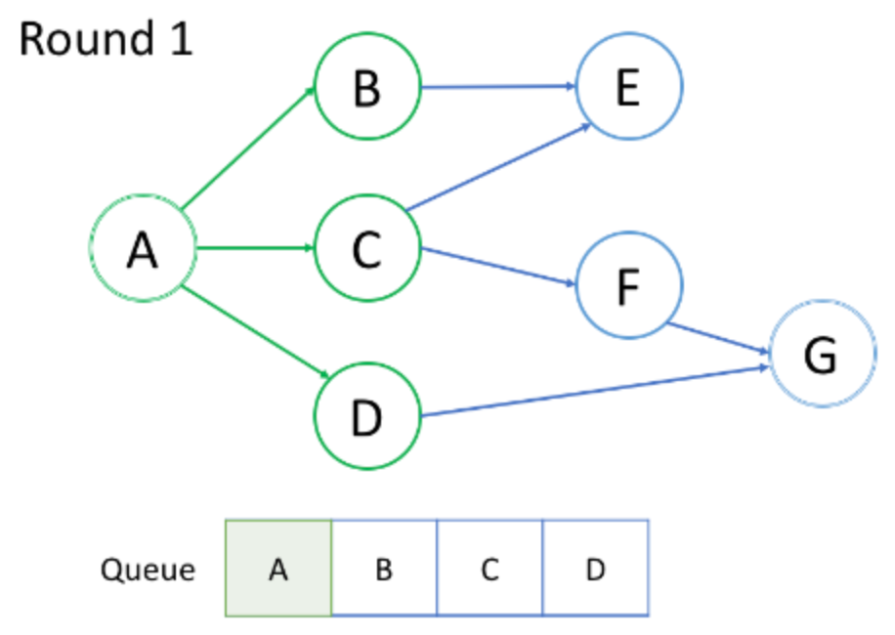

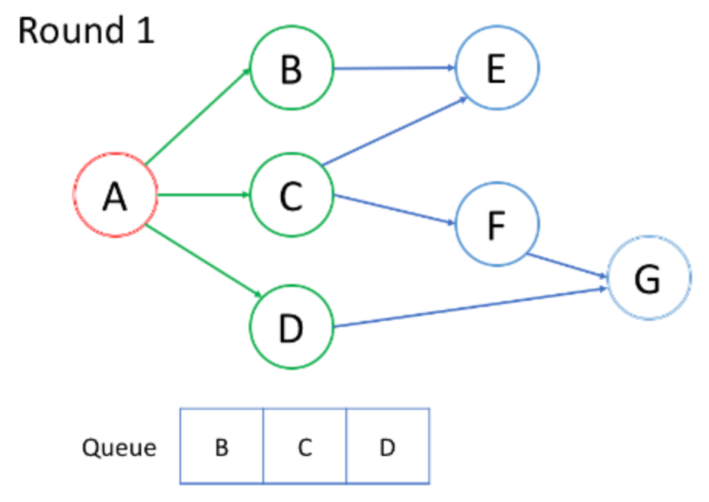

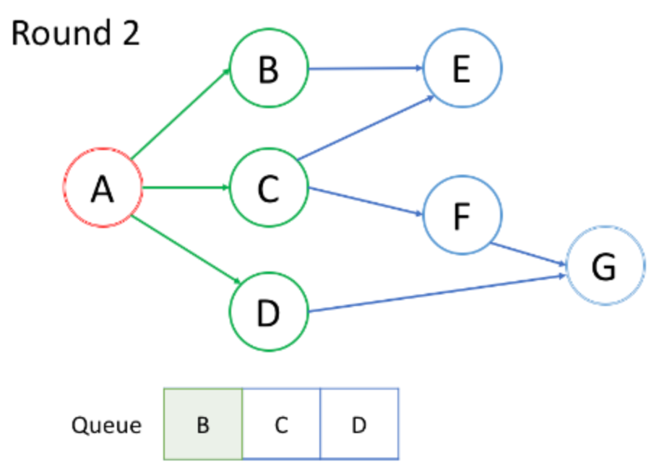

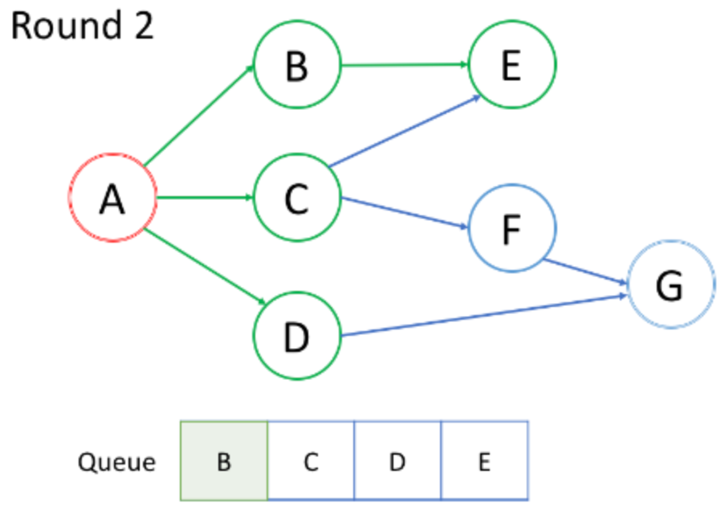

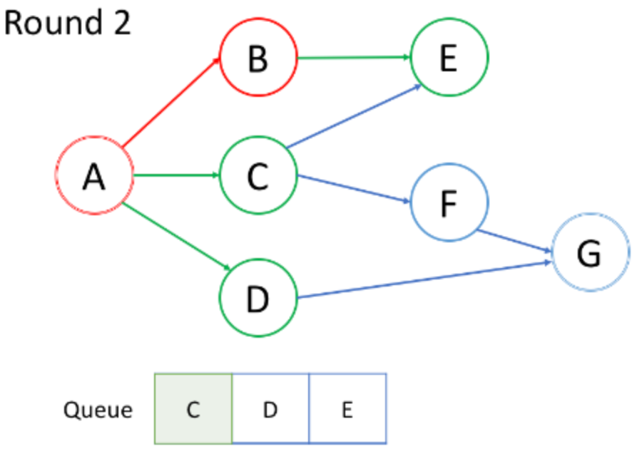

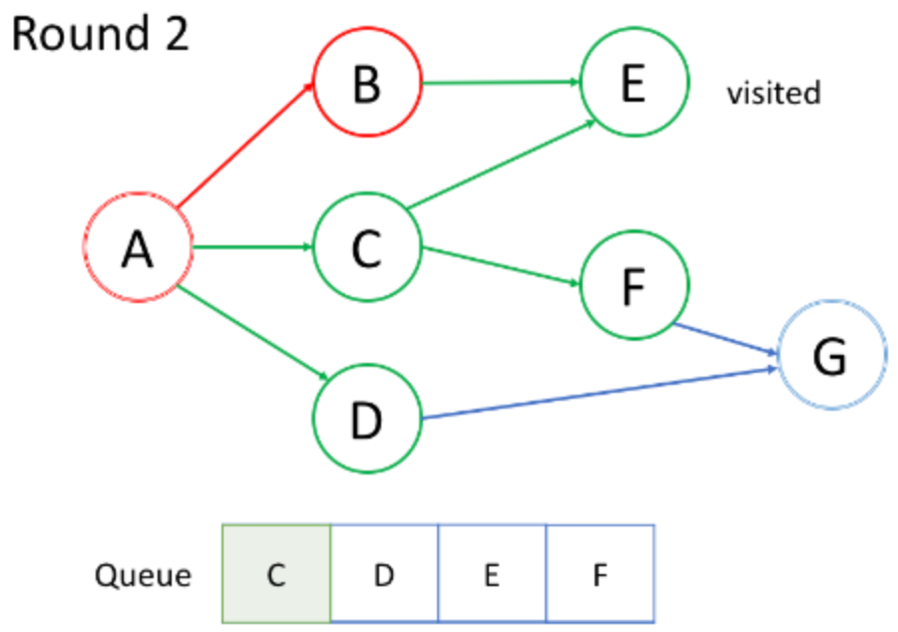

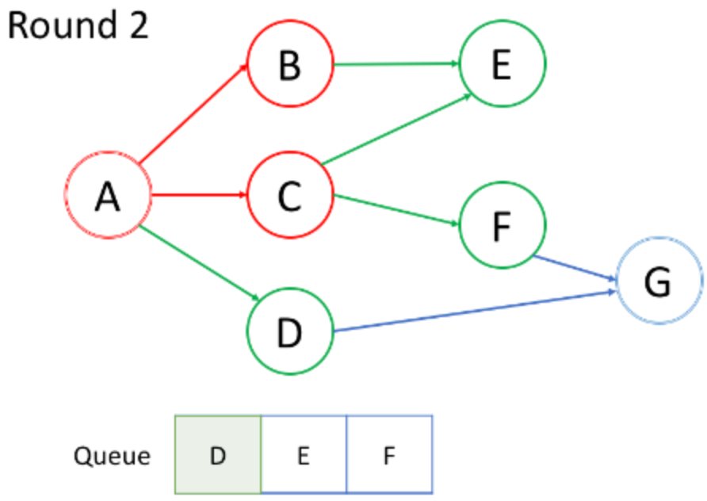

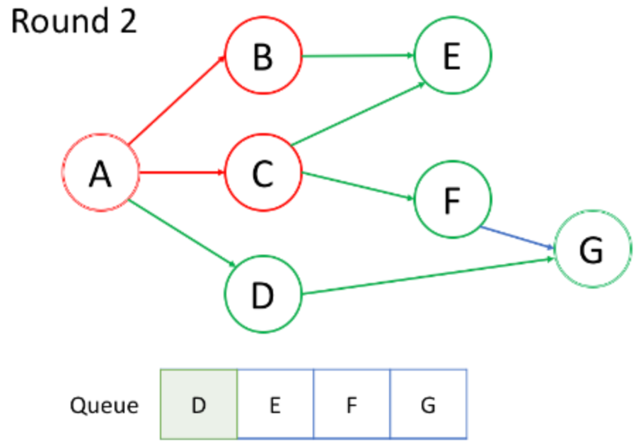

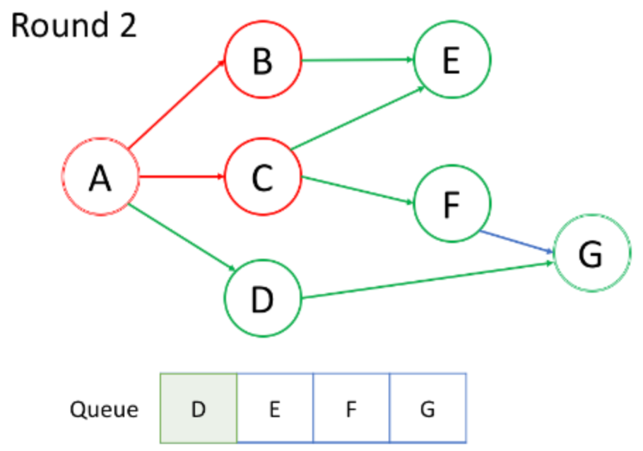

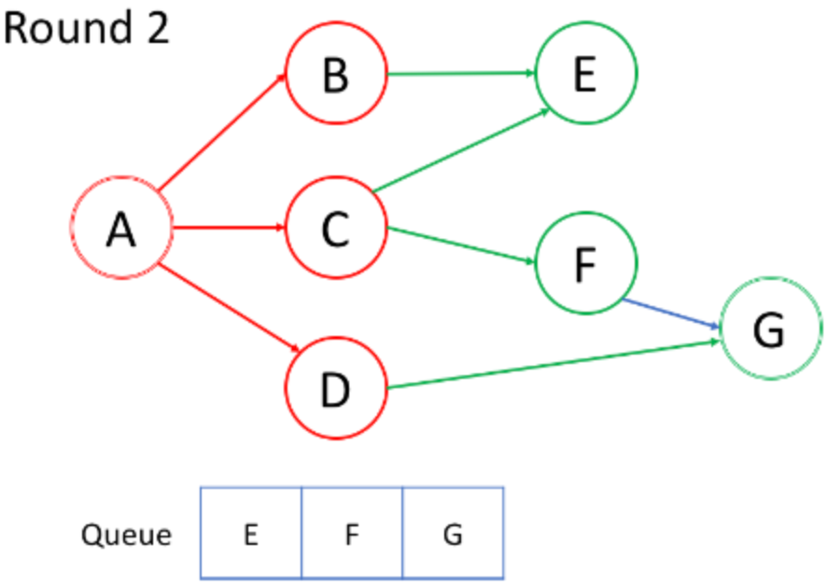

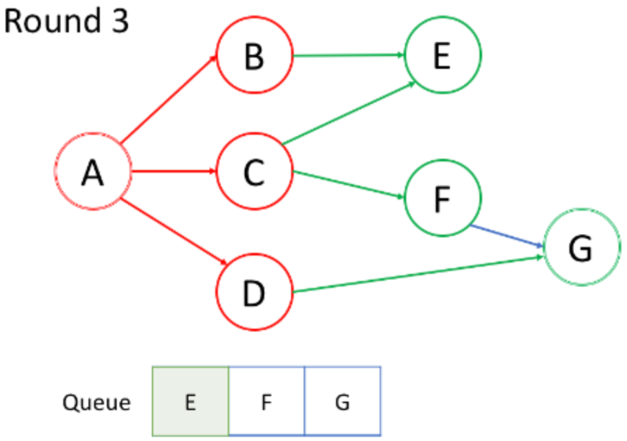

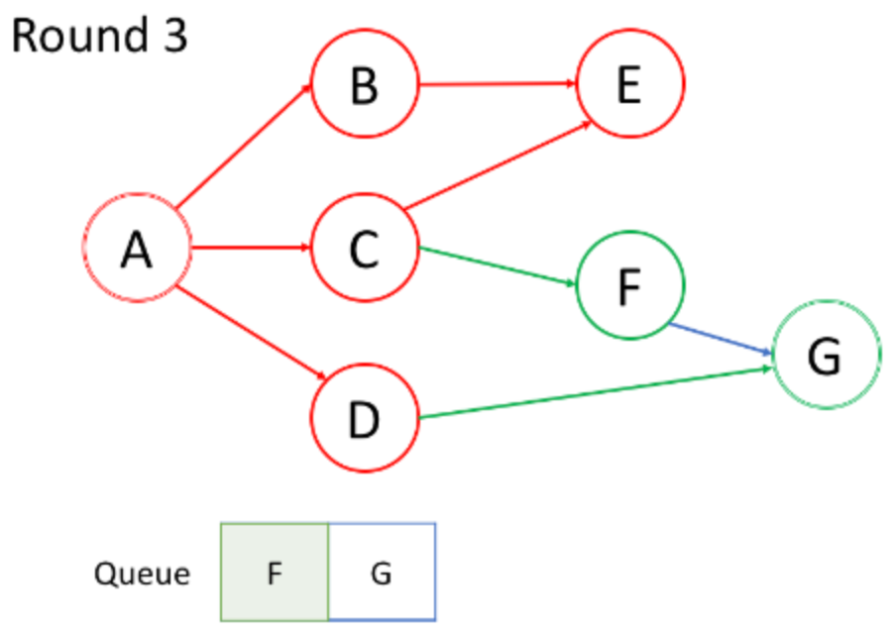

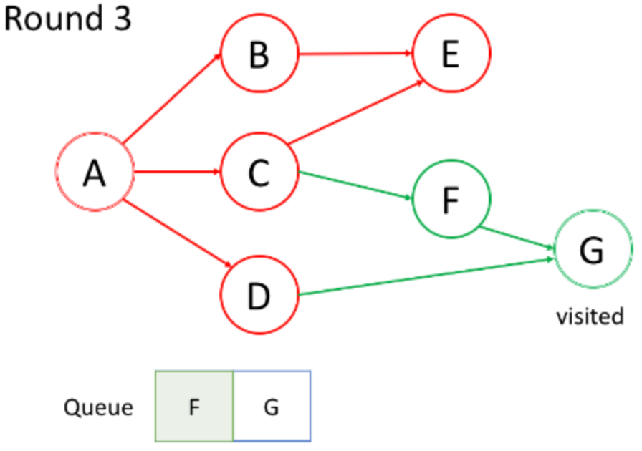

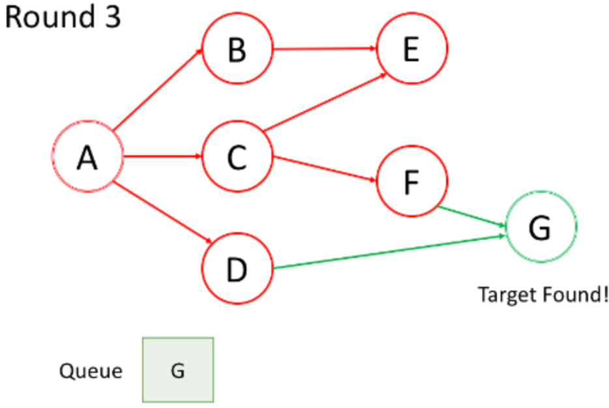

### **Insights**

After watching the animation above, let's answer the following questions:

**1. What is the processing order of the nodes?**

In the first round, we process the root node. In the second round, we process the nodes next to the root node; in the third round, we process the nodes which are two steps from the root node; so on and so forth.

Similar to tree's level-order traversal, the nodes closer to the root node will be traversed earlier.

If a node X is added to the queue in the kth round, the length of the shortest path between the root node and X is exactly k. That is to say, you are already in the shortest path the first time you find the target node.

**2. What is the enqueue and dequeue order of the queue?**

As shown in the animation above, we first enqueue the root node. Then in each round, we process the nodes which are already in the queue one by one and add all their neighbors to the queue. It is worth noting that the newly-added nodes will not be traversed immediately but will be processed in the next round.

The processing order of the nodes is the exact same order as how they were added to the queue, which is First-in-First-out (FIFO). That's why we use a queue in BFS.

**BFS - Template**

Previously, we have already introduced two main scenarios of using BFS: do traversal or find the shortest path. Typically, it happens in a tree or a graph. As we mentioned in the chapter description, BFS can also be used in more abstract scenarios.

In this article, we will provide you with a template. Then, we provide some exercise after this article for practice.

It will be important to determine the nodes and the edges before doing BFS in a specific question. Typically, the node will be an actual node or a status while the edge will be an actual edge or a possible transition.

### ***Template I***

Here we provide a pseudocode for you as a template:

|  |
| --- |
| /**  * Return the length of the shortest path between root and target node.  */  int BFS(Node root, Node target) {  Queue<Node> queue; // store all nodes which are waiting to be processed  int step = 0; // number of steps neeeded from root to current node  // initialize  add root to queue;  // BFS  while (queue is not empty) {  step = step + 1;  // iterate the nodes which are already in the queue  int size = queue.size();  for (int i = 0; i < size; ++i) {  Node cur = the first node in queue;  return step if cur is target;  for (Node next : the neighbors of cur) {  add next to queue;  }  remove the first node from queue;  }  }  return -1; // there is no path from root to target  } |

1. As shown in the code, in each round, the nodes in the queue are the nodes which are waiting to be processed.
2. After each outer while loop, we are one step farther from the root node. The variable step indicates the distance from the root node and the current node we are visiting.

### ***Template II***

Sometimes, it is important to make sure that we never visit a node twice. Otherwise, we might get stuck in an infinite loop, *e.g.* in graph with cycle. If so, we can add a hash set to the code above to solve this problem. Here is the pseudocode after modification:

|  |
| --- |
| /**  * Return the length of the shortest path between root and target node.  */  int BFS(Node root, Node target) {  Queue<Node> queue; // store all nodes which are waiting to be processed  Set<Node> visited; // store all the nodes that we've visited  int step = 0; // number of steps neeeded from root to current node  // initialize  add root to queue;  add root to visited;  // BFS  while (queue is not empty) {  step = step + 1;  // iterate the nodes which are already in the queue  int size = queue.size();  for (int i = 0; i < size; ++i) {  Node cur = the first node in queue;  return step if cur is target;  for (Node next : the neighbors of cur) {  if (next is not in used) {  add next to queue;  add next to visited;  }  }  remove the first node from queue;  }  }  return -1; // there is no path from root to target  } |

There are some cases where one does not need keep the visited hash set:

1. You are absolutely sure there is no cycle, for example, in tree traversal;
2. You do want to add the node to the queue multiple times.

**Walls and Gates**

You are given an m x n grid rooms initialized with these three possible values.

* -1 A wall or an obstacle.
* 0 A gate.
* INF Infinity means an empty room. We use the value 231 - 1 = 2147483647 to represent INF as you may assume that the distance to a gate is less than 2147483647.

Fill each empty room with the distance to *its nearest gate*. If it is impossible to reach a gate, it should be filled with INF.

**Example 1:**

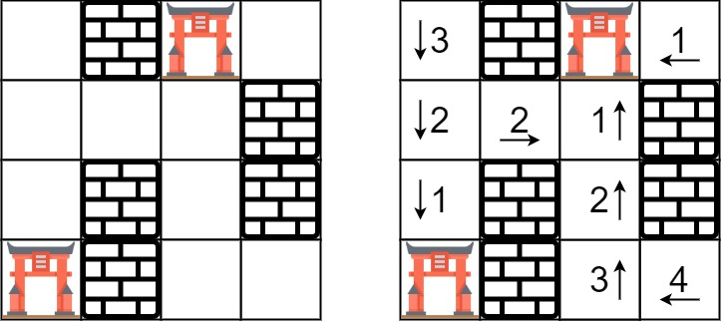

**Input:** rooms = [[2147483647,-1,0,2147483647],[2147483647,2147483647,2147483647,-1],[2147483647,-1,2147483647,-1],[0,-1,2147483647,2147483647]]

**Output:** [[3,-1,0,1],[2,2,1,-1],[1,-1,2,-1],[0,-1,3,4]]

**Example 2:**

**Input:** rooms = [[-1]]

**Output:** [[-1]]

**Example 3:**

**Input:** rooms = [[2147483647]]

**Output:** [[2147483647]]

**Example 4:**

**Input:** rooms = [[0]]

**Output:** [[0]]

**Constraints:**

* m == rooms.length
* n == rooms[i].length
* 1 <= m, n <= 250
* rooms[i][j] is -1, 0, or 231 - 1.

## Solution

#### **Approach #1 (Brute Force) [Time Limit Exceeded]**

The brute force approach is simple, we just implement a breadth-first search from each empty room to its nearest gate.

While we are doing the search, we use a 2D array called distance to keep track of the distance from the starting point. It also implicitly tell us whether a position had been visited so it won't be inserted into the queue again.

|  |
| --- |
| private static final int EMPTY = Integer.MAX_VALUE;  private static final int GATE = 0;  private static final int WALL = -1;  private static final List<int[]> DIRECTIONS = Arrays.asList(  new int[] { 1, 0},  new int[] {-1, 0},  new int[] { 0, 1},  new int[] { 0, -1}  );  public void wallsAndGates(int[][] rooms) {  if (rooms.length == 0) return;  for (int row = 0; row < rooms.length; row++) {  for (int col = 0; col < rooms[0].length; col++) {  if (rooms[row][col] == EMPTY) {  rooms[row][col] = distanceToNearestGate(rooms, row, col);  }  }  }  }  private int distanceToNearestGate(int[][] rooms, int startRow, int startCol) {  int m = rooms.length;  int n = rooms[0].length;  int[][] distance = new int[m][n];  Queue<int[]> q = new LinkedList<>();  q.add(new int[] { startRow, startCol });  while (!q.isEmpty()) {  int[] point = q.poll();  int row = point[0];  int col = point[1];  for (int[] direction : DIRECTIONS) {  int r = row + direction[0];  int c = col + direction[1];  if (r < 0 || c < 0 || r >= m || c >= n || rooms[r][c] == WALL  || distance[r][c] != 0) {  continue;  }  distance[r][c] = distance[row][col] + 1;  if (rooms[r][c] == GATE) {  return distance[r][c];  }  q.add(new int[] { r, c });  }  }  return Integer.MAX_VALUE;  } |

**Complexity analysis**

* Time complexity : O(m^2n^2). For each point in the *m*×*n* size grid, the gate could be at most *m*×*n* steps away.
* Space complexity : *O*(*mn*). The space complexity depends on the queue's size. Since we won't insert points that have been visited before into the queue, we insert at most *m*×*n* points into the queue.

#### **Approach #2 (Breadth-first Search) [Accepted]**

Instead of searching from an empty room to the gates, how about searching the other way round? In other words, we initiate breadth-first search (BFS) from all gates at the same time. Since BFS guarantees that we search all rooms of distance d before searching rooms of distance d + 1, the distance to an empty room must be the shortest.

|  |
| --- |
| private static final int EMPTY = Integer.MAX_VALUE;  private static final int GATE = 0;  private static final List<int[]> DIRECTIONS = Arrays.asList(  new int[] { 1, 0},  new int[] {-1, 0},  new int[] { 0, 1},  new int[] { 0, -1}  );  public void wallsAndGates(int[][] rooms) {  int m = rooms.length;  if (m == 0) return;  int n = rooms[0].length;  Queue<int[]> q = new LinkedList<>();  for (int row = 0; row < m; row++) {  for (int col = 0; col < n; col++) {  if (rooms[row][col] == GATE) {  q.add(new int[] { row, col });  }  }  }  while (!q.isEmpty()) {  int[] point = q.poll();  int row = point[0];  int col = point[1];  for (int[] direction : DIRECTIONS) {  int r = row + direction[0];  int c = col + direction[1];  if (r < 0 || c < 0 || r >= m || c >= n || rooms[r][c] != EMPTY) {  continue;  }  rooms[r][c] = rooms[row][col] + 1;  q.add(new int[] { r, c });  }  }  } |

**Complexity analysis**

* Time complexity : *O*(*mn*).

If you are having difficulty to derive the time complexity, start simple.

Let us start with the case with only one gate. The breadth-first search takes at most *m*×*n* steps to reach all rooms, therefore the time complexity is *O*(*mn*). But what if you are doing breadth-first search from *k* gates?

Once we set a room's distance, we are basically marking it as visited, which means each room is visited at most once. Therefore, the time complexity does not depend on the number of gates and is *O*(*mn*).

* Space complexity : *O*(*mn*). The space complexity depends on the queue's size. We insert at most *m*×*n* points into the queue.

**Number of Islands**

Given an m x n 2d grid map of '1's (land) and '0's (water), return *the number of islands*.

An **island** is surrounded by water and is formed by connecting adjacent lands horizontally or vertically. You may assume all four edges of the grid are all surrounded by water.

**Example 1:**

**Input:** grid = [

["1","1","1","1","0"],

["1","1","0","1","0"],

["1","1","0","0","0"],

["0","0","0","0","0"]

]

**Output:** 1

**Example 2:**

**Input:** grid = [

["1","1","0","0","0"],

["1","1","0","0","0"],

["0","0","1","0","0"],

["0","0","0","1","1"]

]

**Output:** 3

**Constraints:**

* m == grid.length
* n == grid[i].length
* 1 <= m, n <= 300
* grid[i][j] is '0' or '1'.

#### **Approach #1 DFS [Accepted]**

**Intuition**

Treat the 2d grid map as an undirected graph and there is an edge between two horizontally or vertically adjacent nodes of value '1'.

**Algorithm**

Linear scan the 2d grid map, if a node contains a '1', then it is a root node that triggers a Depth First Search. During DFS, every visited node should be set as '0' to mark as visited node. Count the number of root nodes that trigger DFS, this number would be the number of islands since each DFS starting at some root identifies an island.

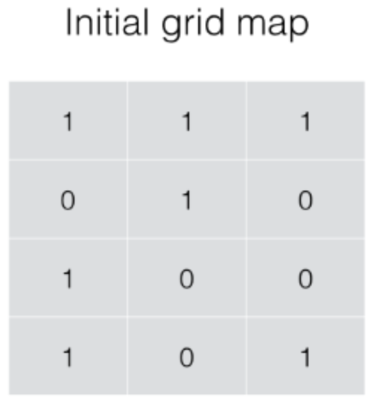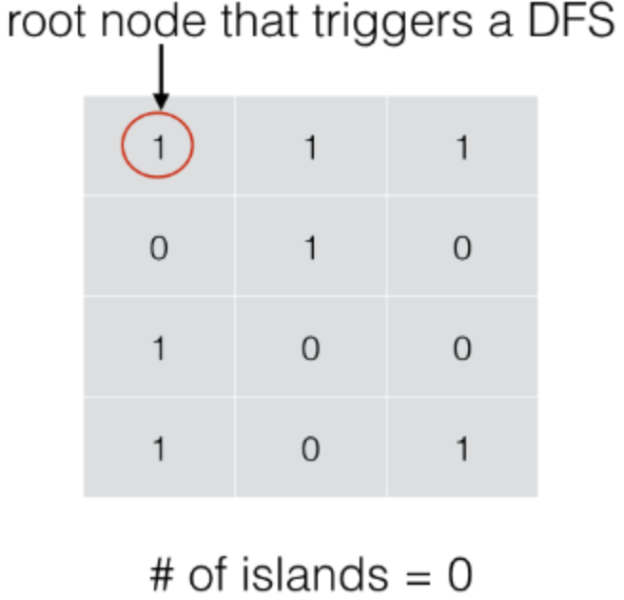

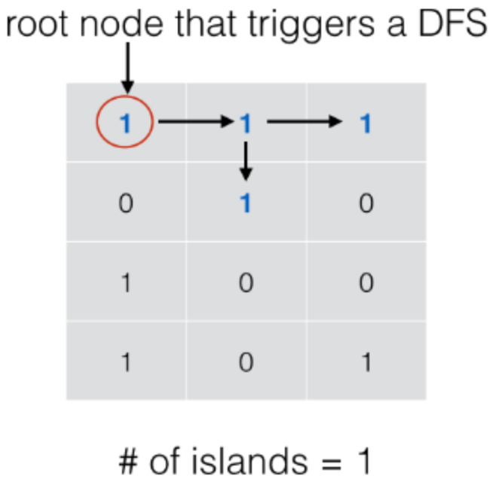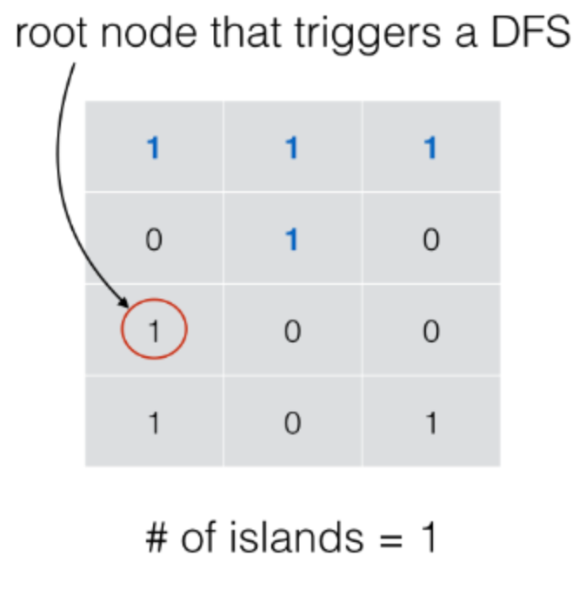

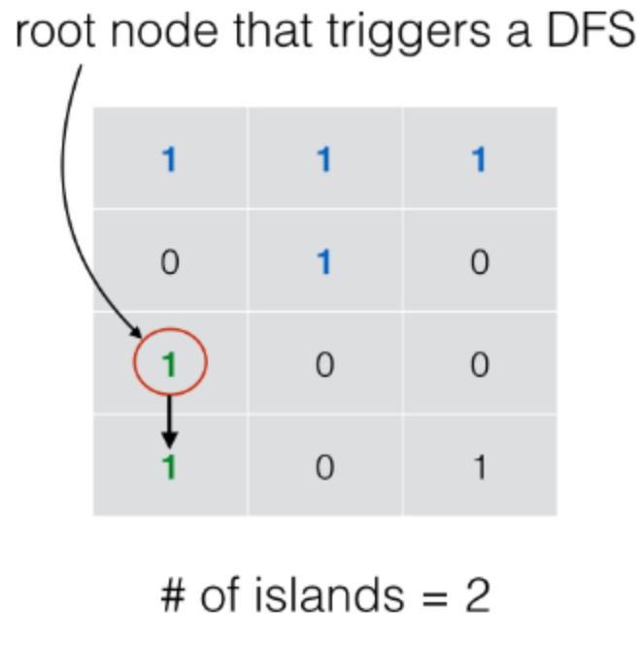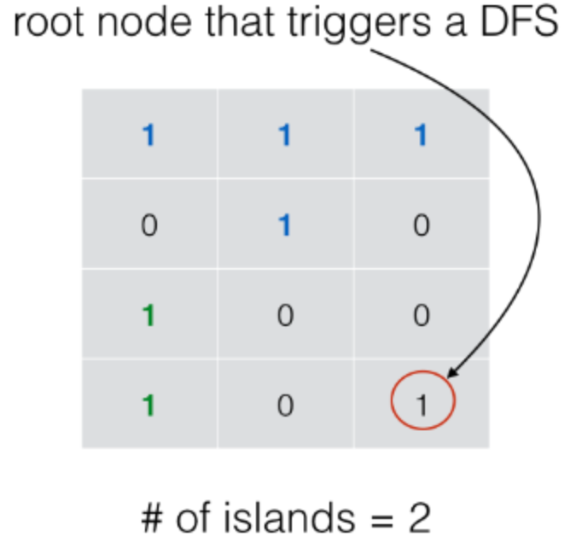

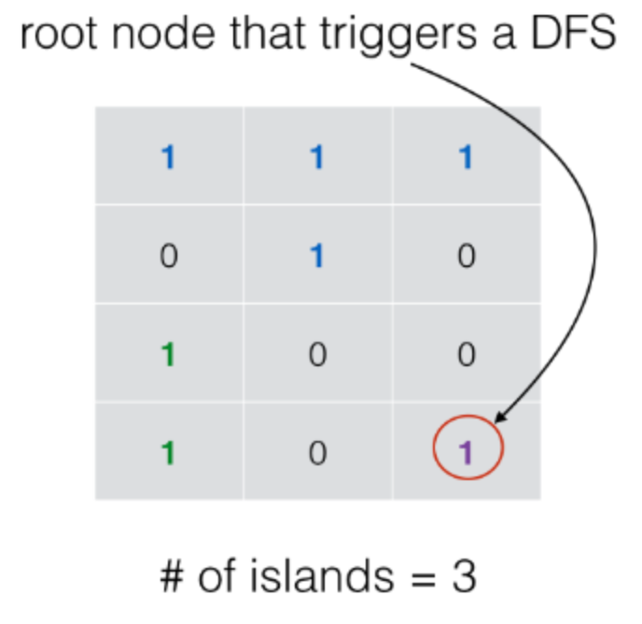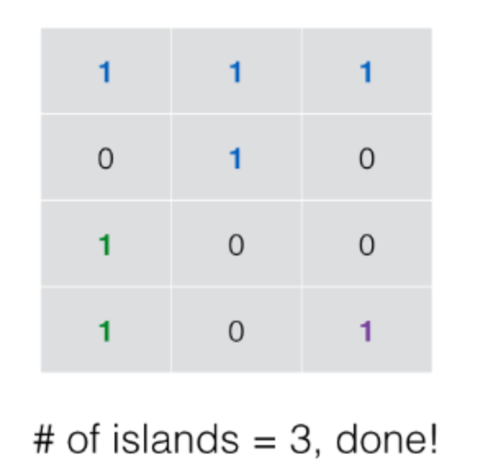

|  |
| --- |
| class Solution {  void dfs(char[][] grid, int r, int c) {  int nr = grid.length;  int nc = grid[0].length;  if (r < 0 || c < 0 || r >= nr || c >= nc || grid[r][c] == '0') {  return;  }  grid[r][c] = '0';  dfs(grid, r - 1, c);  dfs(grid, r + 1, c);  dfs(grid, r, c - 1);  dfs(grid, r, c + 1);  }  public int numIslands(char[][] grid) {  if (grid == null || grid.length == 0) {  return 0;  }  int nr = grid.length;  int nc = grid[0].length;  int num_islands = 0;  for (int r = 0; r < nr; ++r) {  for (int c = 0; c < nc; ++c) {  if (grid[r][c] == '1') {  ++num_islands;  dfs(grid, r, c);  }  }  }  return num_islands;  }  } |

**Complexity Analysis**

* Time complexity : *O*(*M*×*N*) where *M* is the number of rows and *N* is the number of columns.
* Space complexity : worst case *O*(*M*×*N*) in case that the grid map is filled with lands where DFS goes by *M*×*N* deep.

#### **Approach #2: BFS [Accepted]**

**Algorithm**

Linear scan the 2d grid map, if a node contains a '1', then it is a root node that triggers a Breadth First Search. Put it into a queue and set its value as '0' to mark as visited node. Iteratively search the neighbors of enqueued nodes until the queue becomes empty.

|  |
| --- |
| class Solution {  public int numIslands(char[][] grid) {  if (grid == null || grid.length == 0) {  return 0;  }  int nr = grid.length;  int nc = grid[0].length;  int num_islands = 0;  for (int r = 0; r < nr; ++r) {  for (int c = 0; c < nc; ++c) {  if (grid[r][c] == '1') {  ++num_islands;  grid[r][c] = '0'; // mark as visited  Queue<Integer> neighbors = new LinkedList<>();  neighbors.add(r * nc + c);  while (!neighbors.isEmpty()) {  int id = neighbors.remove();  int row = id / nc;  int col = id % nc;  if (row - 1 >= 0 && grid[row-1][col] == '1') {  neighbors.add((row-1) * nc + col);  grid[row-1][col] = '0';  }  if (row + 1 < nr && grid[row+1][col] == '1') {  neighbors.add((row+1) * nc + col);  grid[row+1][col] = '0';  }  if (col - 1 >= 0 && grid[row][col-1] == '1') {  neighbors.add(row * nc + col-1);  grid[row][col-1] = '0';  }  if (col + 1 < nc && grid[row][col+1] == '1') {  neighbors.add(row * nc + col+1);  grid[row][col+1] = '0';  }  }  }  }  }  return num_islands;  }  } |

**Complexity Analysis**

* Time complexity : *O*(*M*×*N*) where *M* is the number of rows and *N* is the number of columns.
* Space complexity : *O*(*min*(*M*,*N*)) because in worst case where the grid is filled with lands, the size of queue can grow up to min(*M*,*N*).

#### **Approach #3: Union Find (aka Disjoint Set) [Accepted]**

**Algorithm**

Traverse the 2d grid map and union adjacent lands horizontally or vertically, at the end, return the number of connected components maintained in the UnionFind data structure.

For details regarding to Union Find, you can refer to this [article](https://leetcode.com/articles/redundant-connection/).

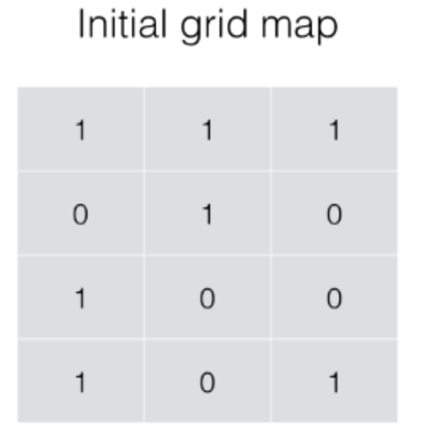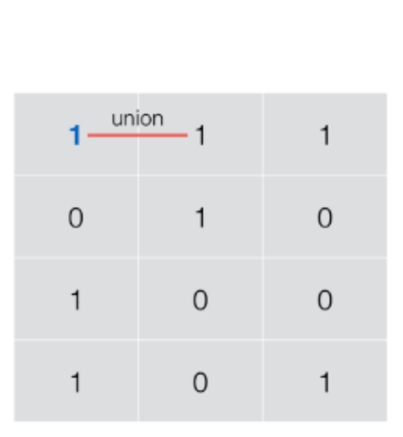

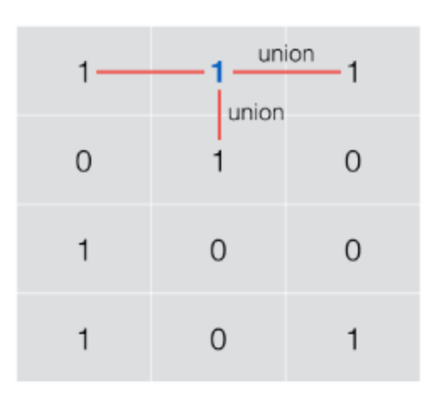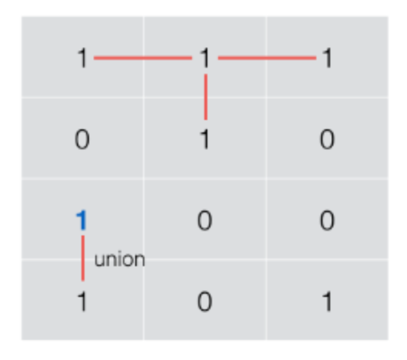

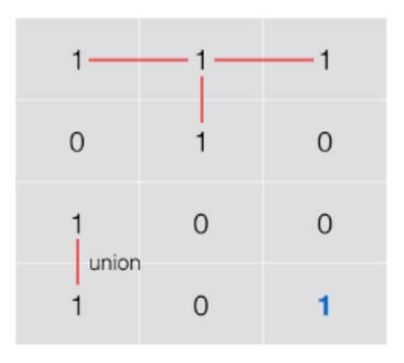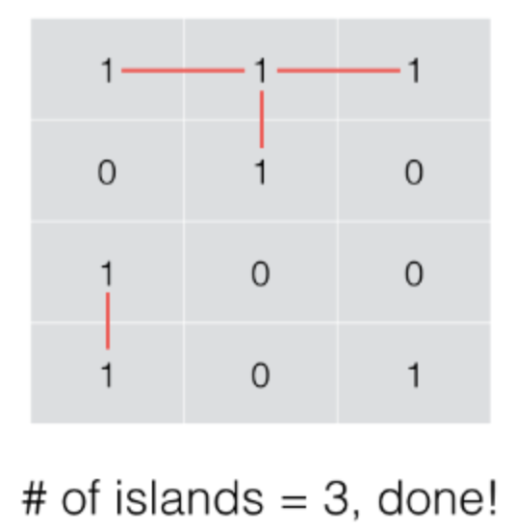

|  |
| --- |
| class Solution {  class UnionFind {  int count; // # of connected components  int[] parent;  int[] rank;  public UnionFind(char[][] grid) { // for problem 200  count = 0;  int m = grid.length;  int n = grid[0].length;  parent = new int[m * n];  rank = new int[m * n];  for (int i = 0; i < m; ++i) {  for (int j = 0; j < n; ++j) {  if (grid[i][j] == '1') {  parent[i * n + j] = i * n + j;  ++count;  }  rank[i * n + j] = 0;  }  }  }  public int find(int i) { // path compression  if (parent[i] != i) parent[i] = find(parent[i]);  return parent[i];  }  public void union(int x, int y) { // union with rank  int rootx = find(x);  int rooty = find(y);  if (rootx != rooty) {  if (rank[rootx] > rank[rooty]) {  parent[rooty] = rootx;  } else if (rank[rootx] < rank[rooty]) {  parent[rootx] = rooty;  } else {  parent[rooty] = rootx; rank[rootx] += 1;  }  --count;  }  }  public int getCount() {  return count;  }  }  public int numIslands(char[][] grid) {  if (grid == null || grid.length == 0) {  return 0;  }  int nr = grid.length;  int nc = grid[0].length;  int num_islands = 0;  UnionFind uf = new UnionFind(grid);  for (int r = 0; r < nr; ++r) {  for (int c = 0; c < nc; ++c) {  if (grid[r][c] == '1') {  grid[r][c] = '0';  if (r - 1 >= 0 && grid[r-1][c] == '1') {  uf.union(r * nc + c, (r-1) * nc + c);  }  if (r + 1 < nr && grid[r+1][c] == '1') {  uf.union(r * nc + c, (r+1) * nc + c);  }  if (c - 1 >= 0 && grid[r][c-1] == '1') {  uf.union(r * nc + c, r * nc + c - 1);  }  if (c + 1 < nc && grid[r][c+1] == '1') {  uf.union(r * nc + c, r * nc + c + 1);  }  }  }  }  return uf.getCount();  }  } |

**Complexity Analysis**

* Time complexity : *O*(*M*×*N*) where *M* is the number of rows and *N* is the number of columns. Note that Union operation takes essentially constant time[[1]](https://leetcode.com/problems/number-of-islands/solution/#fn1) when UnionFind is implemented with both path compression and union by rank.
* Space complexity : *O*(*M*×*N*) as required by UnionFind data structure.

**Open the Lock**

You have a lock in front of you with 4 circular wheels. Each wheel has 10 slots: '0', '1', '2', '3', '4', '5', '6', '7', '8', '9'. The wheels can rotate freely and wrap around: for example we can turn '9' to be '0', or '0' to be '9'. Each move consists of turning one wheel one slot.

The lock initially starts at '0000', a string representing the state of the 4 wheels.

You are given a list of deadends dead ends, meaning if the lock displays any of these codes, the wheels of the lock will stop turning and you will be unable to open it.

Given a target representing the value of the wheels that will unlock the lock, return the minimum total number of turns required to open the lock, or -1 if it is impossible.

**Example 1:**

**Input:** deadends = ["0201","0101","0102","1212","2002"], target = "0202"

**Output:** 6

**Explanation:**

A sequence of valid moves would be "0000" -> "1000" -> "1100" -> "1200" -> "1201" -> "1202" -> "0202".

Note that a sequence like "0000" -> "0001" -> "0002" -> "0102" -> "0202" would be invalid,

because the wheels of the lock become stuck after the display becomes the dead end "0102".

**Example 2:**

**Input:** deadends = ["8888"], target = "0009"

**Output:** 1

**Explanation:**

We can turn the last wheel in reverse to move from "0000" -> "0009".

**Example 3:**

**Input:** deadends = ["8887","8889","8878","8898","8788","8988","7888","9888"], target = "8888"

**Output:** -1

Explanation:

We can't reach the target without getting stuck.

**Example 4:**

**Input:** deadends = ["0000"], target = "8888"

**Output:** -1

**Constraints:**

* 1 <= deadends.length <= 500
* deadends[i].length == 4
* target.length == 4
* target **will not be** in the list deadends.
* target and deadends[i] consist of digits only.

#### **Approach #1: Breadth-First Search [Accepted]**

**Intuition**

We can think of this problem as a shortest path problem on a graph: there are 10000 nodes (strings '0000' to '9999'), and there is an edge between two nodes if they differ in one digit, that digit differs by 1 (wrapping around, so '0' and '9' differ by 1), and if both nodes are not in deadends.

**Algorithm**

To solve a shortest path problem, we use a breadth-first search. The basic structure uses a Queue queue plus a Set seen that records if a node has ever been enqueued. This pushes all the work to the neighbors function - in our Python implementation, all the code after while queue: is template code, except for if node in dead: continue.

As for the neighbors function, for each position in the lock i = 0, 1, 2, 3, for each of the turns d = -1, 1, we determine the value of the lock after the i-th wheel has been turned in the direction d.

Care should be taken in our algorithm, as the graph does not have an edge unless both nodes are not in deadends. If our neighbors function checks only the target for being in deadends, we also need to check whether '0000' is in deadends at the beginning. In our implementation, we check at the visitor level so as to neatly handle this problem in all cases.

In Java, our implementation also inlines the neighbors function for convenience, and uses null inputs in the queue to represent a layer change. When the layer changes, we depth++ our global counter, and queue.peek() != null checks if there are still nodes enqueued.

|  |
| --- |
| class Solution {  public int openLock(String[] deadends, String target) {  Set<String> dead = new HashSet();  for (String d: deadends) dead.add(d);  Queue<String> queue = new LinkedList();  queue.offer("0000");  queue.offer(null);  Set<String> seen = new HashSet();  seen.add("0000");  int depth = 0;  while (!queue.isEmpty()) {  String node = queue.poll();  if (node == null) {  depth++;  if (queue.peek() != null)  queue.offer(null);  } else if (node.equals(target)) {  return depth;  } else if (!dead.contains(node)) {  for (int i = 0; i < 4; ++i) {  for (int d = -1; d <= 1; d += 2) {  int y = ((node.charAt(i) - '0') + d + 10) % 10;  String nei = node.substring(0, i) + ("" + y) + node.substring(i+1);  if (!seen.contains(nei)) {  seen.add(nei);  queue.offer(nei);  }  }  }  }  }  return -1;  }  } |

**Complexity Analysis**

* Time Complexity: *O*(*N*2∗A*N*+*D*) where A is the number of digits in our alphabet, N*N* is the number of digits in the lock, and *D* is the size of deadends. We might visit every lock combination, plus we need to instantiate our set dead. When we visit every lock combination, we spend *O*(*N*2) time enumerating through and constructing each node.
* Space Complexity:  *O*(A*N*+*D*), for the queue and the set dead.

**Perfect Squares**

Given an integer n, return *the least number of perfect square numbers that sum to* n.

A **perfect square** is an integer that is the square of an integer; in other words, it is the product of some integer with itself. For example, 1, 4, 9, and 16 are perfect squares while 3 and 11 are not.

**Example 1:**

**Input:** n = 12

**Output:** 3

**Explanation:** 12 = 4 + 4 + 4.

**Example 2:**

**Input:** n = 13

**Output:** 2

**Explanation:** 13 = 4 + 9.

**Constraints:**

* 1 <= n <= 104

## Solution

#### **Approach 1: Brute-force Enumeration [Time Limit Exceeded]**

**Intuition**

The problem asks us to find the **least** numbers of square numbers that can sum up to a given number. We could rephrase the problem as follows:

Given a list of square numbers and a positive integer number n, one is asked to find a combination of square numbers that sum up to n, and the combination should contain the **least** numbers among all possible solutions.  
Note: one could reuse the square numbers in the combination.

From the above narrative of the problem, it seems to be a combination problem, to which an intuitive solution would be the brute-force enumeration where we enumerate all possible combinations and find the minimal one of them.

We could formulate the problem in the following formula:



From the above formula, one can translate it into a ***recursive*** solution literally. Here is one example.

|  |
| --- |
| class Solution(object):  def numSquares(self, n):  square_nums = [i**2 for i in range(1, int(math.sqrt(n))+1)]  def minNumSquares(k):  """ recursive solution """  # bottom cases: find a square number  if k in square_nums:  return 1  min_num = float('inf')  # Find the minimal value among all possible solutions  for square in square_nums:  if k < square:  break  new_num = minNumSquares(k-square) + 1  min_num = min(min_num, new_num)  return min_num  return minNumSquares(n) |

The above solution could work for small numbers. However, as one would find out, we would quickly run into the Time Limit Exceeded exception even for medium-size numbers (*e.g.* 55).

Or simply we might encounter the Stack Overflow due the to the excessive recursion.

#### **Approach 2: Dynamic Programming**

**Intuition**

The reason why it failed with the brute-force approach is simply because we re-calculate the sub-solutions over and over again. However, the formula that we derived before is still valuable. All we need is a better way to implement the formula.



One might notice that, the problem is similar to the [Fibonacci number problem](https://leetcode.com/problems/fibonacci-number/), judging from the formula. And like Fibonacci number, we have several more efficient ways to calculate the solution, other than the simple recursion.

One of the ideas to solve the stack overflow issue in recursion is to apply the ***Dynamic Programming*** (DP) technique, which is built upon the idea of reusing the results of intermediate sub-solutions to calculate the final solution.

To calculate the value of numSquares(*n*), first we need to calculate all the values before *n*, *i.e. *

If we have already kept the solution for the number *n*−*k* in somewhere, we then would not need to resort to the recursive calculation which prevents the stack overflow.

**Algorithm**

Based on the above intuition, we could implement the DP solution in the following steps.

* As for almost all DP solutions, we first create an array dp of one or multiple dimensions to hold the values of intermediate sub-solutions, as well as the final solution which is usually the last element in the array. *Note that*, we create a fictional element dp[0]=0 to simplify the logic, which helps in the case that the remainder (n-k) happens to be a square number.
* As an additional preparation step, we pre-calculate a list of square numbers (*i.e.* square_nums) that is less than the given number n.
* As the main step, we then loop from the number 1 to n, to calculate the solution for each number i (*i.e.* numSquares(i)). At each iteration, we keep the result of numSquares(i) in dp[i], while resuing the previous results stored in the array.
* At the end of the loop, we then return the last element in the array as the result of the solution.

In the graph below, we illustrate how to calculate the results of numSquares(4) and numSquares(5) which correspond to the values in dp[4] and dp[5].

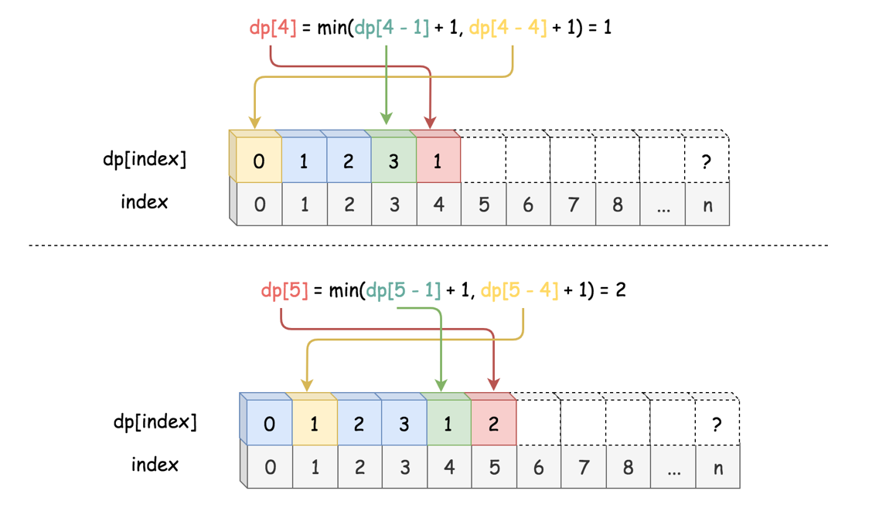

Here are some sample implementations. In particular, the Python solution took ~3500 ms, which was faster than ~50% submissions at the time.

**Note:** the following python solution works for Python2 only. For some unknown reason, it takes significantly longer time for Python3 to run the same code.

|  |
| --- |
| class Solution {  public int numSquares(int n) {  int dp[] = new int[n + 1];  Arrays.fill(dp, Integer.MAX_VALUE);  // bottom case  dp[0] = 0;  // pre-calculate the square numbers.  int max_square_index = (int) Math.sqrt(n) + 1;  int square_nums[] = new int[max_square_index];  for (int i = 1; i < max_square_index; ++i) {  square_nums[i] = i * i;  }  for (int i = 1; i <= n; ++i) {  for (int s = 1; s < max_square_index; ++s) {  if (i < square_nums[s])  break;  dp[i] = Math.min(dp[i], dp[i - square_nums[s]] + 1);  }  }  return dp[n];  }  } |

**Complexity**

* Time complexity:  O(*n*⋅ sqrt{n}​). In main step, we have a nested loop, where the outer loop is of *n* iterations and in the inner loop it takes at maximum sqrt{n} iterations.
* Space Complexity: O(*n*). We keep all the intermediate sub-solutions in the array dp[].

#### **Approach 3: Greedy Enumeration**

**Intuition**

Recursion isn't bad though. Above all, it provides us a concise and intuitive way to understand the problem. We could still resolve the problem with recursion. To improve the above brute-force enumeration solution, we could add a touch of Greedy into the recursion process. We could reformulate the enumeration solution as follows:

Starting from the combination of one single number to multiple numbers, *once* we find a combination that can sum up to the given number n, then we can say that we must have found the smallest combination, since we enumerate the combinations *greedily* from small to large.

To better explain the above intuition, let us first define a function called is_divided_by(n, count) which returns a boolean value to indicate whether the number n can be divided by a combination with count number of square numbers, rather than returning the exact size of combination as the previous function numSquares(n).

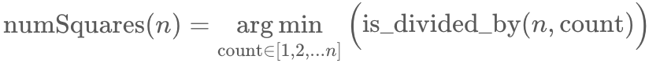

In addition, the function is_divided_by(n, count) could also assume the form of recursion as follows:



Different from the recursive function of numSquare(n), the recursion process of is_divided_by(n, count) would boil down to its bottom case (*i.e.* count==1) much more *rapid*.

Here is one example on how the function is_divided_by(n, count) breaks down for the input n=5 and count=2.

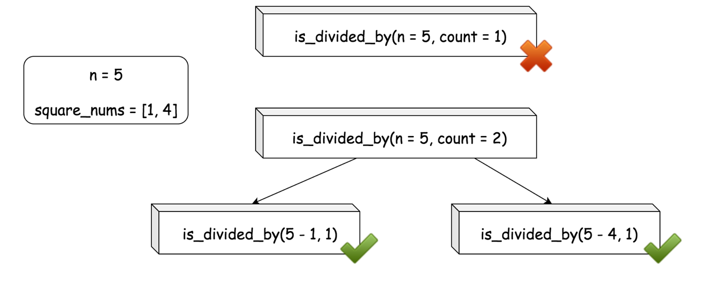

With this trick of reformulation, we could dramatically reduce the risk of stack overflow.

**Algorithm**

* First of all, we prepare a list of square numbers (named square_nums) that are less than the given number n.
* In the main loop, iterating the size of combination (named count) from one to n, we check if the number n can be divided by the sum of the combination, *i.e.* is_divided_by(n, count).
* The function is_divided_by(n, count) can be implemented in the form of recursion as we defined in the intuition section.
* In the bottom case, we have count==1, we just need to check if the number n is a square number itself. We could use the inclusion test with the list square_nums that we prepared before, *i.e.* *n* ∈ square_nums. And if we use the set data structure for square_nums, we could obtain a faster running time than the approach of n == int(sqrt(n))^2.

Concerning the correctness of the algorithm, often the case we could prove the Greedy algorithm by **contradiction**. This is no exception. Suppose we find a count=m that can divide the number n, and suppose in the later iterations there exists another number count=p that can also divide the number and the combination is smaller than the found one *i.e.* p < m. Given the order of the iteration, the count=p would have been discovered before count=m which is contradict to the fact that p comes later than m. Therefore, we can say that the algorithm works as expected, which always finds the minimal size of combination.

Here are some sample implementation. In particular, the Python solution took ~*70ms*, which was faster than ~ *90%* submissions at the time.

|  |
| --- |
| class Solution {  Set<Integer> square_nums = new HashSet<Integer>();  protected boolean is_divided_by(int n, int count) {  if (count == 1) {  return square_nums.contains(n);  }  for (Integer square : square_nums) {  if (is_divided_by(n - square, count - 1)) {  return true;  }  }  return false;  }  public int numSquares(int n) {  this.square_nums.clear();  for (int i = 1; i * i <= n; ++i) {  this.square_nums.add(i * i);  }  int count = 1;  for (; count <= n; ++count) {  if (is_divided_by(n, count))  return count;  }  return count;  }  } |

**Complexity**

* Time complexity: 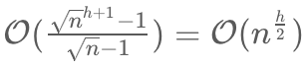 where h is the maximal number of recursion that could happen. As one might notice, the above formula actually resembles the formula to calculate the number of nodes in a complete N-ary tree. Indeed, the trace of recursive calls in the algorithm form a N-ary tree, where N is the number of squares in square_nums, i.e. 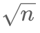​. In the worst case, we might have to traverse the entire tree to find the solution.
* Space Complexity: 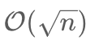 We keep a list of square_nums, which is of ​ size. In addition, we would need additional space for the recursive call stack. But as we will learn later, the size of the call track would not exceed 4.

#### **Approach 4: Greedy + BFS (Breadth-First Search)**

**Intuition**

As we mentioned in the complexity analysis in the above Greedy approach, the trace of the call stack forms a N-ary tree where each node represents a call to the is_divided_by(n, count) function. Based on the above intuition, again we could reformulate the original problem as follows:

Given a N-ary tree, where each node represents a **remainder** of the number n subtracting a combination of square numbers, our task is to find a node in the tree, which should meet two conditions: 1). the value of the node (i.e. the remainder) should be a square number as well. 2). the distance between the node and the root should be minimal among all nodes that meet the condition (1).

Here is an example how the tree would look like.

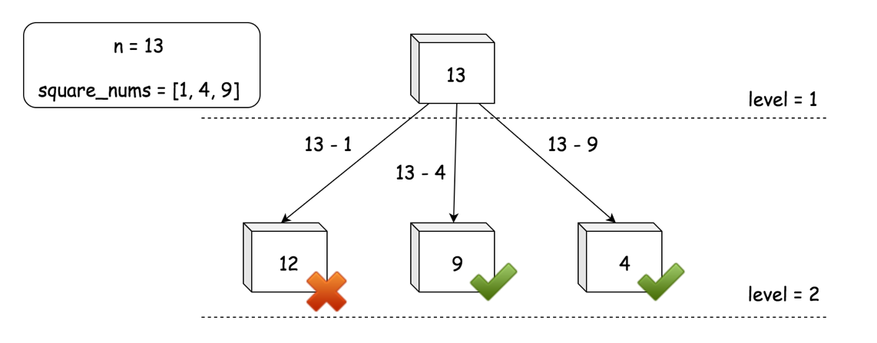

In the previous Approach #3, due to the Greedy strategy that we perform the calls, we were actually constructing the N-ary tree level-by-level from top to down. And the we were traversing it in a **BFS** (Breadth-First Search) manner. At each level of the N-ary tree, we were enumerating the combinations that are of the same size.

The order of traversing is of BFS, rather than DFS (Depth-First Search), is due to the fact that before exhausting all the possibilities of decomposing a number n with a fixed amount of squares, we would not explore any potential combination that needs more elements.

**Algorithm**

* Again, first of all, we prepare a list of square numbers (named square_nums) that are less than the given number n.
* We then create a queue variable which would keep all the remainders to enumerate at each level.
* In the main loop, we iterate over the queue variable. At each iteration, we check if the remainder is one of the square numbers. If the remainder is not a square number, we subtract it with one of the square numbers to obtain a new remainder and then add the new remainder to the next_queue for the iteration of the next level. We break out of the loop once we encounter a remainder that is of a square number, which also means that we find the solution.

**Note**: in a typical BFS algorithm, the queue variable usually would be of array or list type. However, here we use the set type, in order to eliminate the redundancy of remainders within the same level. As it turns out, this tiny trick could even provide a 5 times speedup on running time.

In the following graph, we illustrate the layout of the queue, on the example of numSquares(7).

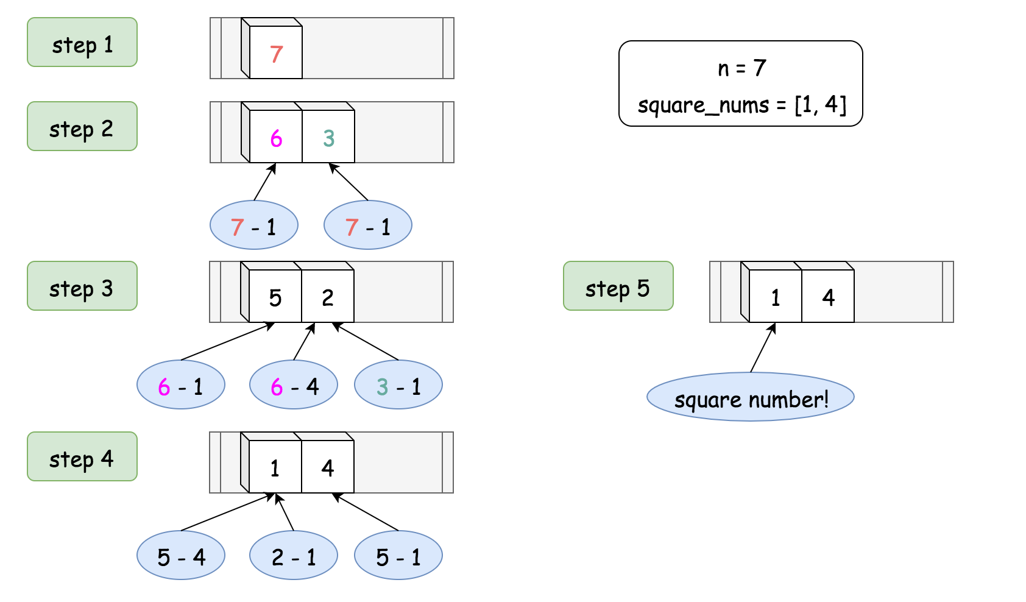

Here are some sample implementations. In particular, the Python implementation inspired from the post of [ChrisZhang12240](https://leetcode.com/problems/perfect-squares/discuss/71475/Short-Python-solution-using-BFS) took ~200 ms which was faster than ~72% of submission at that time.

|  |
| --- |
| class Solution {  public int numSquares(int n) {  ArrayList<Integer> square_nums = new ArrayList<Integer>();  for (int i = 1; i * i <= n; ++i) {  square_nums.add(i * i);  }  Set<Integer> queue = new HashSet<Integer>();  queue.add(n);  int level = 0;  while (queue.size() > 0) {  level += 1;  Set<Integer> next_queue = new HashSet<Integer>();  for (Integer remainder : queue) {  for (Integer square : square_nums) {  if (remainder.equals(square)) {  return level;  } else if (remainder < square) {  break;  } else {  next_queue.add(remainder - square);  }  }  }  queue = next_queue;  }  return level;  }  } |

**Complexity**

* Time complexity:  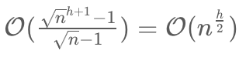 where h is the height of the N-ary tree. One can see the detailed explanation on the previous Approach #3.
* Space complexity: 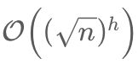, which is also the maximal number of nodes that can appear at the level h. As one can see, though we keep a list of square_nums, the main consumption of the space is the queue variable, which keep track of the remainders to visit for a given level of N-ary tree.

#### **Approach 5: Mathematics**

**Intuition**

The problem can be solved with the mathematical theorems that have been proposed and proved over time. We will break down the problem into several cases in this section.

In 1770, [Joseph Louis Lagrange](https://en.wikipedia.org/wiki/Lagrange%27s_four-square_theorem) proved a theorem, called *Lagrange's four-square theorem*, also known as Bachet's conjecture, which states that every natural number can be represented as the sum of four integer squares: 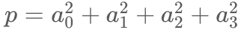 where the four numbers *a*0​,*a*1​,*a*2​,*a*3​ are integers.

For example, 3, 31 can be represented as the sum of four squares as follows: 

Case 1). The Lagrange's four-square theorem sets the upper bound for the results of the problem, *i.e.* if the number n cannot be decomposed into a fewer number of squares, *at least* it can be decomposed into the sum of **4** square numbers, *i.e.* numSquares(*n*)≤4.

As one might notice in the above example, the number zero is also considered as a square number, so we can consider that the number 3 can either be decomposed into 3 or 4 square numbers.

*However, Lagrange's four-square theorem does not tell us directly the least numbers of square to decompose a natural number.*

Later, in 1797, [Adrien-Marie Legendre](https://en.wikipedia.org/wiki/Adrien-Marie_Legendre) completed the four-square theorem with his ***three-square theorem***, by proving a particular condition that a positive integer can be expressed as the sum of three squares:  where *k* and *m* are integers.

Case 2). Unlike the four-square theorem, Adrien-Marie Legendre's three-square theorem gives us a **necessary** and **sufficient** condition to check if the number can **ONLY** be decomposed into 4 squares, not fewer.

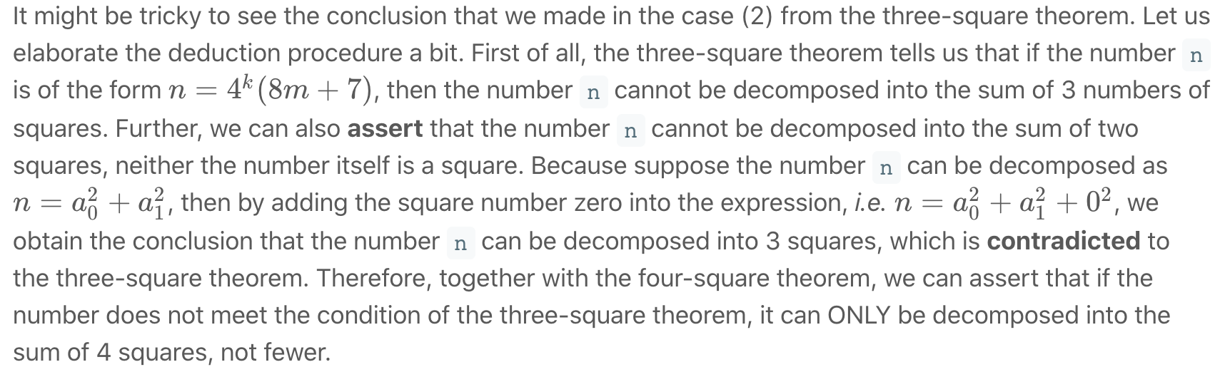

If the number meets the condition of the three-square theorem, we know that if can be decomposed into 3 squares. But what we don't know is that whether the number can be decomposed into fewer squares, *i.e.* one or two squares. So before we attribute the number to the bottom case (three-square theorem), here are the two cases remained to check, namely:

Case 3.1). if the number is a square number itself, which is easy to check *e.g.* n == int(sqrt(n)) ^ 2.

Case 3.2). if the number can be decomposed into the sum of two squares. Unfortunately, there is no mathematical weapon that can help us to check this case in one shot. We need to resort to the **enumeration** approach.

**Algorithm**

One can literally follow the above cases to implement the solution.

* First, we check if the number n is of the form *n*=4k(8*m*+7), if so we return 4 directly.
* Otherwise, we further check if the number is of a square number itself or the number can be decomposed the sum of two squares.
* In the bottom case, the number can be decomposed into the sum of 3 squares, though we can also consider it decomposable by 4 squares by adding zero according to the four-square theorem. But we are asked to find the least number of squares.

We give some sample implementations here. The solution is inspired from the posts of [TCarmic](https://leetcode.com/problems/perfect-squares/discuss/376795/100-O(log-n)-Python3-Solution-Lagrange's-four-square-theorem) and [StefanPochmann](https://tinyurl.com/y4falx4f) in the [Discussion](https://leetcode.com/problems/perfect-squares/discuss/) forum.

|  |
| --- |
| class Solution {  protected boolean isSquare(int n) {  int sq = (int) Math.sqrt(n);  return n == sq * sq;  }  public int numSquares(int n) {  // four-square and three-square theorems.  while (n % 4 == 0)  n /= 4;  if (n % 8 == 7)  return 4;  if (this.isSquare(n))  return 1;  // enumeration to check if the number can be decomposed into sum of two squares.  for (int i = 1; i * i <= n; ++i) {  if (this.isSquare(n - i * i))  return 2;  }  // bottom case of three-square theorem.  return 3;  }  } |

**Complexity**

* Time complexity: 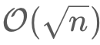 In the main loop, we check if the number can be decomposed into the sum of two squares, which takes  iterations. In the rest of cases, we do the check in constant time.
* Space complexity:  O(1). The algorithm consumes a constant space, regardless the size of the input number.

## Stack: Last-in-first-out Data Structure

In this chapter, we are going to introduce another processing order, Last-in-First-out (LIFO), and the corresponding data structure, Stack.

After this chapter, you should:

1. Understand the definition of LIFO and Stack;
2. Be able to implement a stack using dynamic array;
3. Be familiar with the built-in stack structure;
4. Be able to use a stack to solve problems.

**Last-in-first-out Data Structure**

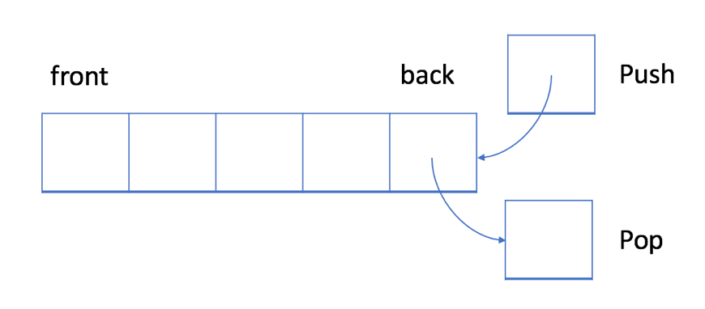

In a LIFO data structure, the newest element added to the queue will be processed first.

Different from the queue, the stack is a LIFO data structure. Typically, the insert operation is called push in a stack. Similar to the queue, a new element is always added at the end of the stack. However, the delete operation, pop, will always remove the last element which is opposite from the queue.

### ***Example - Stack***

1. Push: you can click Push button below to see how a new element 6 is added to the stack.

2. Pop: you can click Pop button below to see which element will be removed when you pop an element from the stack.

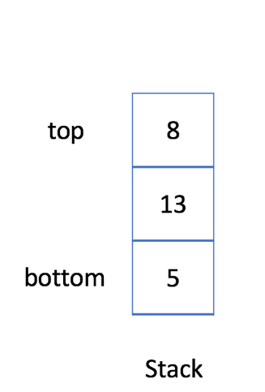 **push 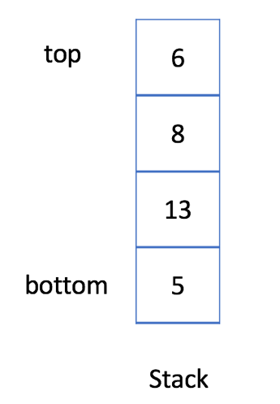 pop**

*Implementation - Stack*

The implementation of a Stack is easier than a Queue. A dynamic array is sufficient to implement a stack structure. Here we provide a simple implementation for your reference:

|  |
| --- |
| // "static void main" must be defined in a public class.  class MyStack {  private List<Integer> data; // store elements  public MyStack() {  data = new ArrayList<>();  }  /** Insert an element into the stack. */  public void push(int x) {  data.add(x);  }  /** Checks whether the queue is empty or not. */  public boolean isEmpty() {  return data.isEmpty();  }  /** Get the top item from the queue. */  public int top() {  return data.get(data.size() - 1);  }  /** Delete an element from the queue. Return true if the operation is successful. */  public boolean pop() {  if (isEmpty()) {  return false;  }  data.remove(data.size() - 1);  return true;  }  };  public class Main {  public static void main(String[] args) {  MyStack s = new MyStack();  s.push(1);  s.push(2);  s.push(3);  for (int i = 0; i < 4; ++i) {  if (!s.isEmpty()) {  System.out.println(s.top());  }  System.out.println(s.pop());  }  }  } |

**Stack - Usage**

Most popular languages provide built-in stack library so you don't have to reinvent the wheel. Besides initialization, we need to know how to use the two most important operations, pop and push. Also, you should be able to get the top element from the stack. Below are some code examples for your reference:

|  |
| --- |
| // "static void main" must be defined in a public class.  public class Main {  public static void main(String[] args) {  // 1. Initialize a stack.  Stack<Integer> s = new Stack<>();  // 2. Push new element.  s.push(5);  s.push(13);  s.push(8);  s.push(6);  // 3. Check if stack is empty.  if (s.empty() == true) {  System.out.println("Stack is empty!");  return;  }  // 4. Pop an element.  s.pop();  // 5. Get the top element.  System.out.println("The top element is: " + s.peek());  // 6. Get the size of the stack.  System.out.println("The size is: " + s.size());  }  } |

From now on, we are able to use the built-in stack library to solve problems more conveniently. Let's start with an interesting problem ([Min Stack](https://leetcode.com/explore/learn/card/queue-stack/230/usage-stack/1360/)) to help you review the useful operations. Then we will take a look at some classic Stack problems. When you want to process the last element first, the stack will be the most appropriate data structure.

**Min Stack**

Design a stack that supports push, pop, top, and retrieving the minimum element in constant time.

* push(x) -- Push element x onto stack.
* pop() -- Removes the element on top of the stack.
* top() -- Get the top element.
* getMin() -- Retrieve the minimum element in the stack.

**Example 1:**

**Input**

["MinStack","push","push","push","getMin","pop","top","getMin"]

[[],[-2],[0],[-3],[],[],[],[]]

**Output**

[null,null,null,null,-3,null,0,-2]

**Explanation**

MinStack minStack = new MinStack();

minStack.push(-2);

minStack.push(0);

minStack.push(-3);

minStack.getMin(); // return -3

minStack.pop();

minStack.top(); // return 0

minStack.getMin(); // return -2

**Constraints:**

* Methods pop, top and getMin operations will always be called on **non-empty** stacks.

Hint #1

Consider each node in the stack having a minimum value. (Credits to @aakarshmadhavan)

## Solution

#### **Overview**

Firstly, don't feel bad if you find this question a bit tricky! While it's one of the easier data structure design questions, it's still one of Leetcode's more difficult "easy" questions, requiring some clever observations and problem-solving techniques.

Now, here's a few things to keep in mind before we get started.

* **Make sure that you read the question carefully**. The getMin(...) operation only needs to return the value of the minimum, it does not remove items from the *MinStack*.
* We're told that **all the MinStack operations must run in constant time**, i.e. *O*(1) time. For this reason, we can immediately rule out the use of a Binary Search Tree or Heap. While these data structures are often great for keeping track of a minimum, their core operations (find, add, and remove) are *O*(log*n*), which isn't good enough here! We will need to explore better ways.
* Some people have mentioned on the discussion forums that **the question doesn't say what to do in invalid cases**. For example, what if you are told to pop(...), getMin(...), or top(...) while there are no values on your MinStack? Because the question doesn't say, here on Leetcode that means **you can safely assume the test cases will always be valid**. In a real interview though, you should always ask the interviewer before making assumptions. They will probably either say you can assume these cases won't happen, or that you should return -1 or throw an exception if they do.
* **Finally, there is the issue of whether or not it is "fair" to use a built-in Stack** data structure as the basis of your MinStack implementation, or whether you should only use Lists or even Arrays. Because I don't think there is much advantage to using a built-in Stack here—you still need to figure out how to use it to achieve the minimum functionality—this solution article uses Stack's. Implementing an underlying *Stack* yourself shouldn't be too difficult, and is ideally something you already know how to do if you're working on this question.

**Suggestion for further study**: Once you've read through this guide and understood how to implement the MinStack class, have a go at writing a MaxStack class on your own to test your understanding! Don't simply copy-paste the MinStack code and attempt to modify it into the new role, instead write the MaxStack code without looking at the *MinStack* code again.

#### **Approach 1: Stack of Value/ Minimum Pairs**

**Intuition**

An **invariant** is something that is always true or consistent. You should always be on the lookout for useful invariants when problem-solving in math and computer science.

Recall that with a Stack, we only ever add (push) and remove (pop) numbers from the top. Therefore, an important **invariant** of a Stack is that when a new number, which we'll call x, is placed on a Stack, the numbers below it will not change for as long as number x remains on the Stack. Numbers could come and go above x for the duration of x's presence, but never below.

So, whenever number x **is** the top of the *Stack*, the minimum will always be the same, as it's simply the minimum out of x and all the numbers below it.

Therefore, in addition to putting a number on an underlying Stack inside our MinStack, we could also put its corresponding minimum value alongside it. Then whenever that particular number is at the top of the underlying Stack, the getTop(...) operation of MinStack is as simple as retrieving its corresponding minimum value.

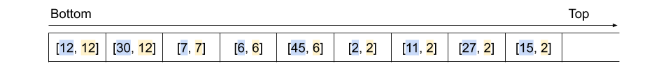

So, how can we actually determine what the corresponding minimum for our new number is? (in (O(1)(*O*(1) time). Have a look at the diagram above. All the minimum values are equal to either the minimum value immediately before, or the actual stack value alongside.

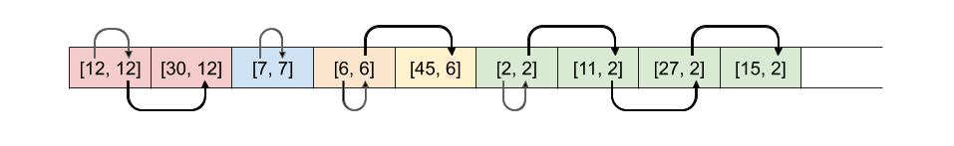

Therefore, when we put a new number on the underlying Stack, we need to decide whether the minimum at that point is the new number itself, or whether it's the minimum before. It makes sense that it would always be the smallest of these two values.

Here is an animation showing the entire algorithm described above.

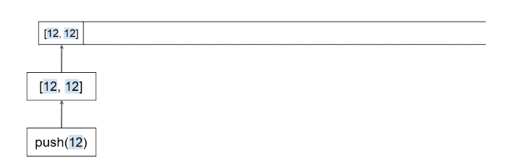

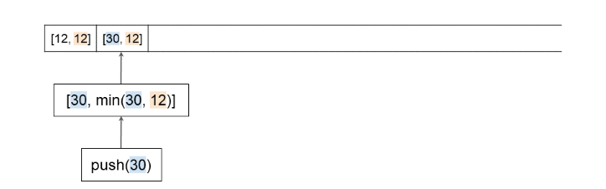

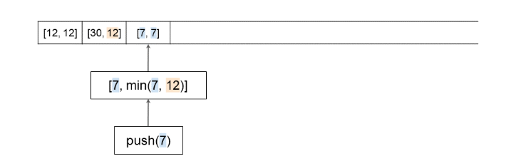

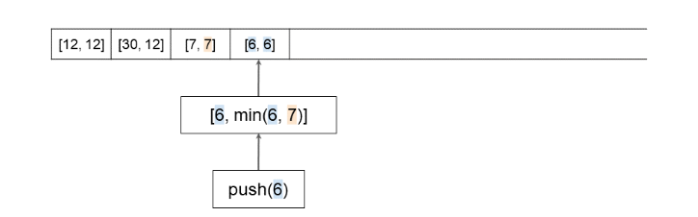

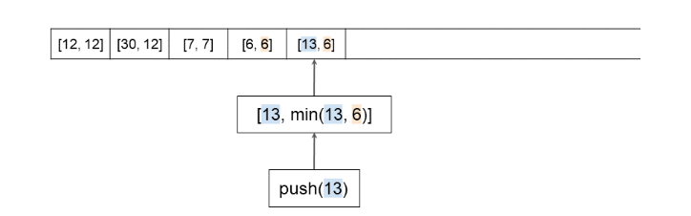

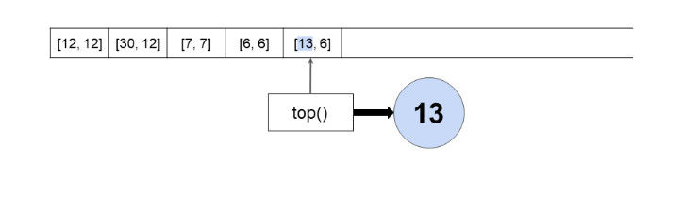

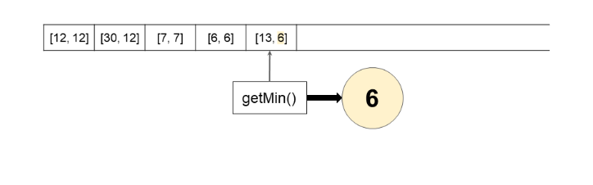

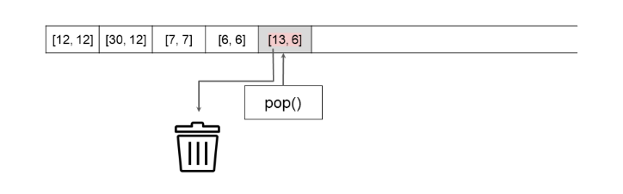

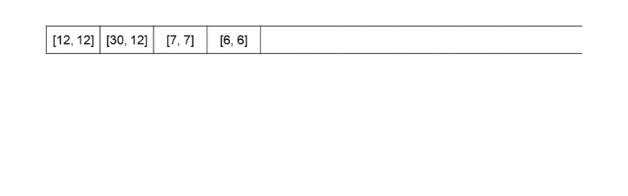

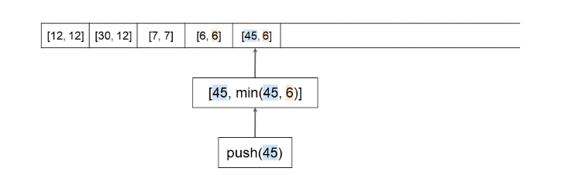

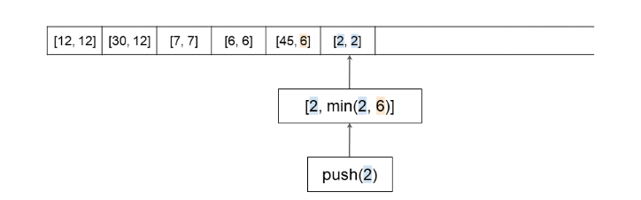

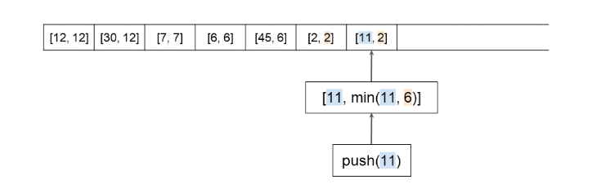

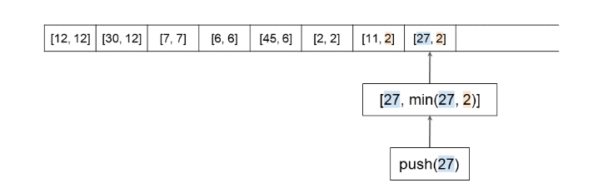

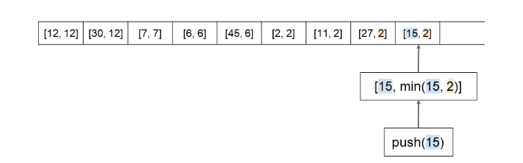

**Algorithm**

Note for Python: Recall that index -1 refers to the *last* item in in a list. i.e. self.stack[-1] in Python is equivalent to stack.peek() in Java and other languages.

|  |
| --- |
| class MinStack {  private Stack<int[]> stack = new Stack<>();  public MinStack() { }  public void push(int x) {    /* If the stack is empty, then the min value  * must just be the first value we add. */  if (stack.isEmpty()) {  stack.push(new int[]{x, x});  return;  }    int currentMin = stack.peek()[1];  stack.push(new int[]{x, Math.min(x, currentMin)});  }    public void pop() {  stack.pop();  }    public int top() {  return stack.peek()[0];  }    public int getMin() {  return stack.peek()[1];  }  } |

**Complexity Analysis**

Let n*n* be the total number of operations performed.

* Time Complexity : *O*(1) for all operations.

push(...): Checking the top of a Stack, comparing numbers, and pushing to the top of a Stack (or adding to the end of an Array or List) are all *O*(1) operations. Therefore, this overall is an *O*(1) operation.

pop(...): Popping from a Stack (or removing from the end of an Array, or List) is an *O*(1) operation.

top(...): Looking at the top of a Stack is an *O*(1) operation.

getMin(...): Same as above. This operation is *O*(1) because we do not need to compare values to find it. If we had not kept track of it on the Stack, and instead had to search for it each time, the overall time complexity would have been *O*(*n*).

* Space Complexity : *O*(*n*).

Worst case is that all the operations are push. In this case, there will be *O*(2⋅*n*)=*O*(*n*) space used.

#### **Approach 2: Two Stacks**

**Intuition**

There's another, somewhat different approach to implementing a MinStack. Approach 1 required storing two values in each slot of the underlying Stack. Sometimes though, the minimum values are very repetitive. Do we actually need to store the same minimum value over and over again?

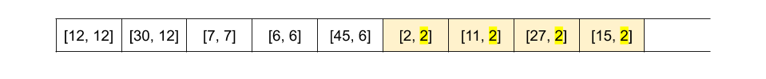

Turns out we don't—we could instead have two Stackss inside our MinStack. The main Stack should keep track of the order numbers arrived (a standard Stack), and the second Stack should keep track of the current minimum. We'll call this second Stack the "min-tracker" Stack for clarity.

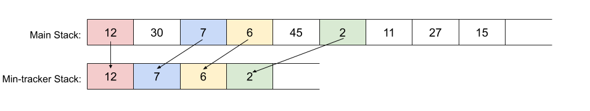

The push(...) method for this implementation of MinStack is straightforward. Items should always be pushed onto the main Stack, but they should only be pushed onto the min-tracker Stack if they are smaller than the current top of it. Well, that's mostly correct. There's one potential pitfall here that we'll look at soon.

MinStack's two getter methods, top(...) and getMin(...) are also straightforward with this approach. top(...) returns (but doesn't remove) the top value of the main Stack, whereas getMin(...) returns (but doesn't remove) the top of the min-tracker Stack.

This leaves us still needing to implement MinStack's pop(...) method. The value we actually need to pop is always on the top of the main underlying Stack. However, if we simply popped it from there, the min-tracker Stack would become incorrect once its top value had been removed from the main Stack.

A logical solution would be to do the following additional check and modification to the min-tracker Stack when MinStack's pop(...) method is called.

If top of main_stack == top of min_tracker_stack:

min_tracker_stack.pop()

This way, the new minimum would now be the top of the min-tracker Stack. If you're confused about why this is, think back to the previous approach, and remember when the minimum changed.

Here is an animation showing the algorithm so far.

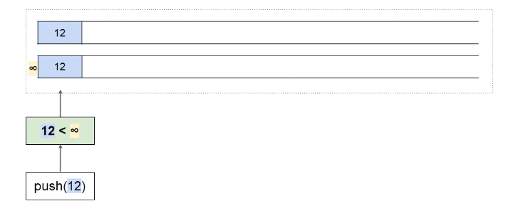

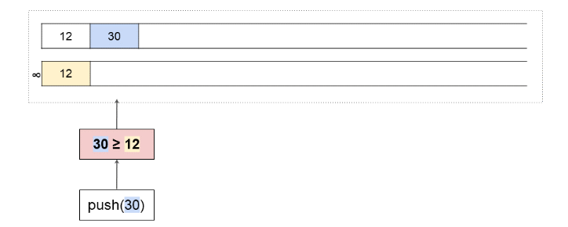

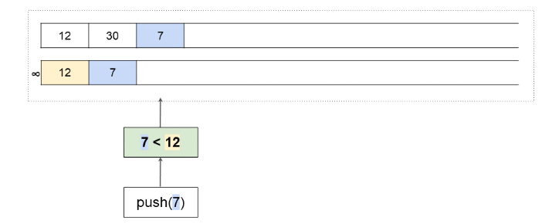

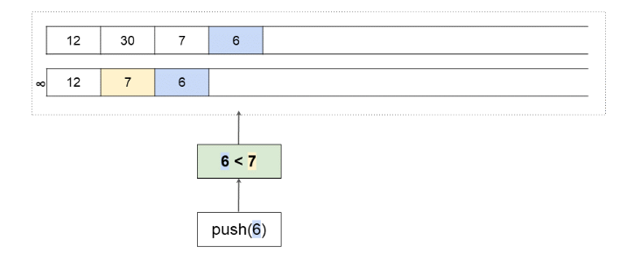

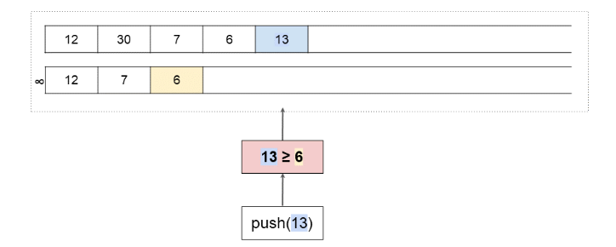

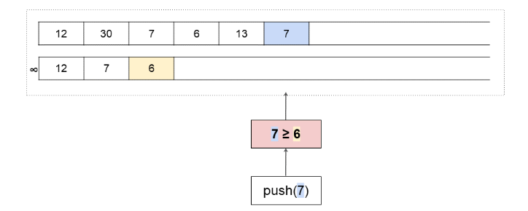

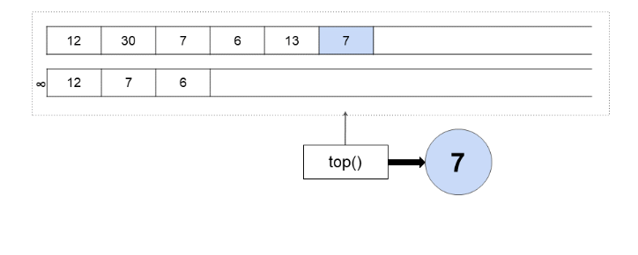

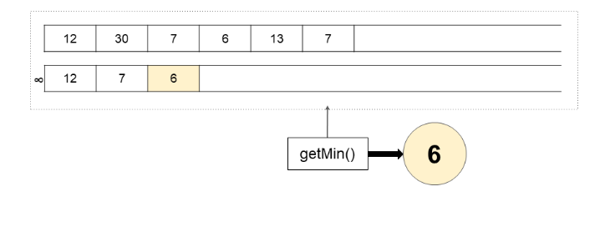

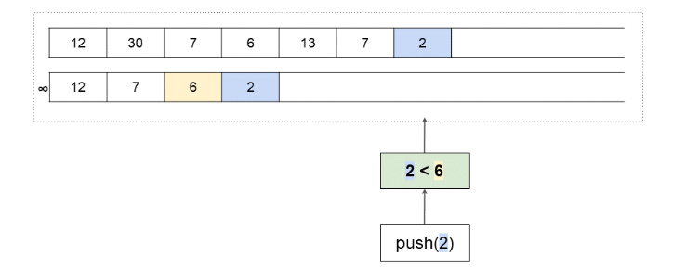

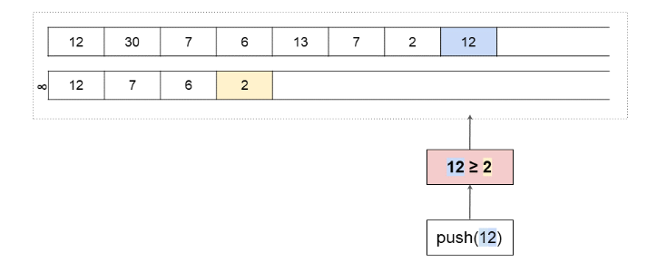

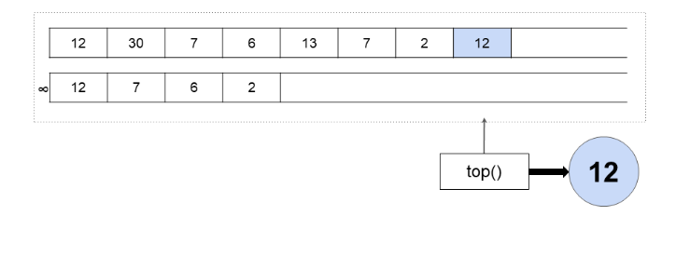

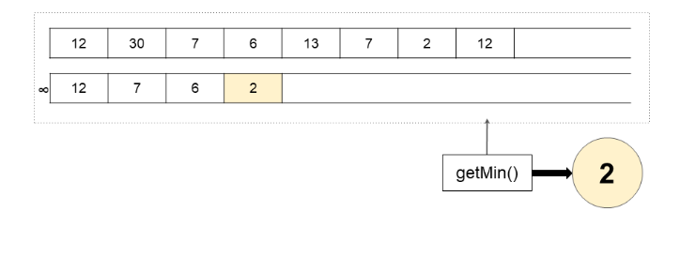

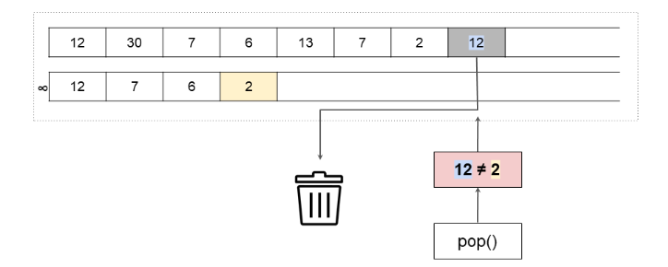

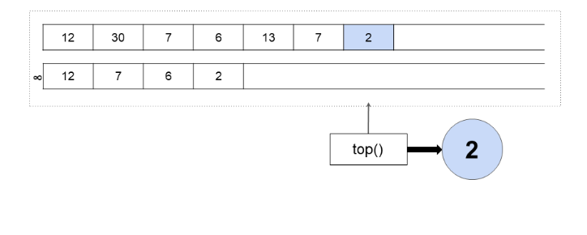

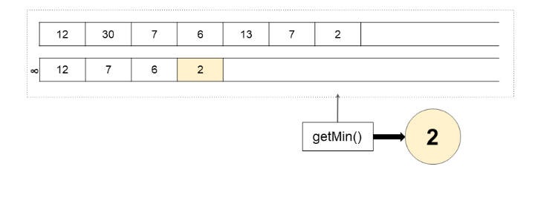

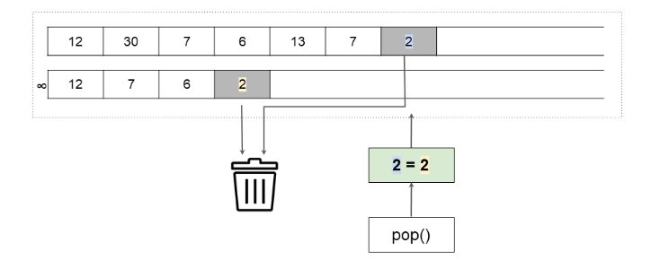

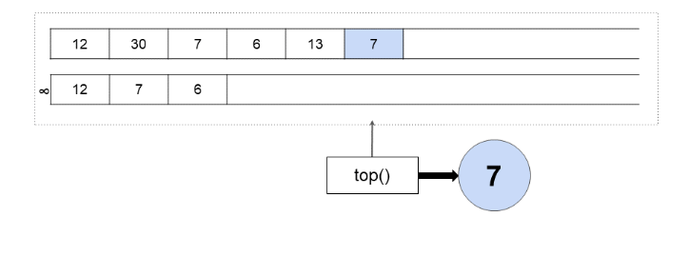

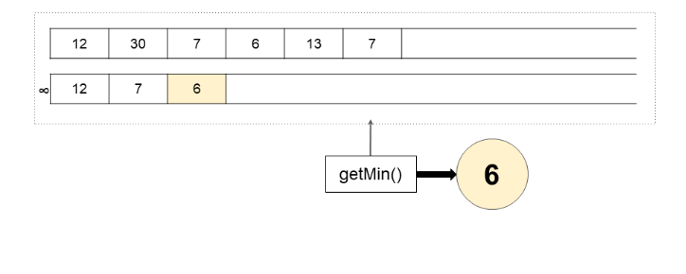

As hinted to above though, there's a potential pitfall with the implementation of MinStack's push(...) method. Consider this situation.



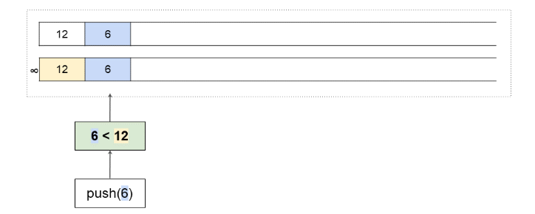

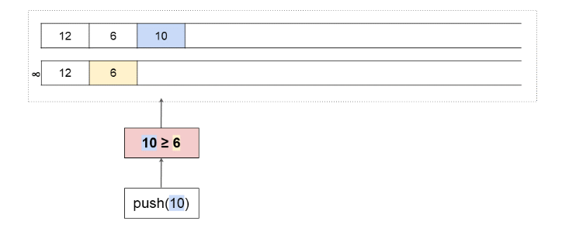

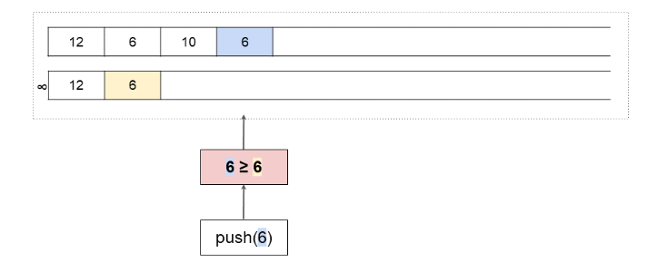

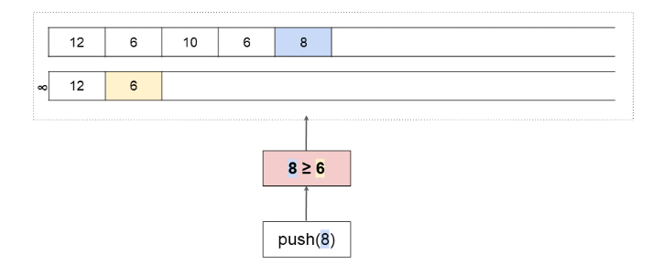

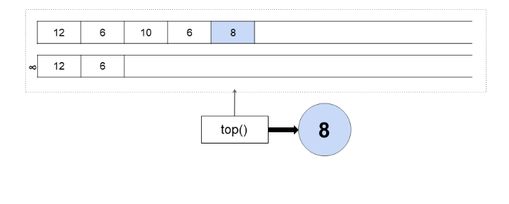

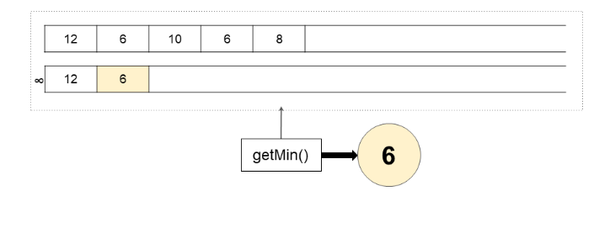

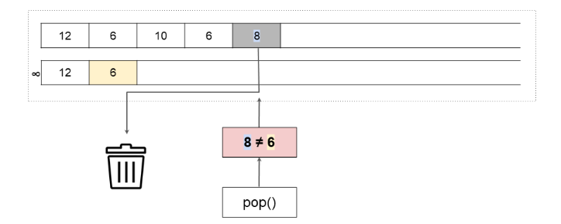

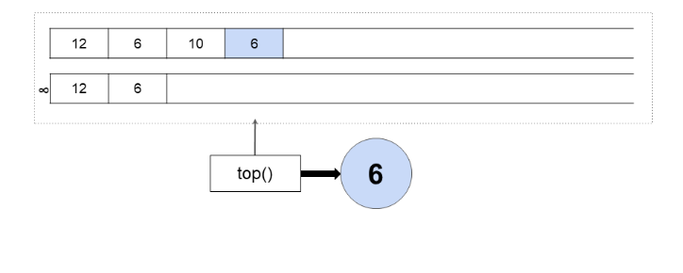

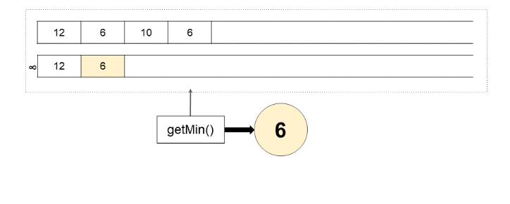

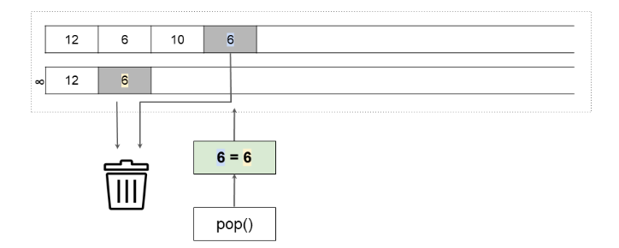

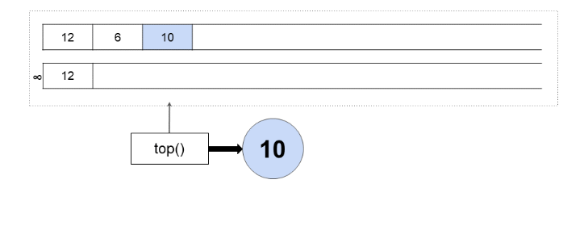

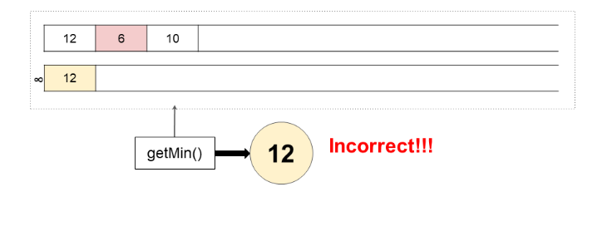

While 6 was already at the top of the min-tracker Stack, we pushed another 6 onto the MinStack. Because this new 6 was equal to the current minimum, it didn't change what the current minimum was, and therefore wasn't pushed. At first, this worked okay.

The problem occurred though when we started calling pop(...) on MinStack. When the most recent 6 was pop'ed, the condition for popping the min-tracker Stack too was triggered (i.e. that both internal stacks have the same top). This isn't what we wanted though—it was the earlier 6 that triggered the push(...) onto the min-tracker Stack, not the latter one! The 6 should have been left alone with that first pop(...).

The way we can solve this is a small modification to the MinStack's push(...) method. Instead of only pushing numbers to the min-tracker Stack if they are *less than* the current minimum, we should push them if they are *less than or equal to* it. While this means that some duplicates are added to the min-tracker Stack, the bug will no longer occur. Here is another animation with the same test case as above, but the bug fixed.

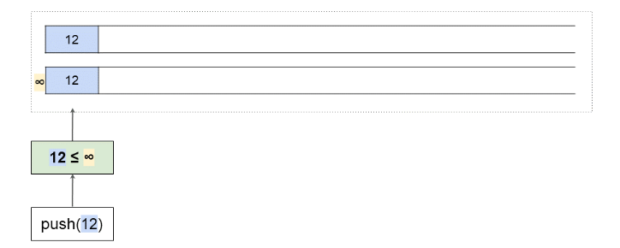

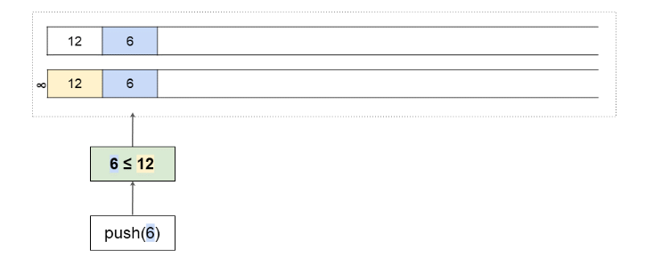

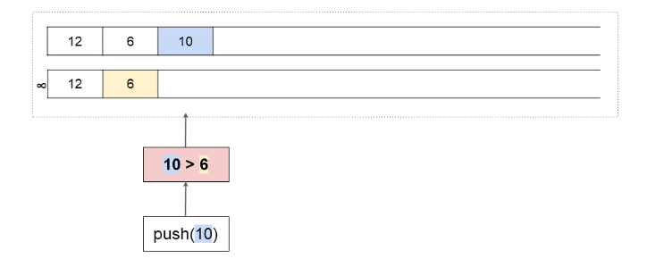

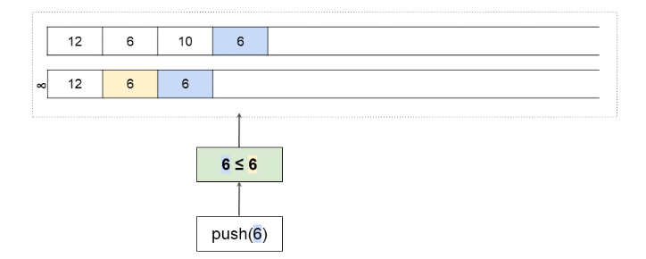

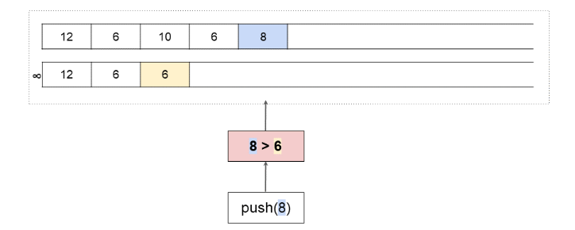

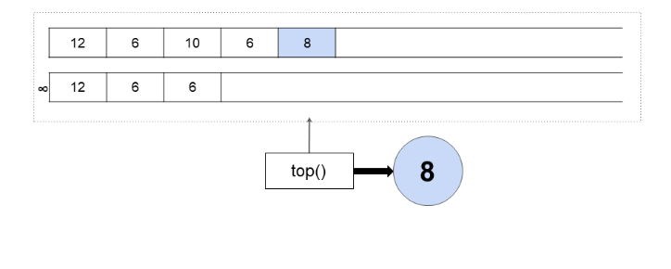

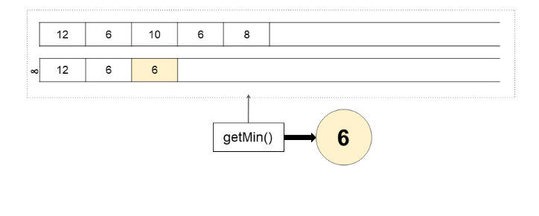

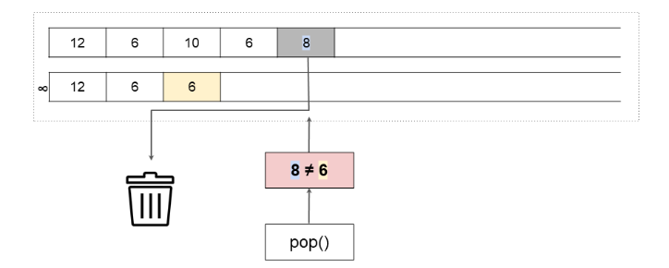

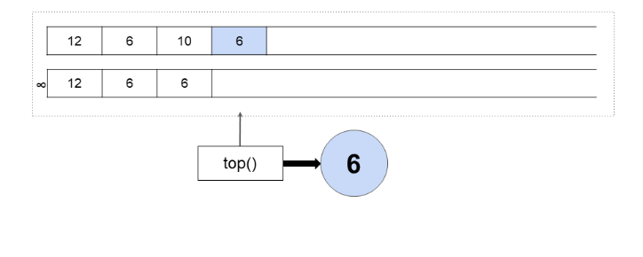

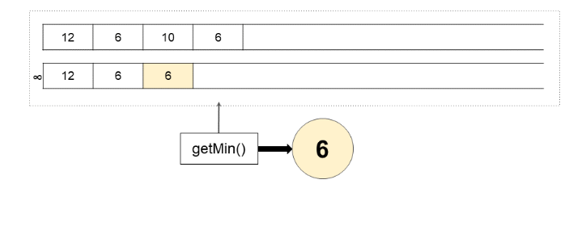

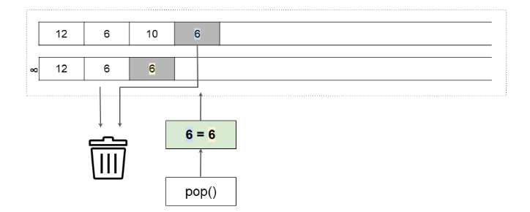

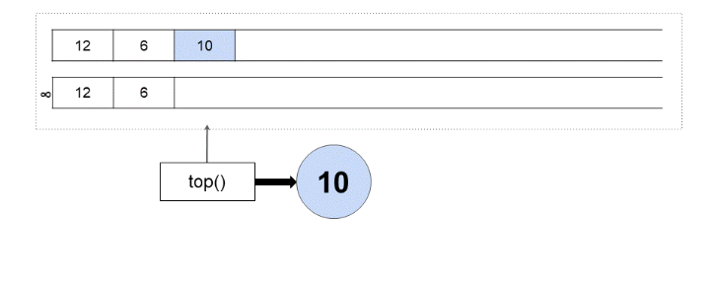

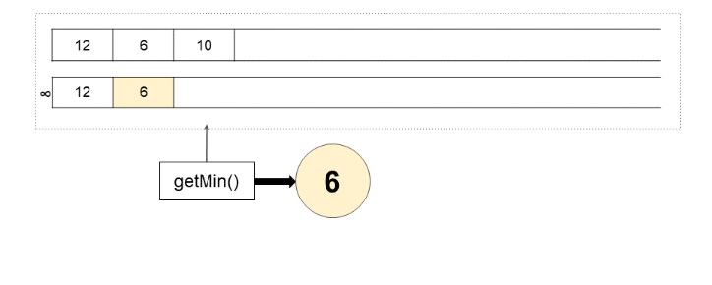

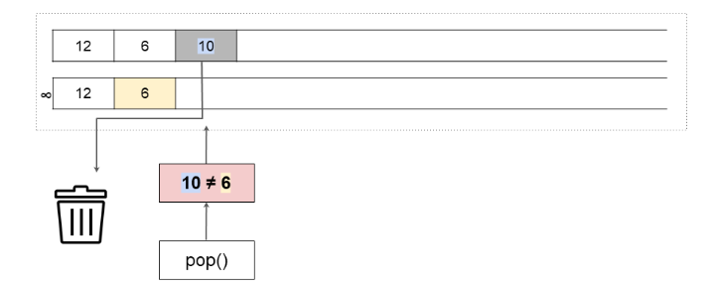

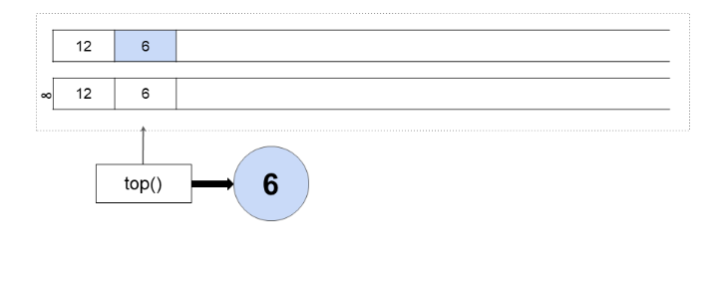

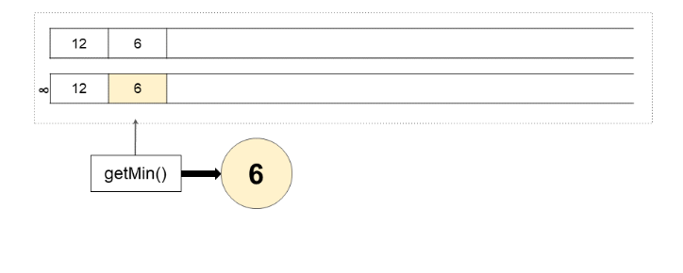

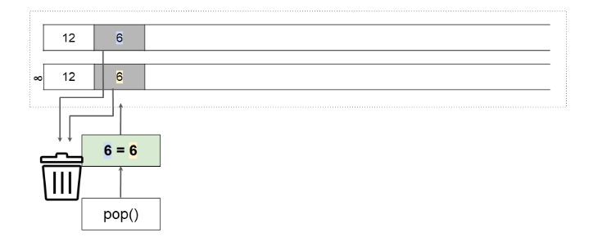

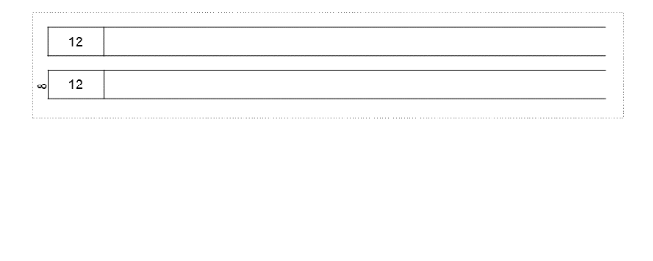

|  |
| --- |
| class MinStack {  private Stack<Integer> stack = new Stack<>();  private Stack<Integer> minStack = new Stack<>();    public MinStack() { }    public void push(int x) {  stack.push(x);  if (minStack.isEmpty() || x <= minStack.peek()) {  minStack.push(x);  }  }    public void pop() {  if (stack.peek().equals(minStack.peek())) {  minStack.pop();  }  stack.pop();  }    public int top() {  return stack.peek();  }  public int getMin() {  return minStack.peek();  }  } |

**Complexity Analysis**

Let *n* be the total number of operations performed.

* Time Complexity : *O*(1) for all operations.

Same as above. All our modifications are still *O*(1).

* Space Complexity : *O*(*n*).

Same as above.

#### **Approach 3: Improved Two Stacks**

**Intuition**

In the above approach, we pushed a new number onto the min-tracker Stack if, and only if, it was *less than or equal to* the current minimum.

One downside of this solution is that if the *same number* is pushed repeatedly onto MinStack, and that number also happens to be the current minimum, there'll be a lot of needless repetition on the min-tracker Stack. Recall that we put this repetition in to prevent a bug from occurring (refer to Approach 2).

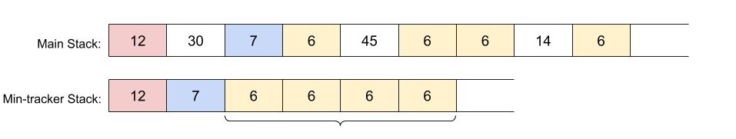

An improvement is to put *pairs* onto the min-tracker Stack. The first value of the pair would be the same as before, and the second value would be how many times that minimum was repeated. For example, this is how the min-tracker Stack for the example just above would appear.

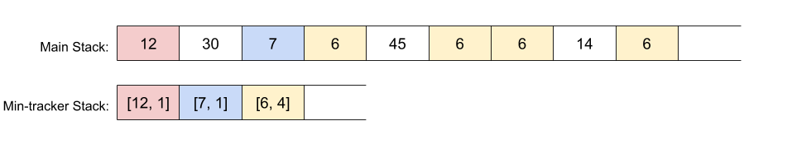

The push(...) and pop(...) operations of MinStack need to be slightly modified to work with the new representation.

**Algorithm**

|  |
| --- |
| class MinStack {  private Stack<Integer> stack = new Stack<>();  private Stack<int[]> minStack = new Stack<>();    public MinStack() { }    public void push(int x) {    // We always put the number onto the main stack.  stack.push(x);    // If the min stack is empty, or this number is smaller than  // the top of the min stack, put it on with a count of 1.  if (minStack.isEmpty() || x < minStack.peek()[0]) {  minStack.push(new int[]{x, 1});  }    // Else if this number is equal to what's currently at the top  // of the min stack, then increment the count at the top by 1.  else if (x == minStack.peek()[0]) {  minStack.peek()[1]++;  }  }    public void pop() {    // If the top of min stack is the same as the top of stack  // then we need to decrement the count at the top by 1.  if (stack.peek().equals(minStack.peek()[0])) {  minStack.peek()[1]--;  }    // If the count at the top of min stack is now 0, then remove  // that value as we're done with it.  if (minStack.peek()[1] == 0) {  minStack.pop();  }    // And like before, pop the top of the main stack.  stack.pop();  }    public int top() {  return stack.peek();  }  public int getMin() {  return minStack.peek()[0];  }  } |

**Complexity Analysis**

Let n*n* be the total number of operations performed.

* Time Complexity : *O*(1) for all operations.

Same as above.

* Space Complexity : *O*(*n*).

Same as above.

**Valid Parentheses**

Given a string s containing just the characters '(', ')', '{', '}', '[' and ']', determine if the input string is valid.

An input string is valid if:

1. Open brackets must be closed by the same type of brackets.
2. Open brackets must be closed in the correct order.

**Example 1:**

**Input:** s = "()"

**Output:** true

**Example 2:**

**Input:** s = "()[]{}"

**Output:** true

**Example 3:**

**Input:** s = "(]"

**Output:** false

**Example 4:**

**Input:** s = "([)]"

**Output:** false

**Example 5:**

**Input:** s = "{[]}"

**Output:** true

**Constraints:**

* 1 <= s.length <= 104
* s consists of parentheses only '()[]{}'.

Hint #1

An interesting property about a valid parenthesis expression is that a sub-expression of a valid expression should also be a valid expression. (Not every sub-expression) e.g.

{ { } [ ] [ [ [ ] ] ] } is VALID expression

[ [ [ ] ] ] is VALID sub-expression

{ } [ ] is VALID sub-expression

Can we exploit this recursive structure somehow?

Hint #2

What if whenever we encounter a matching pair of parenthesis in the expression, we simply remove it from the expression? This would keep on shortening the expression. e.g.

{ { ( { } ) } }

|_|

{ { ( ) } }

|______|

{ { } }

|__________|

{ }

|________________|

VALID EXPRESSION!

Hint #3

The **stack** data structure can come in handy here in representing this recursive structure of the problem. We can't really process this from the inside out because we don't have an idea about the overall structure. But, the stack can help us process this recursively i.e. from outside to inwards.

## Solution

**Intuition**

Imagine you are writing a small compiler for your college project and one of the tasks (or say sub-tasks) for the compiler would be to detect if the parenthesis are in place or not.

The algorithm we will look at in this article can be then used to process all the parenthesis in the program your compiler is compiling and checking if all the parenthesis are in place. This makes checking if a given string of parenthesis is valid or not, an important programming problem.

The expressions that we will deal with in this problem can consist of three different type of parenthesis:

* (),
* {} and
* []

Before looking at how we can check if a given expression consisting of these parenthesis is valid or not, let us look at a simpler version of the problem that consists of just one type of parenthesis. So, the expressions we can encounter in this simplified version of the problem are e.g.

(((((()))))) -- VALID

()()()() -- VALID

(((((((() -- INVALID

((()(()))) -- VALID

Let's look at a simple algorithm to deal with this problem.

1. We process the expression one bracket at a time starting from the left.
2. Suppose we encounter an opening bracket i.e. (, it may or may not be an invalid expression because there can be a matching ending bracket somewhere in the remaining part of the expression. Here, we simply increment the counter keeping track of left parenthesis till now. left += 1
3. If we encounter a closing bracket, this has two meanings:
   1. One, there was no matching opening bracket for this closing bracket and in that case we have an invalid expression. This is the case when left == 0 i.e. when there are no unmatched left brackets available.
   2. We had some unmatched opening bracket available to match this closing bracket. This is the case when left > 0 i.e. we have unmatched left brackets available.
4. If we encounter a closing bracket i.e. ) when left == 0, then we have an invalid expression on our hands. Else, we decrement left thus reducing the number of unmatched left parenthesis available.
5. Continue processing the string until all parenthesis have been processed.
6. If in the end we still have unmatched left parenthesis available, this implies an invalid expression.

The reason we discussed this particular algorithm here is because the approach for the original problem derives its inspiration from this very solution. Have a look at the following dry run of the algorithm we discussed to have a better understanding.

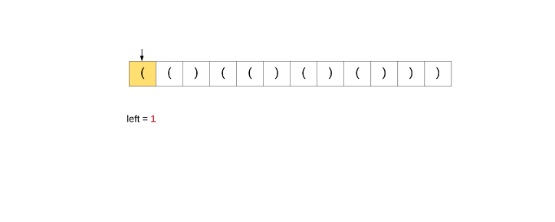

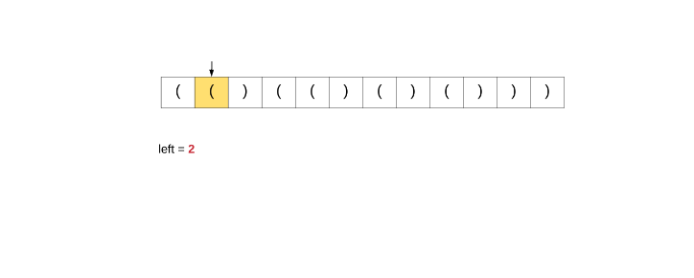

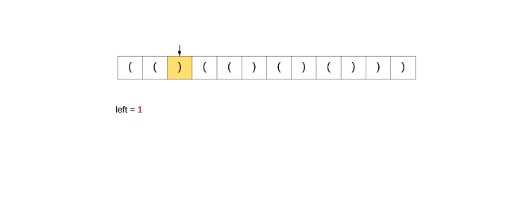

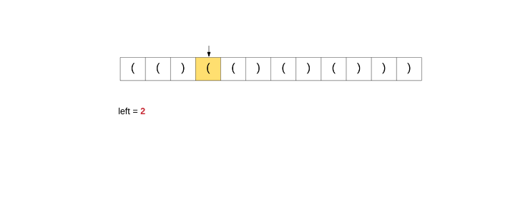

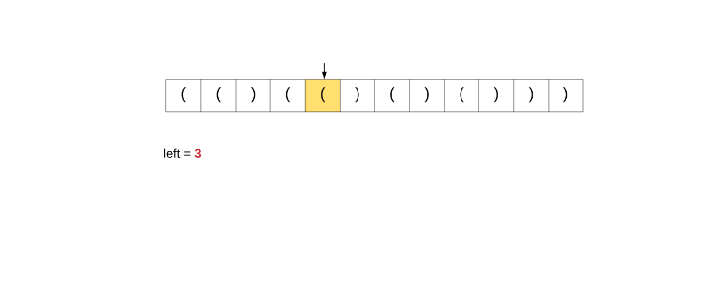

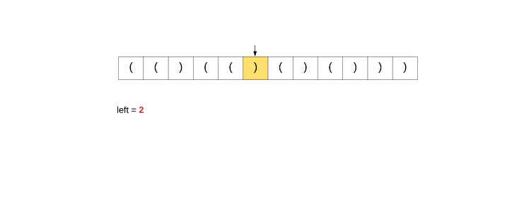

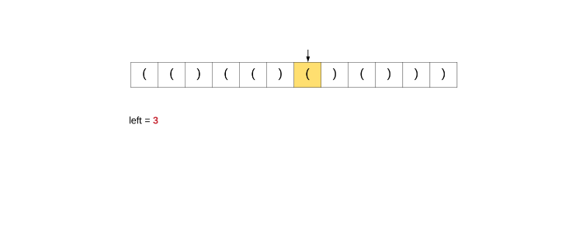

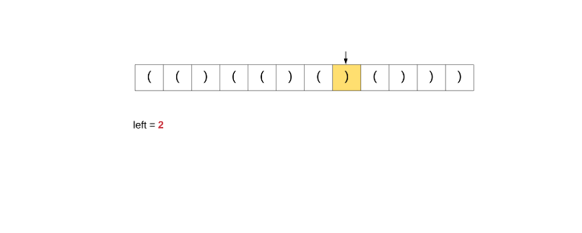

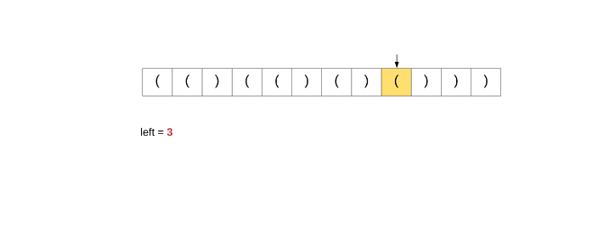

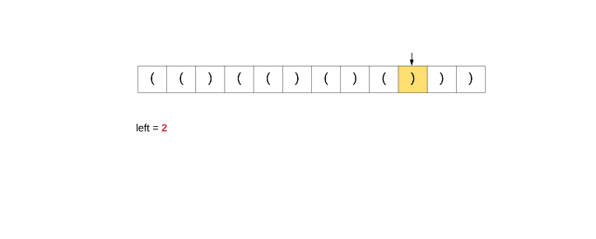

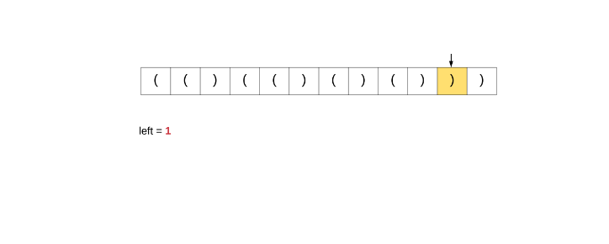

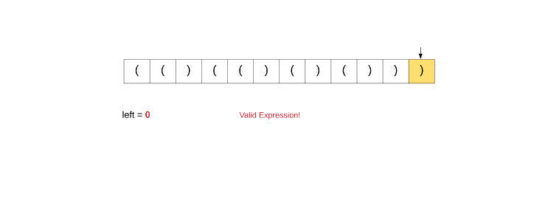

If we try and follow the same approach for our original problem, then it simply won't work. The reason a simple counter based approach works above is because all the parenthesis are of the same type. So when we encounter a closing bracket, we simply assume a corresponding opening matching bracket to be available i.e. if left > 0.

But, in our problem, if we encounter say ], we don't really know if there is a corresponding opening [ available or not. You could say:

Why not maintain a separate counter for the different types of parenthesis?

This doesn't work because the relative placement of the parenthesis also matters here. e.g.:

[{]

If we simply keep counters here, then as soon as we encounter the closing square bracket, we would know there is an unmatched opening square bracket available as well. But, the **closest unmatched opening bracket available is a curly bracket and not a square bracket** and hence the counting approach breaks here.

#### **Approach 1: Stacks**

An interesting property about a valid parenthesis expression is that a sub-expression of a valid expression should also be a valid expression. (Not every sub-expression) e.g.

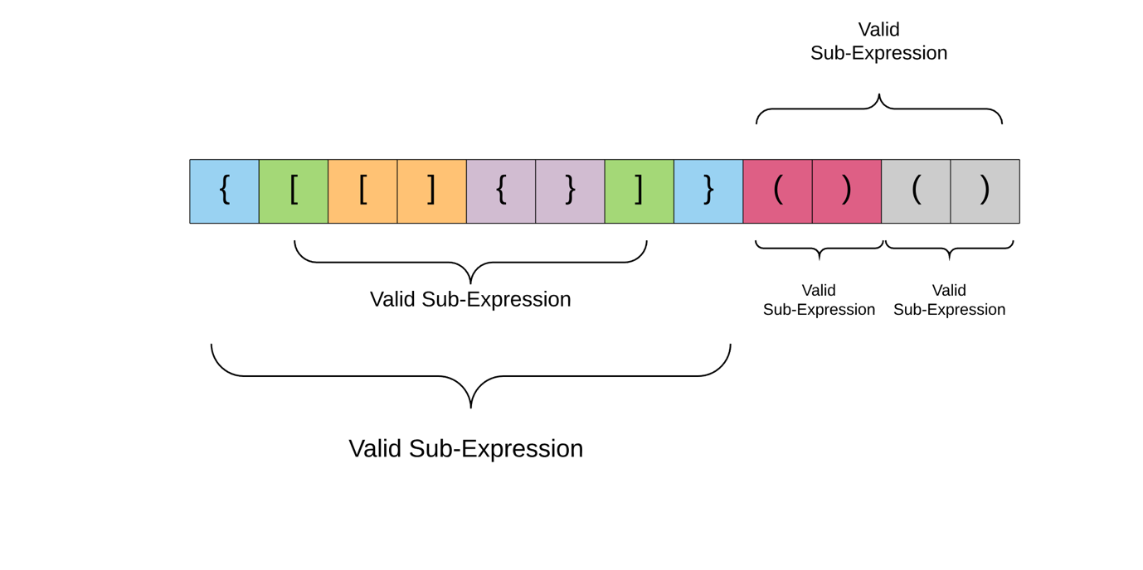

Also, if you look at the above structure carefully, the color coded cells mark the opening and closing pairs of parenthesis. The entire expression is valid, but sub portions of it are also valid in themselves. This lends a sort of a recursive structure to the problem. For e.g. Consider the expression enclosed within the two green parenthesis in the diagram above. The opening bracket at index 1 and the corresponding closing bracket at index 6.

What if whenever we encounter a matching pair of parenthesis in the expression, we simply remove it from the expression?

Let's have a look at this idea below where remove the smaller expressions one at a time from the overall expression and since this is a valid expression, we would be left with an empty string in the end.

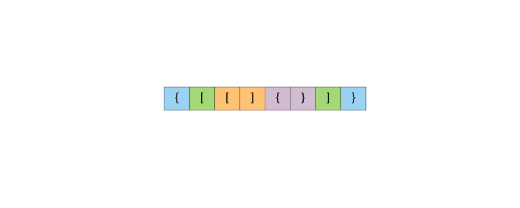

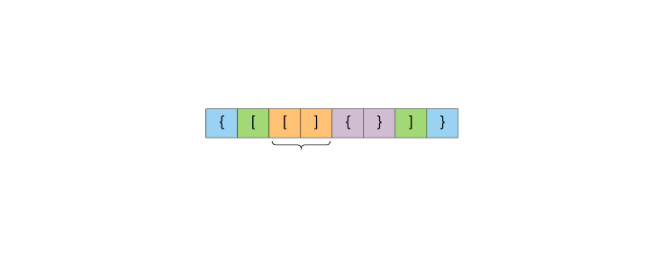

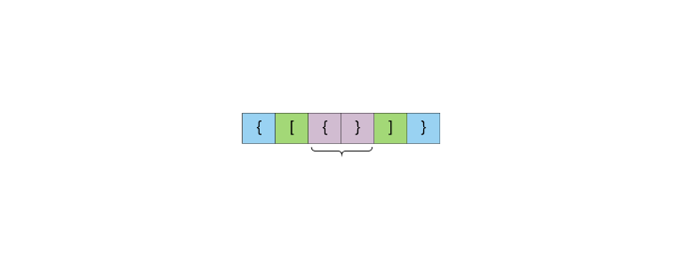





The stack data structure can come in handy here in representing this recursive structure of the problem. We can't really process this from the inside out because we don't have an idea about the overall structure. But, the stack can help us process this recursively i.e. from outside to inwards.

Let us have a look at the algorithm for this problem using stacks as the intermediate data structure.

**Algorithm**

1. Initialize a stack S.
2. Process each bracket of the expression one at a time.
3. If we encounter an opening bracket, we simply push it onto the stack. This means we will process it later, let us simply move onto the **sub-expression** ahead.
4. If we encounter a closing bracket, then we check the element on top of the stack. If the element at the top of the stack is an opening bracket of the same type, then we pop it off the stack and continue processing. Else, this implies an invalid expression.
5. In the end, if we are left with a stack still having elements, then this implies an invalid expression.

We'll have a look a dry run for the algorithm and then move onto the implementation.

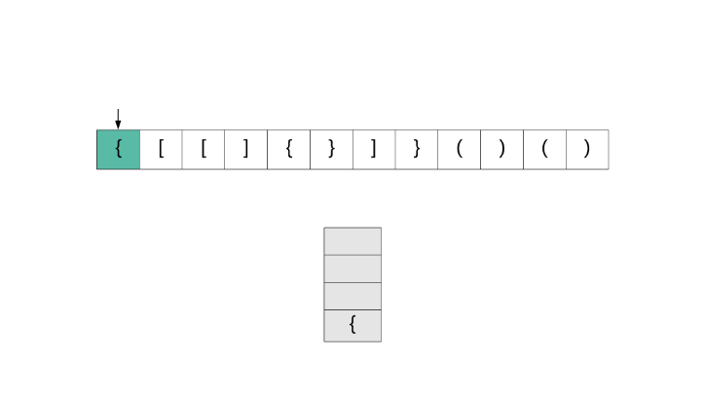

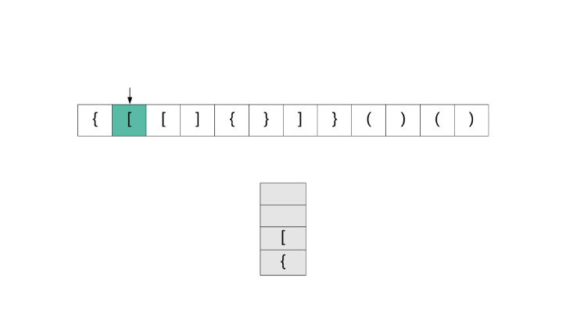

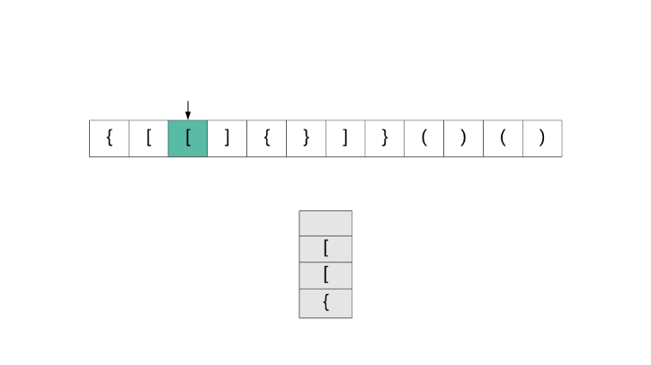

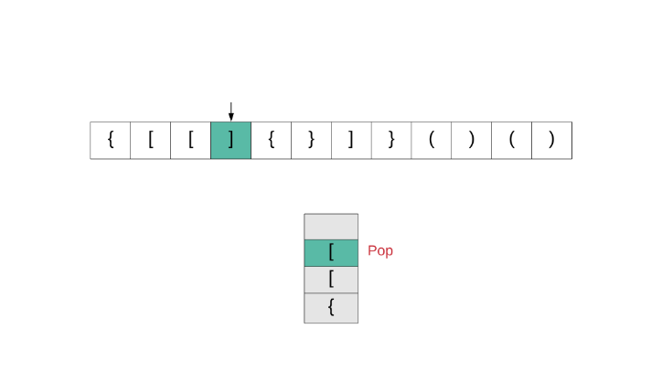

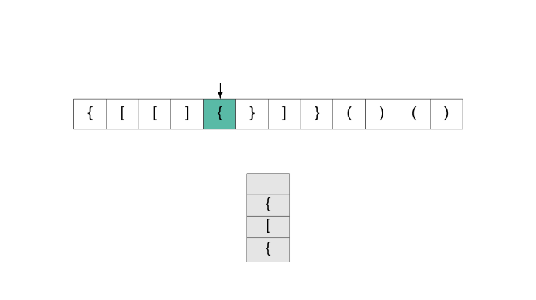

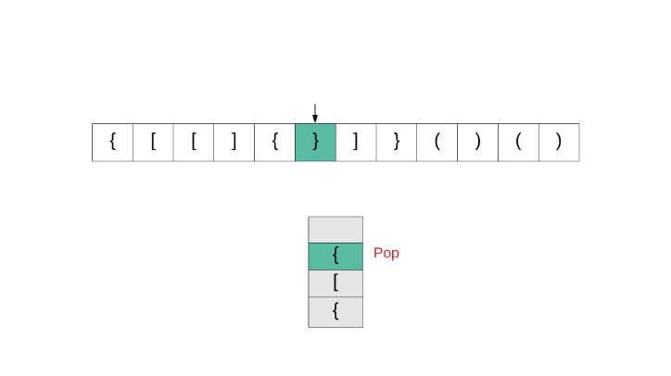

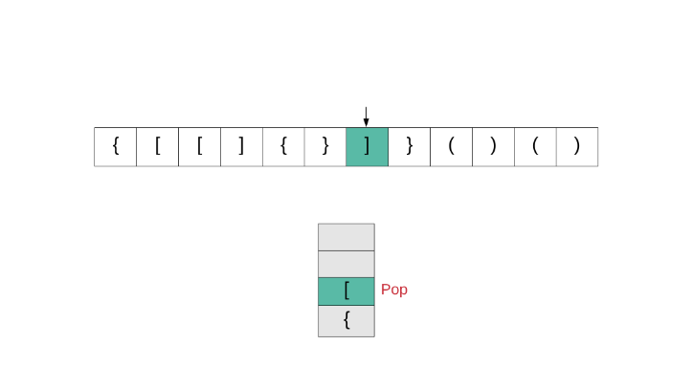

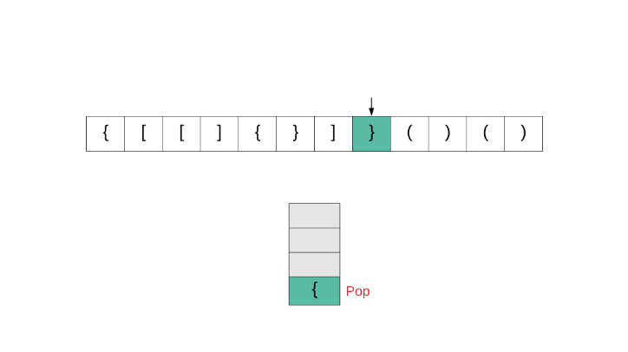

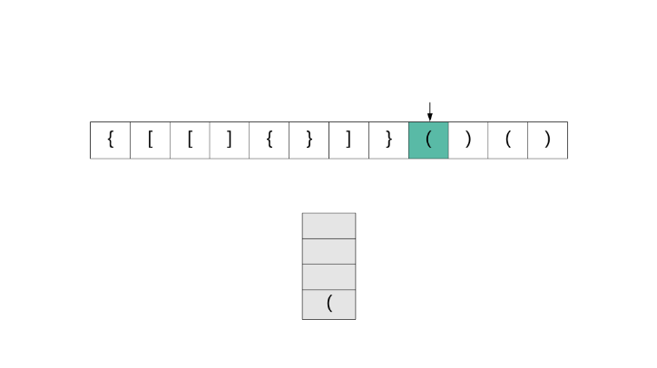

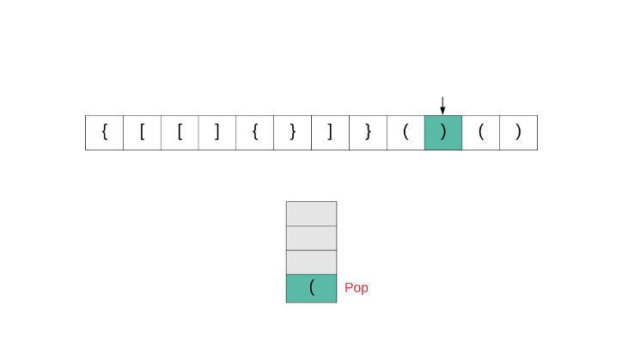

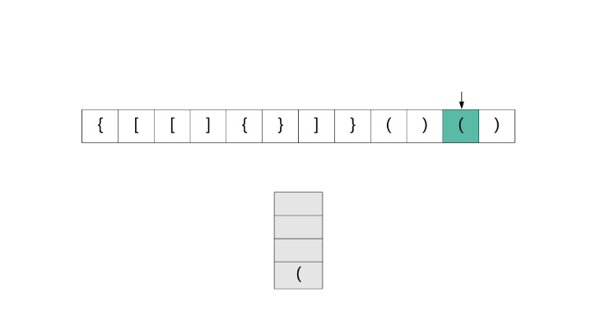

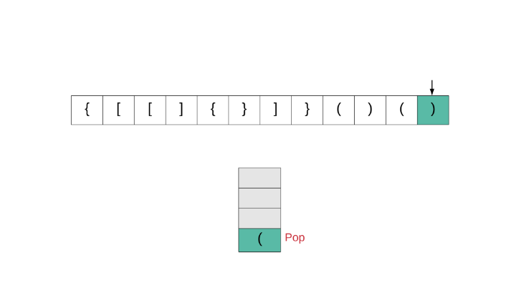

Let us now have a look at the implementation for this algorithm.

|  |
| --- |
| class Solution {  // Hash table that takes care of the mappings.  private HashMap<Character, Character> mappings;  // Initialize hash map with mappings. This simply makes the code easier to read.  public Solution() {  this.mappings = new HashMap<Character, Character>();  this.mappings.put(')', '(');  this.mappings.put('}', '{');  this.mappings.put(']', '[');  }  public boolean isValid(String s) {  // Initialize a stack to be used in the algorithm.  Stack<Character> stack = new Stack<Character>();  for (int i = 0; i < s.length(); i++) {  char c = s.charAt(i);  // If the current character is a closing bracket.  if (this.mappings.containsKey(c)) {  // Get the top element of the stack. If the stack is empty, set a dummy value of '#'  char topElement = stack.empty() ? '#' : stack.pop();  // If the mapping for this bracket doesn't match the stack's top element, return false.  if (topElement != this.mappings.get(c)) {  return false;  }  } else {  // If it was an opening bracket, push to the stack.  stack.push(c);  }  }  // If the stack still contains elements, then it is an invalid expression.  return stack.isEmpty();  }  } |

**Complexity analysis**

* Time complexity : *O*(*n*) because we simply traverse the given string one character at a time and push and pop operations on a stack take *O*(1) time.
* Space complexity : *O*(*n*) as we push all opening brackets onto the stack and in the worst case, we will end up pushing all the brackets onto the stack. e.g. ((((((((((.

**Daily Temperatures**

Given a list of daily temperatures T, return a list such that, for each day in the input, tells you how many days you would have to wait until a warmer temperature. If there is no future day for which this is possible, put 0 instead.

For example, given the list of temperatures T = [73, 74, 75, 71, 69, 72, 76, 73], your output should be [1, 1, 4, 2, 1, 1, 0, 0].

**Note:** The length of temperatures will be in the range [1, 30000]. Each temperature will be an integer in the range [30, 100].

Hint #1

If the temperature is say, 70 today, then in the future a warmer temperature must be either 71, 72, 73, ..., 99, or 100. We could remember when all of them occur next.

#### **Approach #1: Next Array [Accepted]**

**Intuition**

The problem statement asks us to find the next occurrence of a warmer temperature. Because temperatures can only be in [30, 100], if the temperature right now is say, T[i] = 50, we only need to check for the next occurrence of 51, 52, ..., 100 and take the one that occurs soonest.

**Algorithm**

Let's process each i in reverse (decreasing order). At each T[i], to know when the next occurrence of say, temperature 100 is, we should just remember the last one we've seen, next[100].

Then, the first occurrence of a warmer value occurs at warmer_index, the minimum of next[T[i]+1], next[T[i]+2], ..., next[100].

|  |
| --- |
| class Solution {  public int[] dailyTemperatures(int[] T) {  int[] ans = new int[T.length];  int[] next = new int[101];  Arrays.fill(next, Integer.MAX_VALUE);  for (int i = T.length - 1; i >= 0; --i) {  int warmer_index = Integer.MAX_VALUE;  for (int t = T[i] + 1; t <= 100; ++t) {  if (next[t] < warmer_index)  warmer_index = next[t];  }  if (warmer_index < Integer.MAX_VALUE)  ans[i] = warmer_index - i;  next[T[i]] = i;  }  return ans;  }  } |

**Complexity Analysis**

* Time Complexity: *O*(*NW*), where *N* is the length of T and W*W* is the number of allowed values for T[i]. Since *W*=71, we can consider this complexity *O*(*N*).
* Space Complexity: *O*(*N*+*W*), where N*N* is the length of T and W*W* is the number of allowed values for T[i]. Since *W*=71, we can consider the space complexity as *O*(*N*).

#### **Approach #2: Stack [Accepted]**

**Intuition**

Consider trying to find the next warmer occurrence at T[i]. What information (about T[j] for j > i) must we remember?

Say we are trying to find T[0]. If we remembered T[10] = 50, knowing T[20] = 50 wouldn't help us, as any T[i] that has its next warmer ocurrence at T[20] would have it at T[10] instead. However, T[20] = 100 would help us, since if T[0] were 80, then T[20] might be its next warmest occurrence, while T[10] couldn't.

Thus, we should remember a list of indices representing a strictly increasing list of temperatures. For example, [10, 20, 30] corresponding to temperatures [50, 80, 100]. When we get a new temperature like T[i] = 90, we will have [5, 30] as our list of indices (corresponding to temperatures [90, 100]). The most basic structure that will satisfy our requirements is a stack, where the top of the stack is the first value in the list, and so on.

**Algorithm**

As in Approach #1, process indices i in descending order. We'll keep a stack of indices such that T[stack[-1]] < T[stack[-2]] < ..., where stack[-1] is the top of the stack, stack[-2] is second from the top, and so on; and where stack[-1] < stack[-2] < ...; and we will maintain this invariant as we process each temperature.

After, it is easy to know the next occurrence of a warmer temperature: it's simply the top index in the stack.

Here is a worked example of the contents of the stack as we work through T = [73, 74, 75, 71, 69, 72, 76, 73] in reverse order, at the end of the loop (after we add T[i]). For clarity, stack only contains indices i, but we will write the value of T[i] beside it in brackets, such as 0 (73).

* When i = 7, stack = [7 (73)]. ans[i] = 0.
* When i = 6, stack = [6 (76)]. ans[i] = 0.
* When i = 5, stack = [5 (72), 6 (76)]. ans[i] = 1.
* When i = 4, stack = [4 (69), 5 (72), 6 (76)]. ans[i] = 1.
* When i = 3, stack = [3 (71), 5 (72), 6 (76)]. ans[i] = 2.
* When i = 2, stack = [2 (75), 6 (76)]. ans[i] = 4.
* When i = 1, stack = [1 (74), 2 (75), 6 (76)]. ans[i] = 1.
* When i = 0, stack = [0 (73), 1 (74), 2 (75), 6 (76)]. ans[i] = 1.

|  |
| --- |
| class Solution {  public int[] dailyTemperatures(int[] T) {  int[] ans = new int[T.length];  Stack<Integer> stack = new Stack();  for (int i = T.length - 1; i >= 0; --i) {  while (!stack.isEmpty() && T[i] >= T[stack.peek()]) stack.pop();  ans[i] = stack.isEmpty() ? 0 : stack.peek() - i;  stack.push(i);  }  return ans;  }  } |

**Complexity Analysis**

* Time Complexity: *O*(*N*), where N*N* is the length of T and W*W* is the number of allowed values for T[i]. Each index gets pushed and popped at most once from the stack.
* Space Complexity: *O*(*W*). The size of the stack is bounded as it represents strictly increasing temperatures.

**Evaluate Reverse Polish Notation**

Evaluate the value of an arithmetic expression in [Reverse Polish Notation](http://en.wikipedia.org/wiki/Reverse_Polish_notation).

Valid operators are +, -, *, /. Each operand may be an integer or another expression.

**Note:**

* Division between two integers should truncate toward zero.
* The given RPN expression is always valid. That means the expression would always evaluate to a result and there won't be any divide by zero operation.

**Example 1:**

**Input:** ["2", "1", "+", "3", "*"]

**Output:** 9

**Explanation:** ((2 + 1) * 3) = 9

**Example 2:**

**Input:** ["4", "13", "5", "/", "+"]

**Output:** 6

**Explanation:** (4 + (13 / 5)) = 6

**Example 3:**

**Input:** ["10", "6", "9", "3", "+", "-11", "*", "/", "*", "17", "+", "5", "+"]

**Output:** 22

**Explanation:**

((10 * (6 / ((9 + 3) * -11))) + 17) + 5

= ((10 * (6 / (12 * -11))) + 17) + 5

= ((10 * (6 / -132)) + 17) + 5

= ((10 * 0) + 17) + 5

= (0 + 17) + 5

= 17 + 5

= 22

## Solution

If you've attempted this question and can't figure out why you're getting wrong answers, here are a couple of things to check before reading the article:

1. Reverse Polish Notation **is not a "reverse" form of Polish Notation**. It is a bit different.
2. If you're using Java, note that **the input type is an array of strings**, not an array of chars. This means that you should be comparing them with .equals(...), not ==. If your code is working on your computer but not on Leetcode, this is probably why. It is a bug in your code, not in the Leetcode platform.
3. **Some programming languages** (e.g. Python, but not C++ and Java) **do not truncate towards 0 with division**, so you'll need to figure out how to make them do so (we'll discuss ways in the article). For example, if we put -121 // 7 into Python, we get -18, but we actually wanted -17. If unsure about your programming language, either check the documentation or simply write a program that does -121 / 7 (as integer division) and see which result you get.
4. **Did you put numbers around the correct way?** e.g. the test case ["12", "7", "-"] means you should calculate 12 - 7 = 5, and ***not*** 7 - 12 = -5. In most implementations, getting them the correct way around is not immediately obvious. If you aren't certain you have it right, try this test case (["12", "7", "-]) and check whether you get 5 or -5.
5. At the time of writing this solution article, the Wikipedia article has a number of errors and sections that are confusing (in particular, parsing the list in reverse). Try to understand how Reverse Polish Notation works and then design an algorithm yourself rather than following the provided pseudocode too closely. The Introduction section of this solution article also explains how Reverse Polish Notation works.

#### **Introduction**

We'll start with looking at what it means for integer division to truncate towards zero, and then at what Reverse Polish Notation is. Feel free to skip these sections if you already know this stuff.

**Division between two integers should truncate towards zero**

Early on in your programming career, you probably learned about integer division. When dividing 2 positive numbers, we always truncate down to the nearest integer. The non-integer values are in parenthesis afterwards for reference.

6 / 2 = 3 (3.0)

11 / 5 = 2 (2.2)

9 / 5 = 1 (1.8)

Most programming languages do integer division by default (as opposed to float division, where decimal places are kept), and this is how they handle positive integers. Both of the following definitions could be (and are) used to describe the truncation.

1. The result is truncated to a less than or equal number. i.e. 1 is less than 1.8.
2. The truncation is towards zero, i.e. 1 is closer to zero than 1.8 is.

For negative numbers however, it is impossible to satisfy both of these, so one or the other has to be picked. For example, consider the following:

-9 / 5 = ? (-1.8)

1. If we wanted the truncated result to be smaller, we'd have to go to -2, as -2 < -1.
2. If we wanted the truncated result to be nearer to zero, we'd have to go to -1 as -1 is nearer to zero than -2 is.

Some programming languages go with the first definition, and others go with the second. For this problem, you are expected to go with the second definition, regardless of what your chosen programming language uses.

Python, for example, goes with the first definition. This means that we need to find a way of doing the division. Luckily, the int(...) function does truncate towards zero, and therefore we can use the int(a / b) trick. Note that this is not the same as int(a // b). We haven't checked what all the programming languages available on Leetcode do, so if your chosen programming language is not truncating division towards zero, have a look in the math libraries for your chosen programming language or do a web search.

**What is Infix Notation?**

Analysing Infix Notation provides some great context for understanding Reverse Polish Notation.

Most people know how to read expressions written using Infix Notation. Evaluating the following expression is something you will have learned to do in elementary school.

3 + 1 + 9 - 5 = 8

This isn't too difficult. However, many of you will also have seen viral posts circulating social media websites, such as Facebook, that challenge you to evaluate an expression like:

5 * 4 + 9 - 2 / 3 + 1 = ?

When you check the comments, among many other strange answers, you'll probably see people arguing about whether the answer is 10, 28.33, or 29.33.

The reason for the disagreement is because different people have different understandings about how such an expression should be evaluated.

Those who say the answer is 10 evaluated it strictly from left to right, with the following steps:

5 * 4 = 20

20 + 9 = 29

29 - 2 = 27

27 / 3 = 9

9 + 1 = 10

Those who say the answer is 28.33 follow a rule where we evaluate operations in the following order; division, multiplication, addition, and subtraction. This method comes from a common misunderstanding of the widely used mnemonics: PEMDAS/BODMAS/BEDMAS. The steps with this method are as follows:

= 5 * 4 + 9 - 0.66 + 1 (Do division first.)

= 20 + 9 - 0.66 + 1 (Do multiplication second.)

= 29 - 1.66 (Do the additions third.)

= 28.33 (Do the subtraction fourth.)

Those who say the answer is 29.33 use the rules most programming languages use, and that is also the correct interpretation of the mnemonics (PEMDAS/BODMAS/BEDMAS). That is to do division and multiplication first, in order from left to right, and then addition and subtraction, in order from left to right. Their steps are as follows:

= 20 + 9 - 2 / 3 + 1 (Do the multiplication.)

= 20 + 9 - 0.66 + 1 (Do the division.)

= 29 - 0.66 + 1 (Do the first addition.)

= 28.33 + 1 (Do the subtraction, as it's next.)

= 29.33 (Do the last addition.)

Most mathematicians would agree that the correct answer is 29.33. Yet, this is probably not the answer you'd get if you asked a random sample of people in the general public (just look at the Facebook posts!). In school for example, I was taught the method that gives 28.33. It wasn't until I learned programming in university that I learned the correct way!

When we want to do the operations in a different order, we use parenthesis (brackets) around the parts to do first. The parts in parenthesis are always done before the parts outside.

The big disadvantage of **Infix Notation** is hopefully clear now. The rules for evaluating it are surprisingly complex, cause a lot of confusion, and in fact most people don't understand them properly. Additionally, the need to use parentheses correctly adds another layer of complexity.

As we move towards understanding what **Reverse Polish Notation** is, keep in mind that while it seems a bit strange and un-intuitive (at first!), that **Infix Notation** is actually more confusing. The only reason Infix Notation seems intuitive is because you've probably been using it all your life and so it is now second nature to you. People who use Reverse Polish Notation on a daily basis find it very intuitive! Some hand-held calculators still use it!

**What is Reverse Polish Notation?**

Just like Infix Notation, or in fact any other notation, **Reverse Polish Notation** has rules for how to evaluate it. You'll need to know these rules before you can write an algorithm. The rules could either be prior knowledge or supplied by an interviewer.

While there are operators remaining in the list, find the left-most operator. Apply it to the 2 numbers immediately before it, and replace all 3 tokens (the operator and 2 numbers) with the result.

For example in the most simplest case of 3 4 + when we reach + we can replace 3 4 + with it's result 7.

As long as the input was valid, this rule will always work and leave a single number that should be returned. The leftmost operator that hasn't yet been removed will always have 2 numbers immediately before it.

Here is an animation showing a more complicated example.

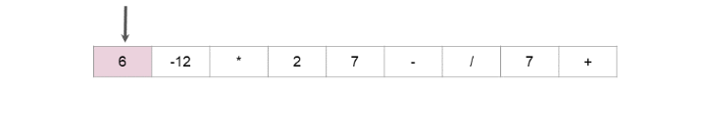

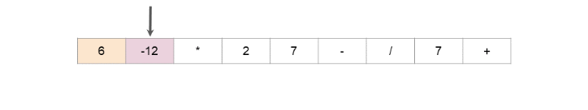

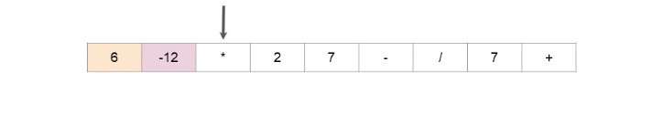

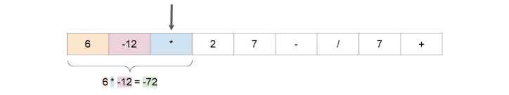

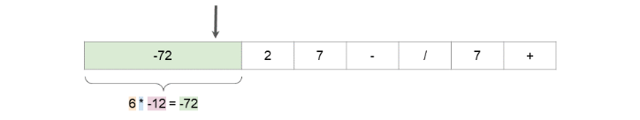

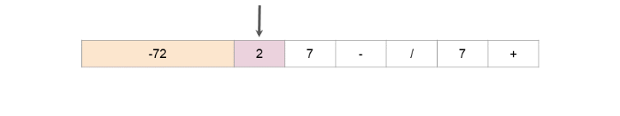

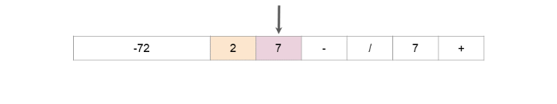

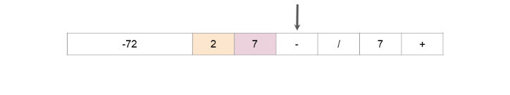

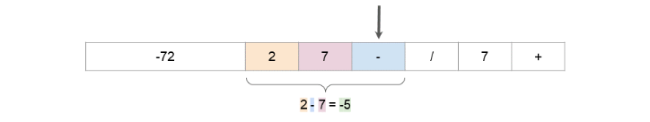

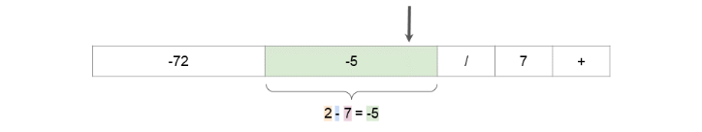

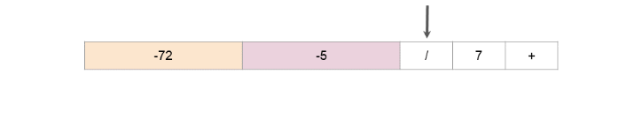

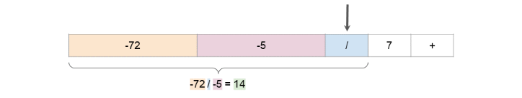

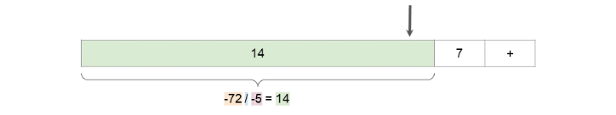

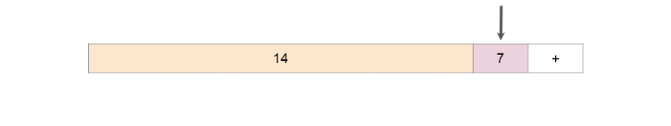

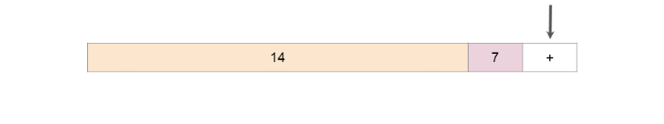

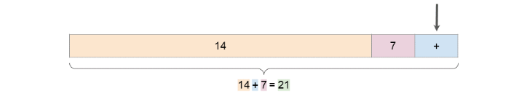

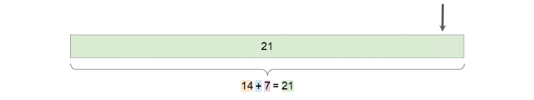

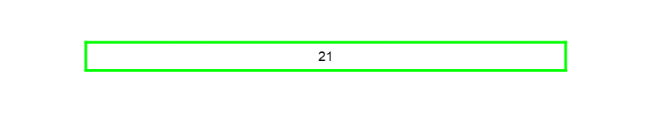

Hopefully the advantage is obvious now. Reverse Polish Notation doesn't require brackets, and the rules for evaluating it are far simpler. In-fact, our [equivalent question for Infix Notation](https://leetcode.com/problems/basic-calculator-iii/) is much more difficult than this one!

#### **Approach 1: Reducing the List In-place**

**Intuition**

This approach literally follows the animation above. A pointer is used to step through the list, and each time an operator (`+-*/) is found, that operator is then applied to the 2 values before it (which are always numbers, as long as the original input was valid). The 3 values are then replaced with the result. This process is repeated until the list is of length 1, containing a single number that is the answer to be returned.

**Algorithm**

The code is simpler for Python than Java. For Java (and other languages where the input type is a fixed size array), we have to define our own method to delete values from an array. This is done by shuffling the other elements down into the gap. Of course, you could start by copying the input into an ArrayList (so that you could then use its delete method), but then the algorithm would require O(n)*O*(*n*) space instead of O(1)*O*(1) space.

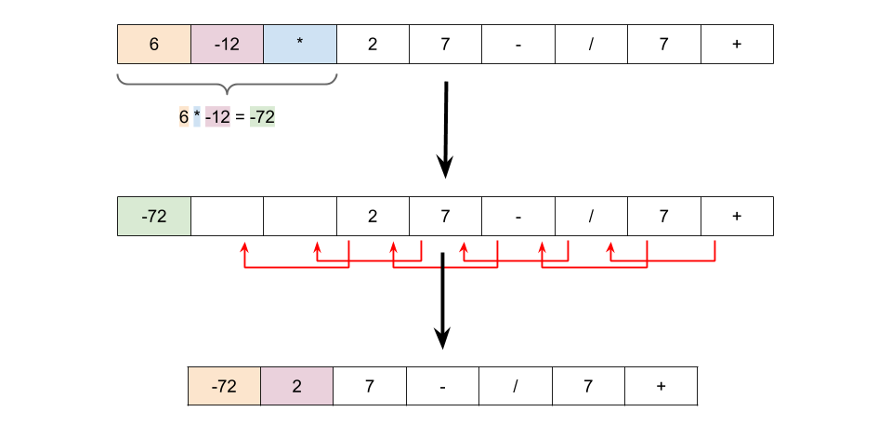

We have to be a little careful about the types in the Python code, as in the middle of processing the list, some numbers will be represent as strings, and others as ints. Additionally, we also need to be aware that python division does not truncate towards zero. We can instead use int(a / b) to achieve the desired result. Note that this is not the same as int(a // b).

In the Java code, we have to convert ints back to Strings, because Java doesn't support mixed lists of Strings and ints.

Finally, If you know how to use lambda functions in your chosen programming language, an ideal solution would use them to elegantly handle the 4 operations (+-*/). The first set of solutions here use lambda functions. If you aren't familiar with lambda functions though (or your chosen programming language doesn't support them), that's fine. You'll get a chance to learn them when you're ready! Scroll down a little more, as we have also provided solutions that don't use them.

|  |
| --- |
| class Solution {    private static final Map<String, BiFunction<Integer, Integer, Integer>> OPERATIONS = new HashMap<>();    // Ensure this only gets done once for ALL test cases.  static {  OPERATIONS.put("+", (a, b) -> a + b);  OPERATIONS.put("-", (a, b) -> a - b);  OPERATIONS.put("*", (a, b) -> a * b);  OPERATIONS.put("/", (a, b) -> a / b);  }    public int evalRPN(String[] tokens) {    int currentPosition = 0;  int length = tokens.length; // We need to keep track of this ourselves.    while (length > 1) {    // Move the position pointer to the next operator token.  while (!OPERATIONS.containsKey(tokens[currentPosition])) {  currentPosition++;  }    // Extract the operation and numbers to apply operation too.  String operation = tokens[currentPosition];  int number1 = Integer.parseInt(tokens[currentPosition - 2]);  int number2 = Integer.parseInt(tokens[currentPosition - 1]);    // Calculate the result to overwrite the operator with.  BiFunction<Integer, Integer, Integer> operator = OPERATIONS.get(operation);  int value = operator.apply(number1, number2);  tokens[currentPosition] = Integer.toString(value);    // Delete numbers and point pointers correctly.  delete2AtIndex(tokens, currentPosition - 2, length);  currentPosition--;  length -= 2;  }    return Integer.parseInt(tokens[0]);  }    private void delete2AtIndex(String[] tokens, int d, int length) {  for (int i = d; i < length - 2; i++) {  tokens[i] = tokens[i + 2];  }  }  } |

Here are the solutions without the use of lambda functions.

|  |
| --- |
| class Solution {  public int evalRPN(String[] tokens) {    int currentPosition = 0;  int length = tokens.length; // We will need to keep track of this ourselves.    while (length > 1) {    // Move the position pointer to the next operator token.  while (!"+-*/".contains(tokens[currentPosition])) {  currentPosition++;  }    // Extract the numbers.  int number1 = Integer.parseInt(tokens[currentPosition - 2]);  int number2 = Integer.parseInt(tokens[currentPosition - 1]);    // Calculate the result to overwrite the operator with.  int newValue = 0;  switch (tokens[currentPosition]) {  case "+":  newValue = number1 + number2;  break;  case "-":  newValue = number1 - number2;  break;  case "*":  newValue = number1 * number2;  break;  case "/":  newValue = number1 / number2;  break;  }  tokens[currentPosition] = Integer.toString(newValue);    // Delete numbers and point pointers correctly.  delete2AtIndex(tokens, currentPosition - 2, length);  currentPosition--;  length -= 2;  }    return Integer.parseInt(tokens[0]);  }    private void delete2AtIndex(String[] tokens, int d, int length) {  for (int i = d; i < length - 2; i++) {  tokens[i] = tokens[i + 2];  }  }  } |

**Complexity Analysis**

Let *n* be the length of the list.

* Time Complexity : O(n2).

Firstly, it helps to calculate how many operators and how many numbers are in the initial list. Each step of the algorithm removes 1 operator, 2 numbers, and adds back 1 number. This is an overall loss of 1 number and 1 operator per step. At the end, we have 1 number left. Therefore, we can infer that at the start, there must always be **exactly 1 more number than there is operators**.

The big inefficiency of this approach is more obvious in the Java code than the Python. Deleting an item from an ArrayList or Array is *O*(*n*), because all the items after have to be shuffled down one place to fill in the gap. The number of these deletions we need to do is the same as the number of operators, which is proportional to *n*. Therefore, the cost of the deletions is O(n2).

This is more obvious in the Java code, because we had to define the deletion method ourselves. However, the Python deletion method works the same way, it's just that you can't see it because it's hidden in a library function call. It's important to always be aware of the cost of library functions as they can sometimes look like they're *O*(1) when they're not!

* Space Complexity : *O*(1).

The only extra space used is a constant number of single-value variables. Therefore, the overall algorithm requires *O*(1) space.

Interestingly, this approach could be adapted to work with a **Double-Linked List**. It would require *O*(*n*) space to create the list, and then take *O*(*n*) time to process it using a similar algorithm to above. This works because the algorithm is traversing the list in a linear fashion and modifications only impact the tokens immediately to the left of the current token.

#### **Approach 2: Evaluate with Stack**

**Intuition**

The first approach worked, but O(n2) is too slow for large *n*. As hinted at above, a **Double-Linked List** could be an option. However, it requires a lot of set-up code, and in practice requires more space than the elegant **Stack** approach we're going to look at now.

We don't want to repeatedly delete items from the middle of a list, as this inevitably leads to O(n2) time performance. So recall that the above algorithm scanned through the list from left to right, and each time it reached an operator, it'd replace the operator and the 2 numbers immediately before it with the result of applying the operator to the 2 numbers.

The two key steps of the above algorithm were:

1. Visit each operator, in linear order. Finding these can be done with a linear search of the original list.
2. Get the 2 most recently seen numbers that haven't yet been replaced. These could be tracked using a **Stack**.

The algorithm would be as follows:

|  |
| --- |
| stack = new Stack()  for each token in tokens:  if token is a number:  stack.push(token)  else (token is operator):  number_2 = stack.pop()  number_1 = stack.pop()  result = apply_operator(token, number_1, number_2)  stack.push(result)  return stack.pop() |

Here is an animation showing the algorithm.

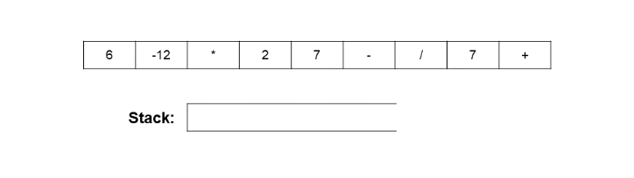

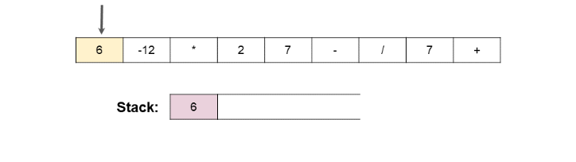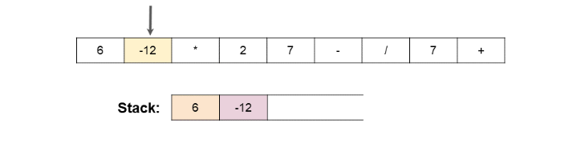

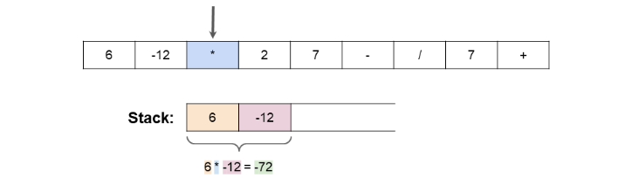

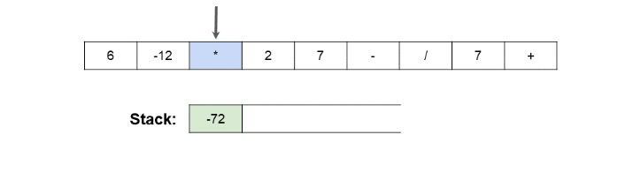

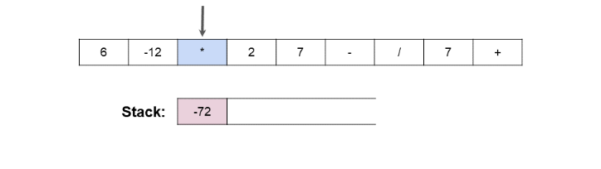

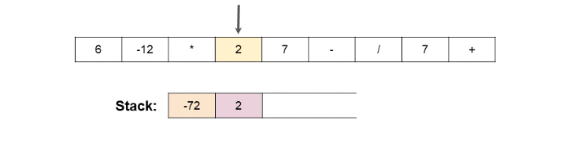

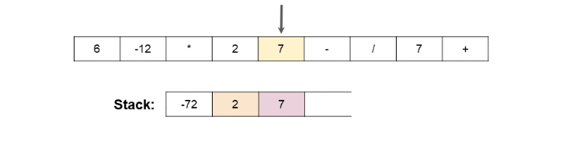

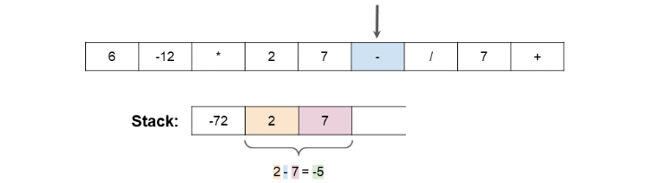

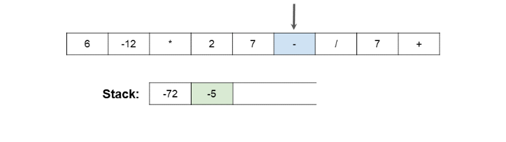

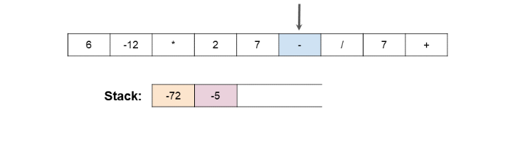

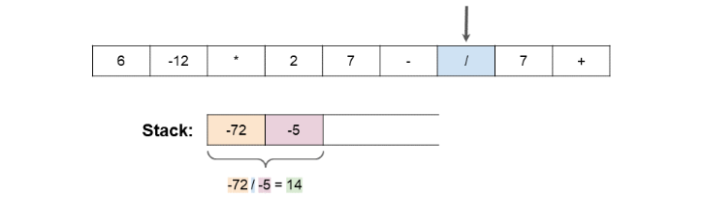

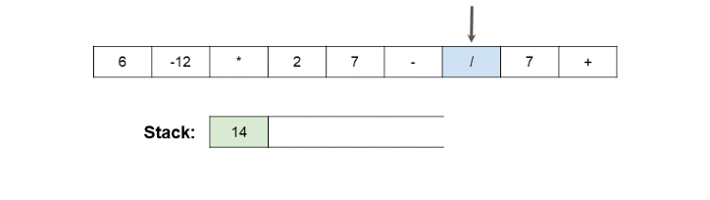

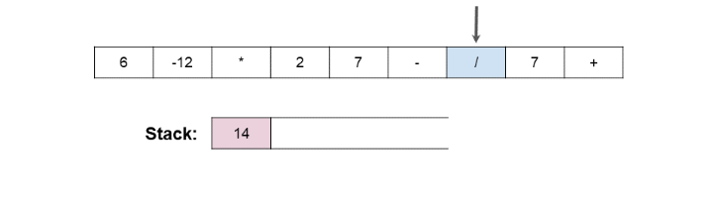

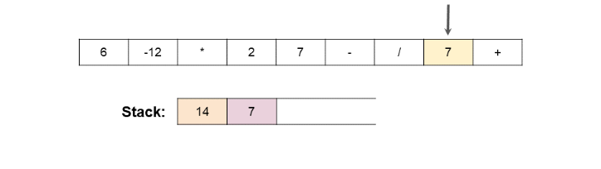

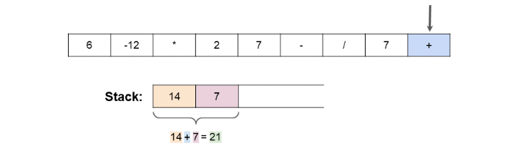

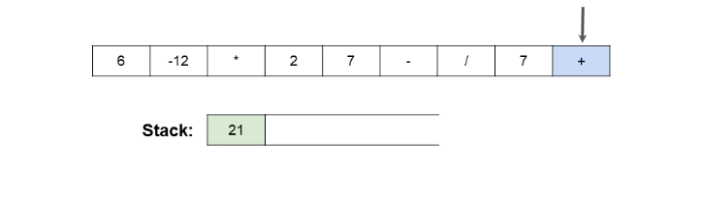

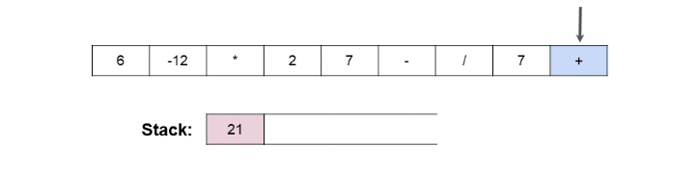

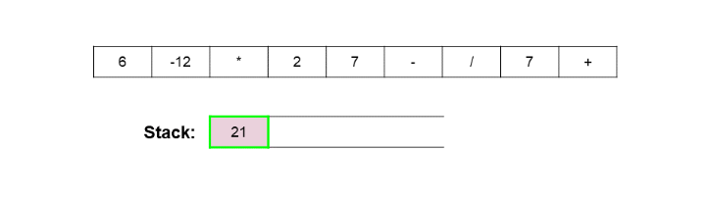

You might have noticed the following 2 lines of the pseudocode could look like they're around the wrong way.

number_2 = stack.pop()

number_1 = stack.pop()

They are correct though. Remember that for division and subtraction, the order of the numbers matters. i.e. 7 - 5 ≠ 5 - 7. On the Stack, we have the *second* on the top. So we need to reverse them before applying the operator.

**Algorithm**

Here is code that uses lambda functionality. Scroll down for code that doesn't.

|  |
| --- |
| class Solution {    private static final Map<String, BiFunction<Integer, Integer, Integer>> OPERATIONS = new HashMap<>();    // Ensure this only gets done once for ALL test cases.  static {  OPERATIONS.put("+", (a, b) -> a + b);  OPERATIONS.put("-", (a, b) -> a - b);  OPERATIONS.put("*", (a, b) -> a * b);  OPERATIONS.put("/", (a, b) -> a / b);  }    public int evalRPN(String[] tokens) {  Stack<Integer> stack = new Stack<>();  for (String token : tokens) {    if (!OPERATIONS.containsKey(token)) {  stack.push(Integer.valueOf(token));  continue;  }    int number2 = stack.pop();  int number1 = stack.pop();  BiFunction<Integer, Integer, Integer> operation;  operation = OPERATIONS.get(token);  int result = operation.apply(number1, number2);  stack.push(result);  }    return stack.pop();    }  } |

Here are the solutions without lambda.

|  |
| --- |
| class Solution {  public int evalRPN(String[] tokens) {  Stack<Integer> stack = new Stack<>();    for (String token : tokens) {    if (!"+-*/".contains(token)) {  stack.push(Integer.valueOf(token));  continue;  }    int number2 = stack.pop();  int number1 = stack.pop();    int result = 0;    switch (token) {  case "+":  result = number1 + number2;  break;  case "-":  result = number1 - number2;  break;  case "*":  result = number1 * number2;  break;  case "/":  result = number1 / number2;  break;  }    stack.push(result);    }  return stack.pop();  }  } |

**Complexity Analysis**

Let *n* be the length of the list.

* Time Complexity : *O*(*n*).

We do a linear search to put all numbers on the stack, and process all operators. Processing an operator requires removing 2 numbers off the stack and replacing them with a single number, which is an *O*(1) operation. Therefore, the total cost is proportional to the length of the input array. Unlike before, we're no longer doing expensive deletes from the middle of an Array or List.

* Space Complexity : *O*(*n*).

In the worst case, the stack will have all the numbers on it at the same time. This is never more than half the length of the input array.

## Stack and DFS

Prerequisite: [Tree Traversal](https://leetcode.com/explore/learn/card/data-structure-tree/134/traverse-a-tree/992/)

Similar to BFS, depth-first search (DFS) is another important algorithm to traverse/search in a tree/graph. And also it can be used in more abstract scenarios.

As mentioned in tree traversal, we can use DFS to do pre-order, in-order and post-order traversal. There is a common feature among these three traversal orders: we never trace back unless we reach the deepest node.

That is also the largest difference between DFS and BFS, BFS never go deeper unless it has already visited all nodes at the current level.

Typically, we implement DFS using recursion. Stack plays an important role in recursion. We will explain the role of the stack when doing recursion in this chapter. We will also show you what's the drawback of recursion and provide another implementation of DFS without recursion.

DFS is an important topic when preparing for the interview. The actual design of DFS varies from problem to problem. This chapter focuses on how stack is applied in DFS and helps you to understand the principle of DFS better. To be a master of DFS algorithm, you still need lots of practice.

**DFS - Template I**

As we mentioned in the chapter's description, in most cases, we can also use DFS when using BFS. But there is an important difference: the traversal order.

Different from BFS, the nodes you visit earlier might not be the nodes which are closer to the root node. As a result, the first path you found in DFS might not be the shortest path.

In this article, we will provide you a recursion template of DFS and show you how the stack helps with this process. And then we provide some exercise after this article for you to practice.

### ***Template - Recursion***

There are two ways to implement DFS. The first one is to do recursion which you might already be familiar with. Here we provide a template as reference:

|  |
| --- |
| /*  * Return true if there is a path from cur to target.  */  boolean DFS(Node cur, Node target, Set<Node> visited) {  return true if cur is target;  for (next : each neighbor of cur) {  if (next is not in visited) {  add next to visted;  return true if DFS(next, target, visited) == true;  }  }  return false;  } |

It seems like we don't have to use any stacks when we implement DFS recursively. But actually, we are using the implicit stack provided by the system, also known as the [Call Stack](https://en.wikipedia.org/wiki/Call_stack).

### ***An Example***

Let's take a look at an example. We want to find a path between node 0 and node 3 in the graph below. We also show you the stack's status during each call.

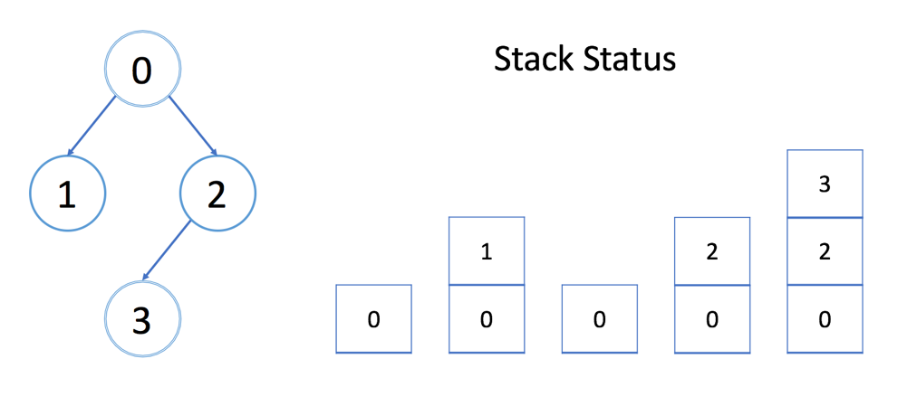

In each stack element, there is an integer cur, an integer target, a reference to array visited and a reference to array edges, which are exactly the parameters we have in the DFS function. We only show cur in the stack above.

Each element costs constant space. And the size of the stack is exactly the depth of DFS. So in the worst case, it costs O(h) to maintain the system stack, where h is the maximum depth of DFS. You should never forget to take the system stack into consideration when calculating the space complexity.

In the template above, we stop when we find the first path.

What if you want to find the shortest path?

Hint: Add one more parameter to indicate the shortest path you have already found.

**Clone Graph**

Given a reference of a node in a [**connected**](https://en.wikipedia.org/wiki/Connectivity_(graph_theory)#Connected_graph) undirected graph.

Return a [**deep copy**](https://en.wikipedia.org/wiki/Object_copying#Deep_copy) (clone) of the graph.

Each node in the graph contains a val (int) and a list (List[Node]) of its neighbors.

class Node {

public int val;

public List<Node> neighbors;

}

**Test case format:**

For simplicity sake, each node's value is the same as the node's index (1-indexed). For example, the first node with val = 1, the second node with val = 2, and so on. The graph is represented in the test case using an adjacency list.

**Adjacency list** is a collection of unordered **lists** used to represent a finite graph. Each list describes the set of neighbors of a node in the graph.

The given node will always be the first node with val = 1. You must return the **copy of the given node** as a reference to the cloned graph.

**Example 1:**

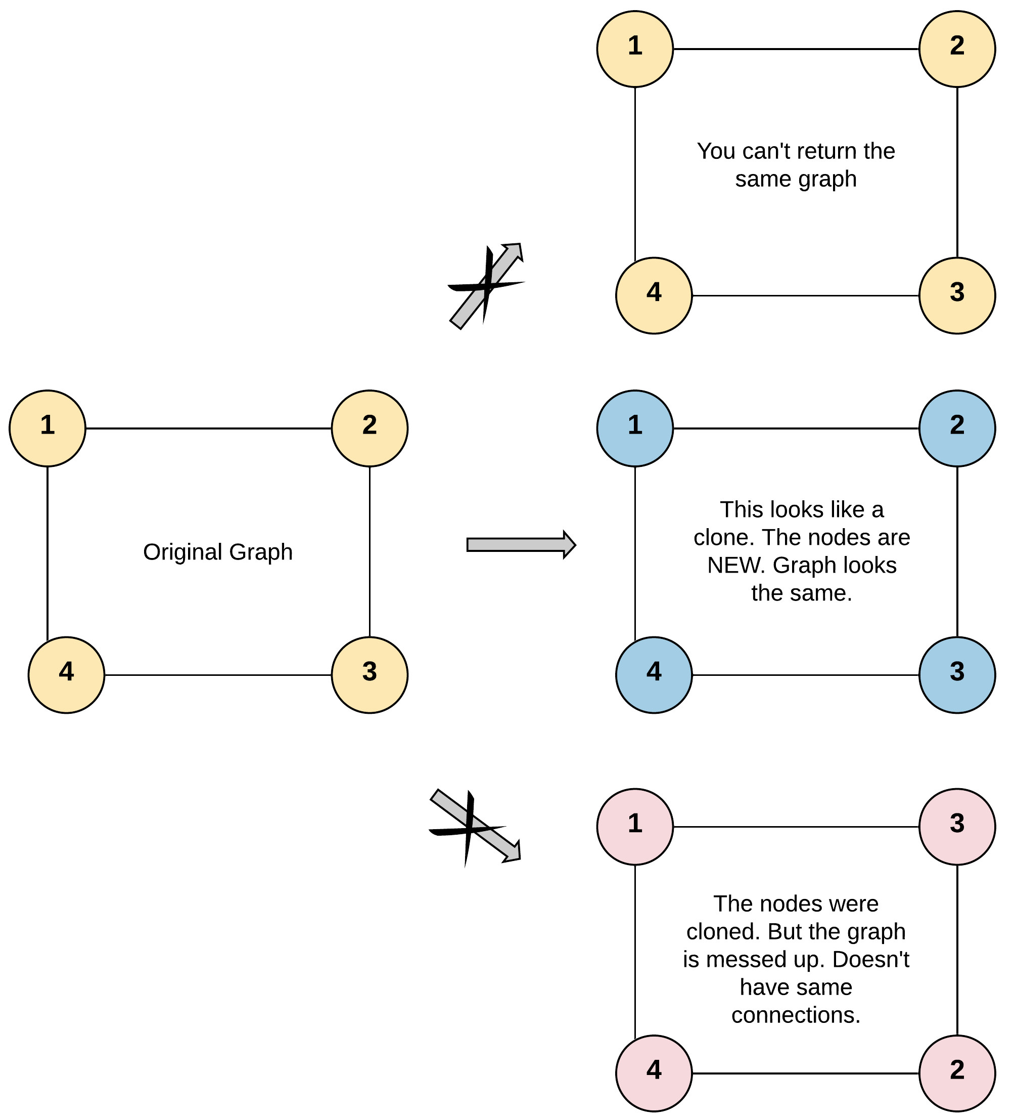

**Input:** adjList = [[2,4],[1,3],[2,4],[1,3]]

**Output:** [[2,4],[1,3],[2,4],[1,3]]

**Explanation:** There are 4 nodes in the graph.

1st node (val = 1)'s neighbors are 2nd node (val = 2) and 4th node (val = 4).

2nd node (val = 2)'s neighbors are 1st node (val = 1) and 3rd node (val = 3).

3rd node (val = 3)'s neighbors are 2nd node (val = 2) and 4th node (val = 4).

4th node (val = 4)'s neighbors are 1st node (val = 1) and 3rd node (val = 3).

**Example 2:**

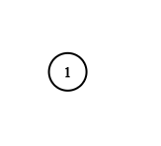

**Input:** adjList = [[]]

**Output:** [[]]

**Explanation:** Note that the input contains one empty list. The graph consists of only one node with val = 1 and it does not have any neighbors.

**Example 3:**

**Input:** adjList = []

**Output:** []

**Explanation:** This an empty graph, it does not have any nodes.

**Example 4:**

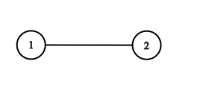

**Input:** adjList = [[2],[1]]

**Output:** [[2],[1]]

**Constraints:**

* 1 <= Node.val <= 100
* Node.val is unique for each node.
* Number of Nodes will not exceed 100.
* There is no repeated edges and no self-loops in the graph.
* The Graph is connected and all nodes can be visited starting from the given node.

## Solution

#### **Approach 1: Depth First Search**

**Intuition**

Note: As we can see this question has garnered a lot of negative reviews. It has a lot more dislikes than the likes. We have tried to improve the problem statement to make it more understandable. However, these are the kinds of situations you might get into in an interview when the problem statement might look a little absurd. What is important then is to ask the interviewer to clarify the problem. This problem statement was confusing to me as well initially and that's why I decided to write the solution hoping to clarify most of the doubts that the readers might have had.

The basic intuition for this problem is to just copy as we go. We need to understand that we are dealing with a graph and this means a node could have any number of neighbors. This is why neighbors is a list. What is also crucial to understand is that we don't want to get stuck in a cycle while we are traversing the graph. According to the problem statement, any given undirected edge could be represented as two directional edges. So, if there is an undirected edge between node A and node B, the graph representation for it would have a directed edge from A to B and another from B to A. After all, an undirected graph is a set of nodes that are connected together, where all the edges are bidirectional. How else would you say that A could be reached from B and B could be reached from A?

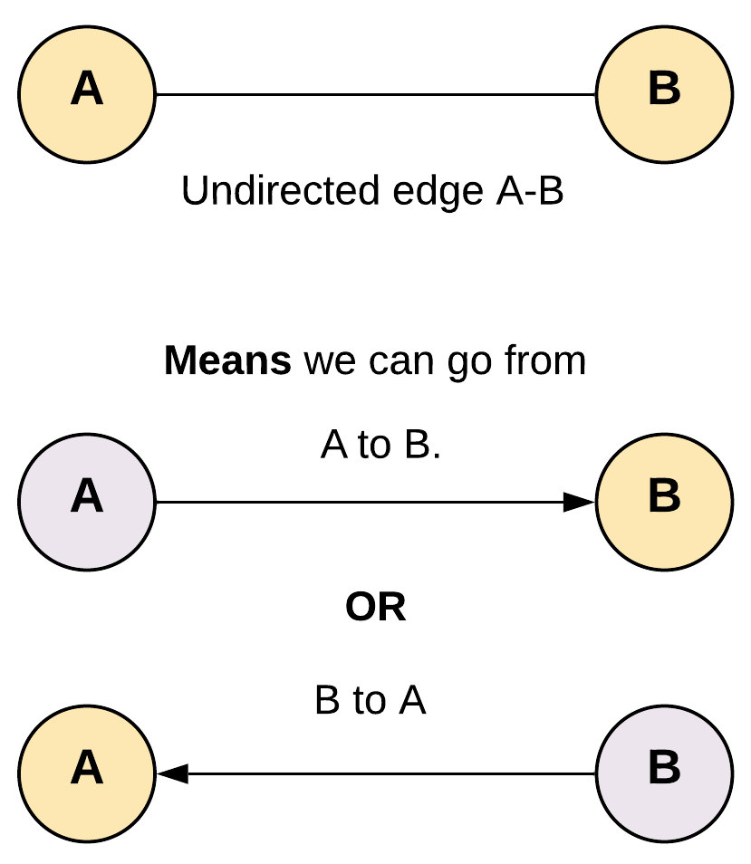

To avoid getting stuck in a loop we would need some way to keep track of the nodes which have already been copied. By doing this we don't end up traversing them again.

**Algorithm**

1. Start traversing the graph from the given node.
2. We would take a hash map to store the reference of the copy of all the nodes that have already been visited and cloned. The key for the hash map would be the node of the original graph and corresponding value would be the corresponding cloned node of the cloned graph. If the node already exists in the visited we return corresponding stored reference of the cloned node.

For a given edge A - B, since A is connected to B and B is also connected to A if we don't use visited we will get stuck in a cycle.

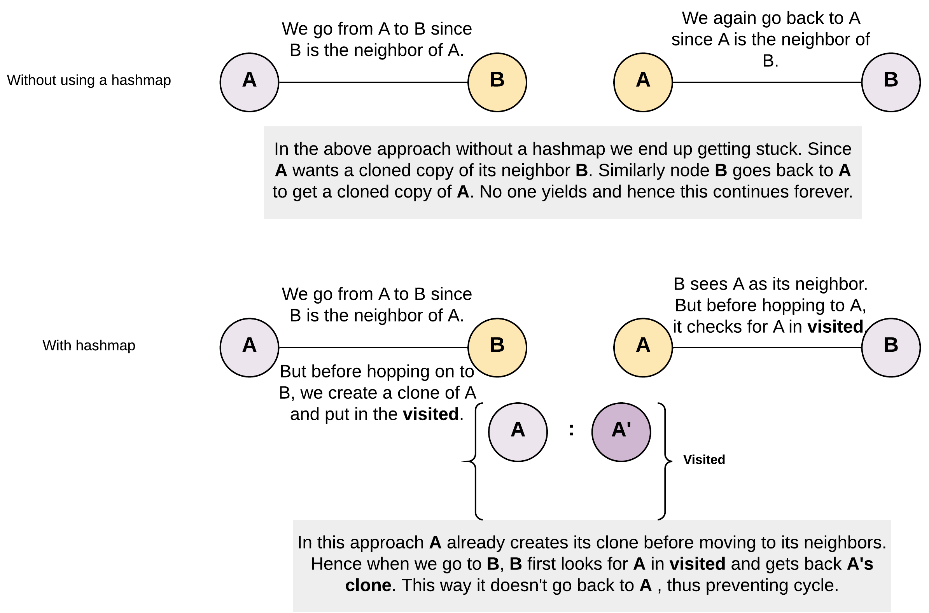

1. If we don't find the node in the visited hash map, we create a copy of it and put it in the hash map. Note, how it's important to create a copy of the node and add to the hash map before entering recursion.

clone_node = Node(node.val, [])

visited[node] = clone_node

In the absence of such an ordering, we would be caught in the recursion because on encountering the node again in somewhere down the recursion again, we will be traversing it again thus getting into cycles.

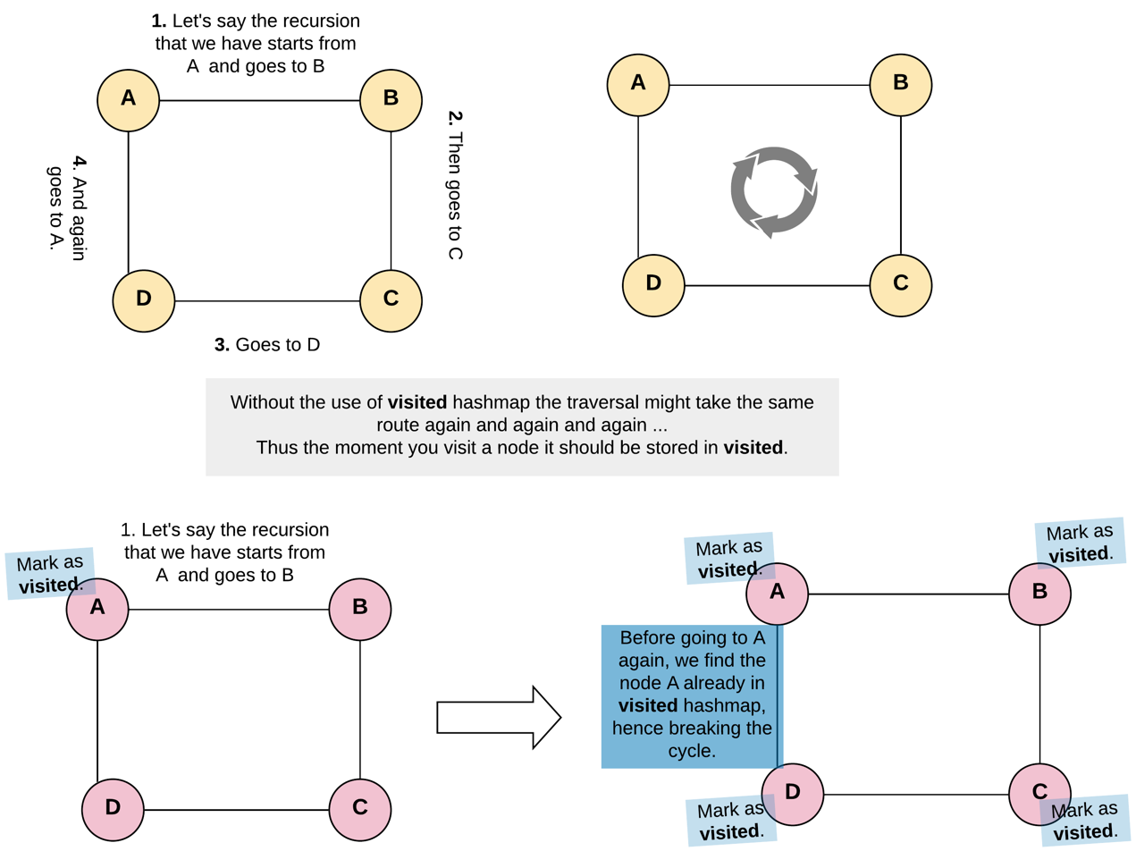

1. Now make the recursive call for the neighbors of the node. Pay attention to how many recursion calls we will be making for any given node. For a given node the number of recursive calls would be equal to the number of its neighbors. Each recursive call made would return the clone of a neighbor. We will prepare the list of these clones returned and put into neighbors of clone node which we had created earlier. This way we will have cloned the given node and it's neighbors.

Tip: Recursion could get a bit cumbersome to grasp, if you try to get into every call yourself and try to see what's happening. And why look at every call when every call does the same thing with different inputs. So, you just worry about ONE such call and let the recursion do the rest. And of course always handle the base case or the termination condition of the recursion. Otherwise how would it end?

|  |
| --- |
| /*  // Definition for a Node.  class Node {  public int val;  public List<Node> neighbors;  public Node() {}  public Node(int _val,List<Node> _neighbors) {  val = _val;  neighbors = _neighbors;  }  };  */  class Solution {  private HashMap <Node, Node> visited = new HashMap <> ();  public Node cloneGraph(Node node) {  if (node == null) {  return node;  }  // If the node was already visited before.  // Return the clone from the visited dictionary.  if (visited.containsKey(node)) {  return visited.get(node);  }  // Create a clone for the given node.  // Note that we don't have cloned neighbors as of now, hence [].  Node cloneNode = new Node(node.val, new ArrayList());  // The key is original node and value being the clone node.  visited.put(node, cloneNode);  // Iterate through the neighbors to generate their clones  // and prepare a list of cloned neighbors to be added to the cloned node.  for (Node neighbor: node.neighbors) {  cloneNode.neighbors.add(cloneGraph(neighbor));  }  return cloneNode;  }  } |

**Complexity Analysis**

* Time Complexity: *O*(*N*+*M*), where N*N* is a number of nodes (vertices) and *M* is a number of edges.
* Space Complexity: *O*(*N*). This space is occupied by the visited hash map and in addition to that, space would also be occupied by the recursion stack since we are adopting a recursive approach here. The space occupied by the recursion stack would be equal to *O*(*H*) where *H* is the height of the graph. Overall, the space complexity would be *O*(*N*).

#### **Approach 2: Breadth First Search**

**Intuition**

We could agree DFS is a good enough solution for this problem. However, if the recursion stack is what we are worried about then DFS is not our best bet. Sure, we can write an iterative version of depth first search by using our own stack. However, we also have the BFS way of doing iterative traversal of the graph and we'll be exploring that solution as well.

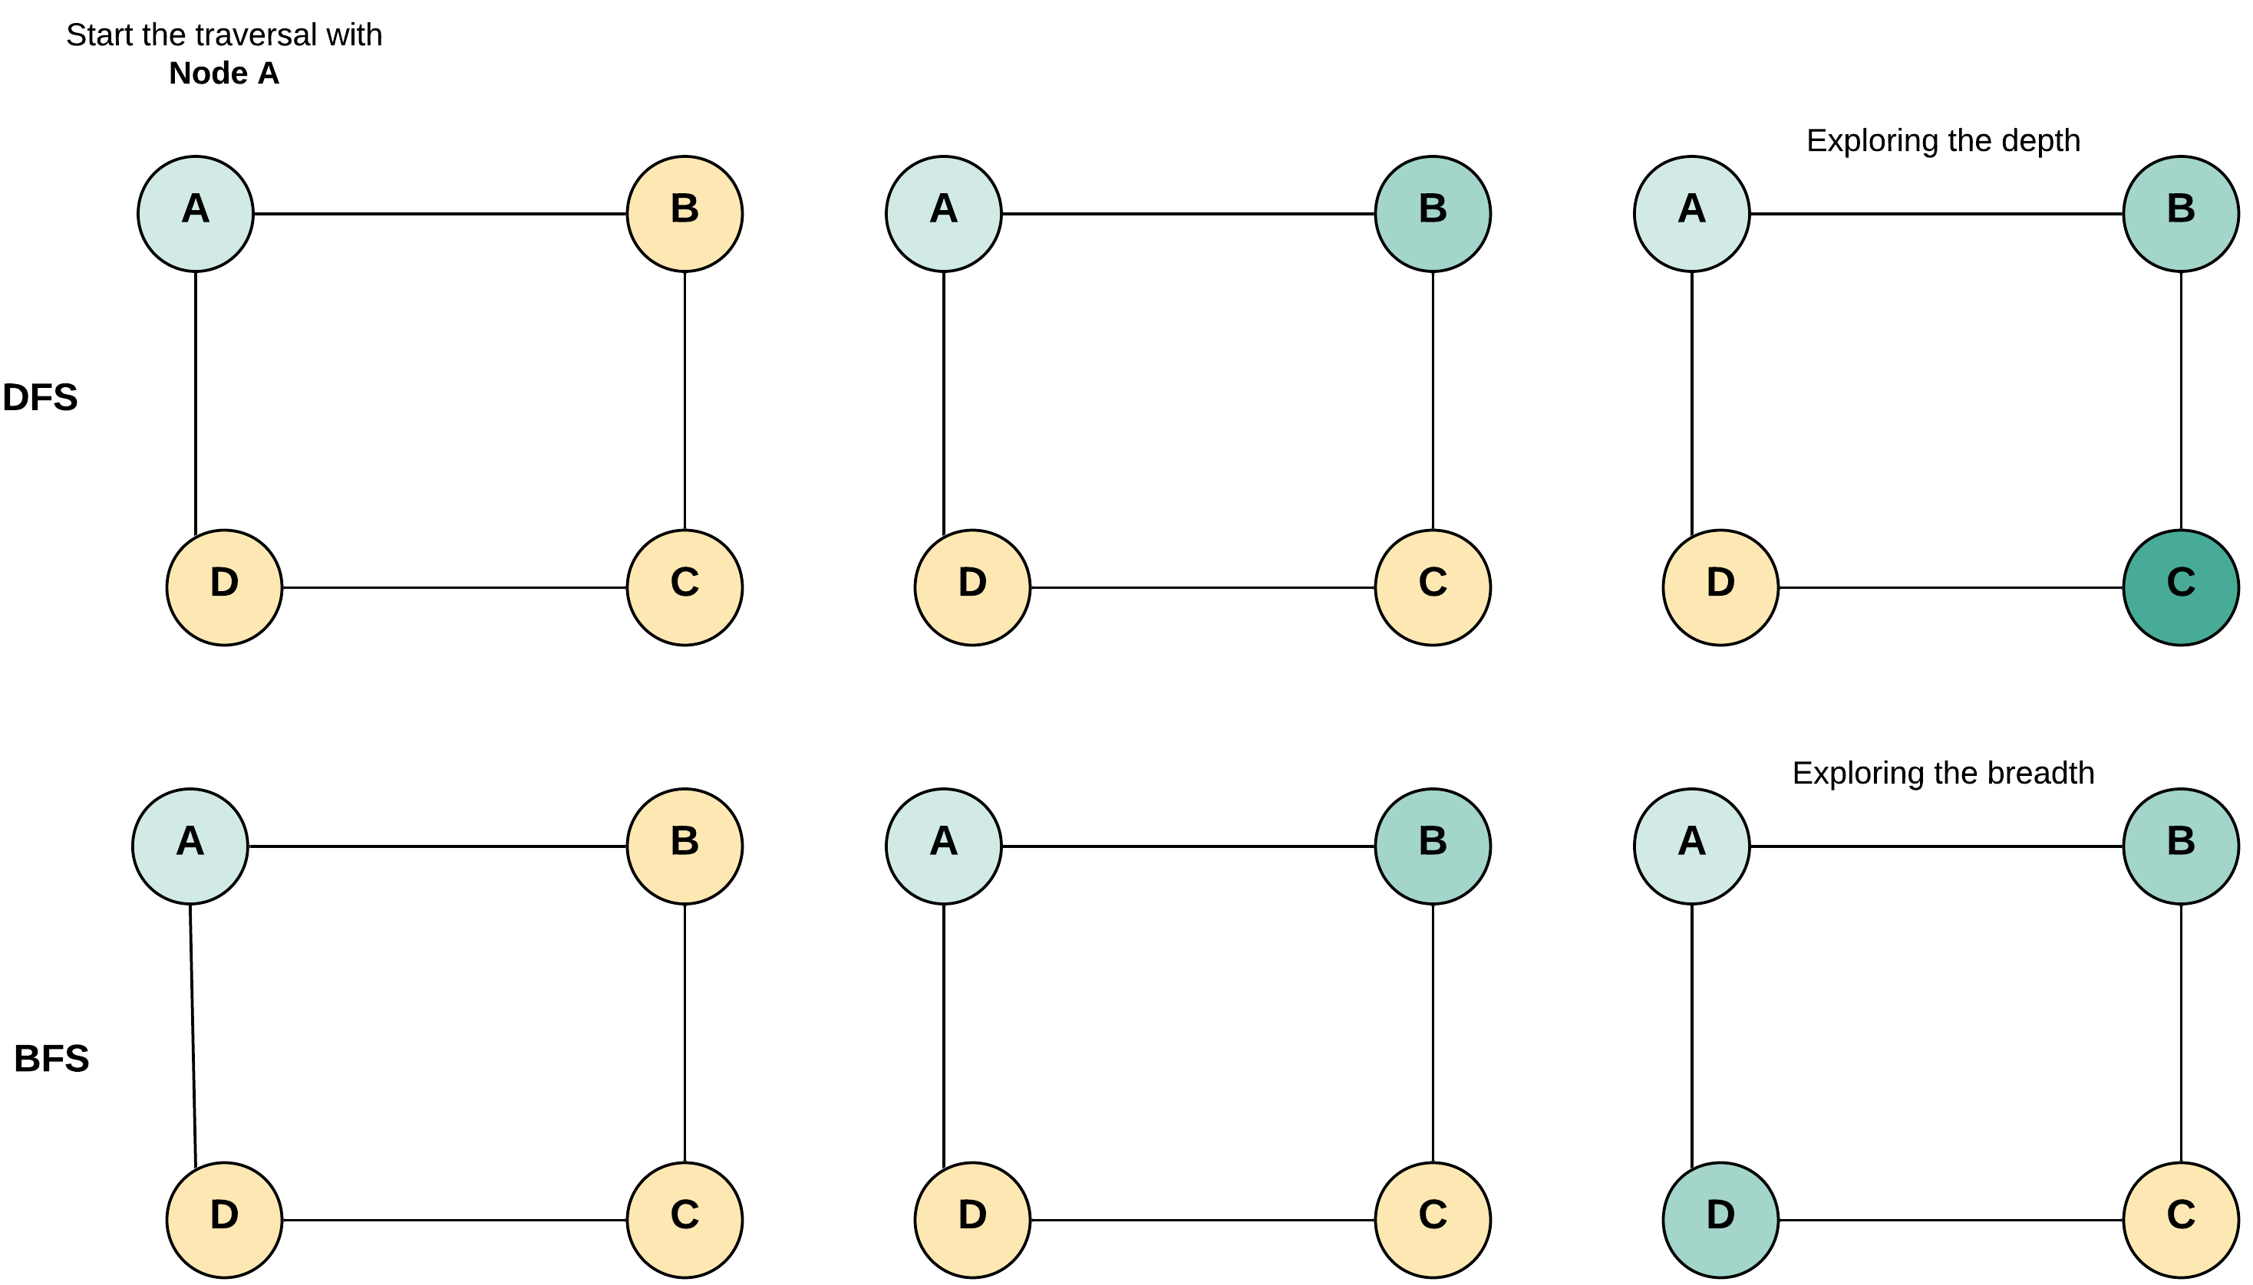

The difference is only in the traversal of DFS and BFS. As the name says it all, DFS explores the depths of the graph first and BFS explores the breadth. Based on the kind of graph we are expecting we can chose one over the other. We would need the visited hash map in both the approaches to avoid cycles.

**Algorithm**

1. We will use a hash map to store the reference of the copy of all the nodes that have already been visited and copied. The key for the hash map would be the node of the original graph and corresponding value would be the corresponding cloned node of the cloned graph. The visited is used to prevent cycles and get the cloned copy of a node.
2. Add the first node to the queue. Clone the first node and add it to visited hash map.
3. Do the BFS traversal.
   * Pop a node from the front of the queue.
   * Visit all the neighbors of this node.
   * If any of the neighbors was already visited then it must be present in the visited dictionary. Get the clone of this neighbor from visited in that case.
   * Otherwise, create a clone and store in the visited.
   * Add the clones of the neighbors to the corresponding list of the clone node.

|  |
| --- |
| /*  // Definition for a Node.  class Node {  public int val;  public List<Node> neighbors;  public Node() {}  public Node(int _val,List<Node> _neighbors) {  val = _val;  neighbors = _neighbors;  }  };  */  class Solution {  public Node cloneGraph(Node node) {  if (node == null) {  return node;  }  // Hash map to save the visited node and it's respective clone  // as key and value respectively. This helps to avoid cycles.  HashMap<Node, Node> visited = new HashMap();  // Put the first node in the queue  LinkedList<Node> queue = new LinkedList<Node> ();  queue.add(node);  // Clone the node and put it in the visited dictionary.  visited.put(node, new Node(node.val, new ArrayList()));  // Start BFS traversal  while (!queue.isEmpty()) {  // Pop a node say "n" from the from the front of the queue.  Node n = queue.remove();  // Iterate through all the neighbors of the node "n"  for (Node neighbor: n.neighbors) {  if (!visited.containsKey(neighbor)) {  // Clone the neighbor and put in the visited, if not present already  visited.put(neighbor, new Node(neighbor.val, new ArrayList()));  // Add the newly encountered node to the queue.  queue.add(neighbor);  }  // Add the clone of the neighbor to the neighbors of the clone node "n".  visited.get(n).neighbors.add(visited.get(neighbor));  }  }  // Return the clone of the node from visited.  return visited.get(node);  }  } |

**Complexity Analysis**

* Time Complexity : *O*(*N*+*M*), where *N* is a number of nodes (vertices) and *M* is a number of edges.
* Space Complexity : *O*(*N*). This space is occupied by the visited dictionary and in addition to that, space would also be occupied by the queue since we are adopting the BFS approach here. The space occupied by the queue would be equal to *O*(*W*) where *W* is the width of the graph. Overall, the space complexity would be *O*(*N*).

**Target Sum**

You are given a list of non-negative integers, a1, a2, ..., an, and a target, S. Now you have 2 symbols + and -. For each integer, you should choose one from + and - as its new symbol.

Find out how many ways to assign symbols to make sum of integers equal to target S.

**Example 1:**

**Input:** nums is [1, 1, 1, 1, 1], S is 3.

**Output:** 5

**Explanation:**

-1+1+1+1+1 = 3

+1-1+1+1+1 = 3

+1+1-1+1+1 = 3

+1+1+1-1+1 = 3

+1+1+1+1-1 = 3

There are 5 ways to assign symbols to make the sum of nums be target 3.

**Constraints:**

* The length of the given array is positive and will not exceed 20.
* The sum of elements in the given array will not exceed 1000.
* Your output answer is guaranteed to be fitted in a 32-bit integer.

## Solution

#### **Approach 1: Brute Force**

**Algorithm**

The brute force approach is based on recursion. We need to try to put both the + and - symbols at every location in the given *nums* array and find out the assignments which lead to the required result S*S*.

For this, we make use of a recursive function calculate(nums, i, sum, S), which returns the assignments leading to the sum *S*, starting from the *ith* index onwards, provided the sum of elements up to the *ith* element is *sum*. This function appends a + sign and a - sign both to the element at the current index and calls itself with the updated *sum* as *sum*+*nums*[*i*] and *sum*−*nums*[*i*] repectively along with the updated current index as *i*+1. Whenever, we reach the end of the array, we compare the sum obtained with S*S*. If they are equal, we increment the *count* value to be returned.

Thus, the function call calculate(nums, 0, 0, S) returns the required no. of assignments.

|  |
| --- |
| public class Solution {  int count = 0;  public int findTargetSumWays(int[] nums, int S) {  calculate(nums, 0, 0, S);  return count;  }  public void calculate(int[] nums, int i, int sum, int S) {  if (i == nums.length) {  if (sum == S)  count++;  } else {  calculate(nums, i + 1, sum + nums[i], S);  calculate(nums, i + 1, sum - nums[i], S);  }  }  } |

**Complexity Analysis**

* Time complexity : O(2n). Size of recursion tree will be 2n. *n* refers to the size of *nums* array.
* Space complexity : *O*(*n*). The depth of the recursion tree can go up to *n*.

#### **Approach 2: Recursion with Memoization**

**Algorithm**

It can be easily observed that in the last approach, a lot of redundant function calls could be made with the same value of i*i* as the current index and the same value of *sum* as the current sum, since the same values could be obtained through multiple paths in the recursion tree. In order to remove this redundancy, we make use of memoization as well to store the results which have been calculated earlier.

Thus, for every call to calculate(nums, i, sum, S), we store the result obtained in *memo*[*i*][*sum*+1000]. The factor of 1000 has been added as an offset to the *sum* value to map all the *sum*s possible to positive integer range. By making use of memoization, we can prune the search space to a good extent.

|  |
| --- |
| public class Solution {  int count = 0;  public int findTargetSumWays(int[] nums, int S) {  int[][] memo = new int[nums.length][2001];  for (int[] row: memo)  Arrays.fill(row, Integer.MIN_VALUE);  return calculate(nums, 0, 0, S, memo);  }  public int calculate(int[] nums, int i, int sum, int S, int[][] memo) {  if (i == nums.length) {  if (sum == S)  return 1;  else  return 0;  } else {  if (memo[i][sum + 1000] != Integer.MIN_VALUE) {  return memo[i][sum + 1000];  }  int add = calculate(nums, i + 1, sum + nums[i], S, memo);  int subtract = calculate(nums, i + 1, sum - nums[i], S, memo);  memo[i][sum + 1000] = add + subtract;  return memo[i][sum + 1000];  }  }  } |

**Complexity Analysis**

* Time complexity: O(*l*⋅*n*). The memo array of size *l*∗*n* has been filled just once. Here, *l* refers to the range of *sum* and *n* refers to the size of *nums* array.
* Space complexity: O(*l*⋅*n*). The depth of recursion tree can go upto *n*. The memo array contains *l*⋅*n* elements.

#### **Approach 3: 2D Dynamic Programming**

**Algorithm**

The idea behind this approach is as follows. Suppose we can find out the number of times a particular sum, say ***sumi***​ is possible upto a particular index, say *i*, in the given ***nums*** array, which is given by say ***counti***​. Now, we can find out the number of times the sum ***sumi*​+*nums*[*i*]** can occur easily as ***counti***​. Similarly, the number of times the sum ***sumi*​−*nums*[*i*]** occurs is also given by ***counti***​.

Thus, if we know all the sums ***sumj*​'s** which are possible upto the ***jth*** index by using various assignments, along with the corresponding count of assignments, ***countj***​, leading to the same sum, we can determine all the sums possible upto the **(*j*+1)*th*** index along with the corresponding count of assignments leading to the new sums.

Based on this idea, we make use of a ***dp*** to determine the number of assignments which can lead to the given sum. ***dp*[*i*][*j*]** refers to the number of assignments which can lead to a sum of ***j*** upto the ***ith*** index. To determine the number of assignments which can lead to a sum of ***sum*+*nums*[*i*]** upto the **(*i*+1)*th*** index, we can use

*dp*[*i*][*sum*+*nums*[*i*]]=*dp*[*i*][*sum*+*nums*[*i*]]+*dp*[*i*−1][*sum*].

Similarly,

*dp*[*i*][*sum*−*nums*[*i*]]=*dp*[*i*][*sum*+*nums*[*i*]]+*dp*[*i*−1][*sum*].

We iterate over the ***dp*** array in a rowwise fashion i.e. Firstly we obtain all the sums which are possible upto a particular index along with the corresponding count of assignments and then proceed for the next element(index) in the ***nums*** array.

But, since the *sum* can range from -1000 to +1000, we need to add an offset of 1000 to the sum indices (column number) to map all the sums obtained to positive range only.

At the end, the value of *dp*[*n*−1][*S*+1000] gives us the required number of assignments. Here, *n* refers to the number of elements in the *nums* array.

The animation below shows the way various sums are generated along with the corresponding indices. The example assumes sum*sum* values to lie in the range of -6 to +6 just for the purpose of illustration. This animation is inspired by [@Chidong](http://leetcode.com/Chidong)

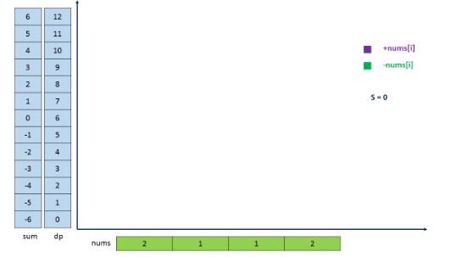

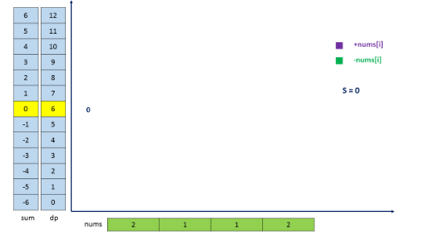

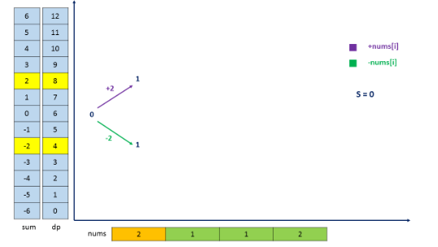

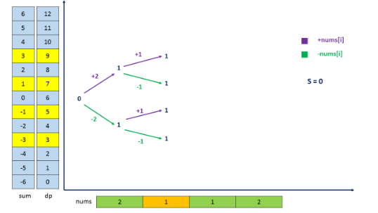

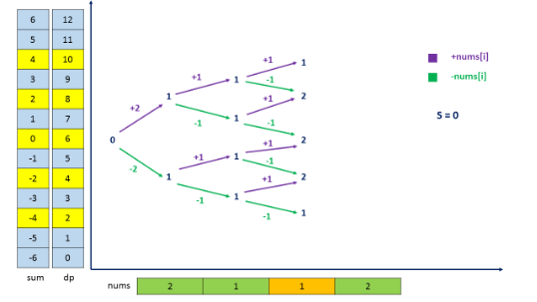

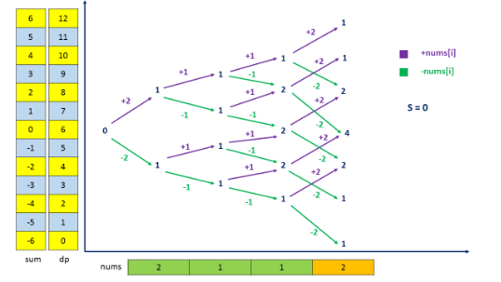

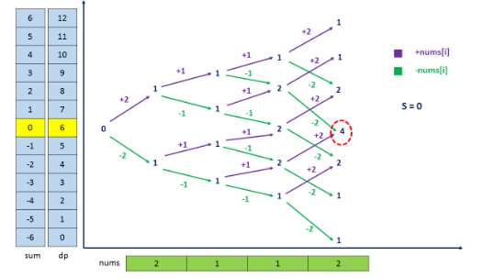

|  |
| --- |
| public class Solution {  public int findTargetSumWays(int[] nums, int S) {  int[][] dp = new int[nums.length][2001];  dp[0][nums[0] + 1000] = 1;  dp[0][-nums[0] + 1000] += 1;  for (int i = 1; i < nums.length; i++) {  for (int sum = -1000; sum <= 1000; sum++) {  if (dp[i - 1][sum + 1000] > 0) {  dp[i][sum + nums[i] + 1000] += dp[i - 1][sum + 1000];  dp[i][sum - nums[i] + 1000] += dp[i - 1][sum + 1000];  }  }  }  return S > 1000 ? 0 : dp[nums.length - 1][S + 1000];  }  } |

**Complexity Analysis**

* Time complexity : *O*(*l*∗*n*). The entire *nums* array is travesed 2001(constant no.: *l*) times. *n* refers to the size of *nums* array. *l* refers to the range of *sum* possible.
* Space complexity : *O*(*l*∗*n*). *dp* array of size *l*∗*n* is used.

#### **Approach 4: 1D Dynamic Programming**

**Algorithm**

If we look closely at the last solution, we can observe that for the evaluation of the current row of dp*dp*, only the values of the last row of *dp* are needed. Thus, we can save some space by using a 1D DP array instead of a 2-D DP array. The only difference that needs to be made is that now the same *dp* array will be updated for every row traversed.

|  |
| --- |
| public class Solution {  public int findTargetSumWays(int[] nums, int S) {  int[] dp = new int[2001];  dp[nums[0] + 1000] = 1;  dp[-nums[0] + 1000] += 1;  for (int i = 1; i < nums.length; i++) {  int[] next = new int[2001];  for (int sum = -1000; sum <= 1000; sum++) {  if (dp[sum + 1000] > 0) {  next[sum + nums[i] + 1000] += dp[sum + 1000];  next[sum - nums[i] + 1000] += dp[sum + 1000];  }  }  dp = next;  }  return S > 1000 ? 0 : dp[S + 1000];  }  } |

**Complexity Analysis**

* Time complexity : *O*(*l*.*n*). The entire *nums* array is traversed *l* times. *n* refers to the size of *nums* array. *l* refers to the range of *sum* possible.
* Space complexity : *O*(*n*). *dp* array of size *n* is used.

**DFS - Template II**

The advantage of the recursion solution is that it is easier to implement. However, there is a huge disadvantage: if the depth of recursion is too high, you will suffer from stack overflow. In that case, you might want to use BFS instead or implement DFS using an explicit stack.

Here we provide a template using an explicit stack:

|  |
| --- |
| /*  * Return true if there is a path from cur to target.  */  boolean DFS(int root, int target) {  Set<Node> visited;  Stack<Node> stack;  add root to stack;  while (s is not empty) {  Node cur = the top element in stack;  remove the cur from the stack;  return true if cur is target;  for (Node next : the neighbors of cur) {  if (next is not in visited) {  add next to visited;  add next to stack;  }  }  }  return false;  } |

The logic is exactly the same with the recursion solution. But we use while loop and stack to simulate the system call stack during recursion. Running through several examples manually will definitely help you understand it better.

**Binary Tree Inorder Traversal**

Given the root of a binary tree, return the inorder traversal of its nodes' values.

**Example 1:**

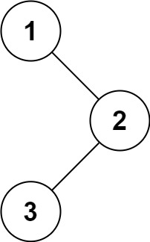

**Input:** root = [1,null,2,3]

**Output:** [1,3,2]

**Example 2:**

**Input:** root = []

**Output:** []

**Example 3:**

**Input:** root = [1]

**Output:** [1]

**Example 4:**

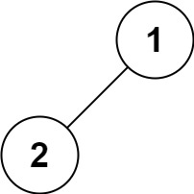

**Input:** root = [1,2]

**Output:** [2,1]

**Example 5:**

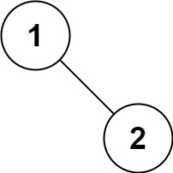

**Input:** root = [1,null,2]

**Output:** [1,2]

**Constraints:**

* The number of nodes in the tree is in the range [0, 100].
* -100 <= Node.val <= 100

**Follow up:**

Recursive solution is trivial, could you do it iteratively?

## Solution

#### **Approach 1: Recursive Approach**

The first method to solve this problem is using recursion. This is the classical method and is straightforward. We can define a helper function to implement recursion.

|  |
| --- |
| class Solution {  public List < Integer > inorderTraversal(TreeNode root) {  List < Integer > res = new ArrayList < > ();  helper(root, res);  return res;  }  public void helper(TreeNode root, List < Integer > res) {  if (root != null) {  if (root.left != null) {  helper(root.left, res);  }  res.add(root.val);  if (root.right != null) {  helper(root.right, res);  }  }  }  } |

**Complexity Analysis**

* Time complexity : *O*(*n*). The time complexity is *O*(*n*) because the recursive function is *T*(*n*)=2⋅*T*(*n*/2)+1.
* Space complexity : The worst case space required is *O*(*n*), and in the average case it's *O*(log*n*) where *n* is number of nodes.

#### **Approach 2: Iterating method using Stack**

The strategy is very similiar to the first method, the different is using stack.

Here is an illustration:

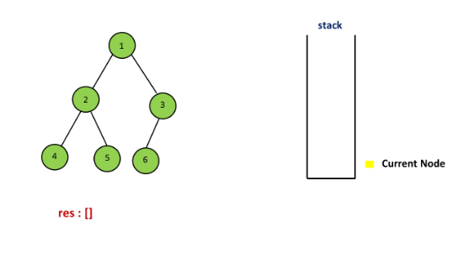

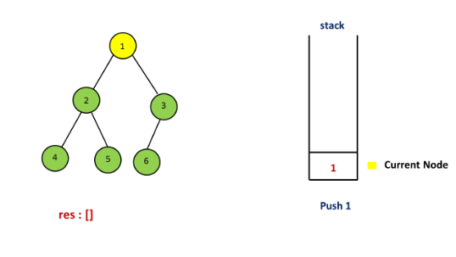

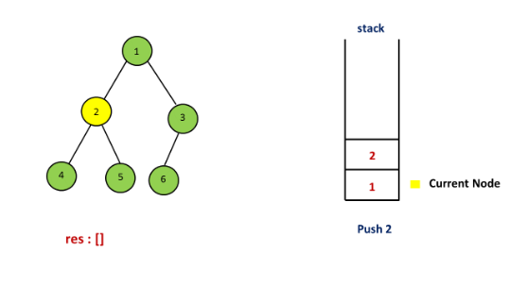

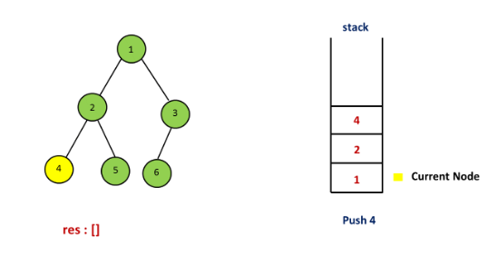

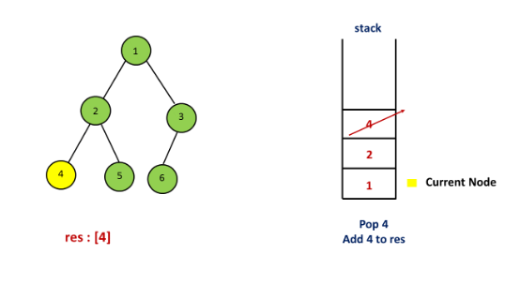

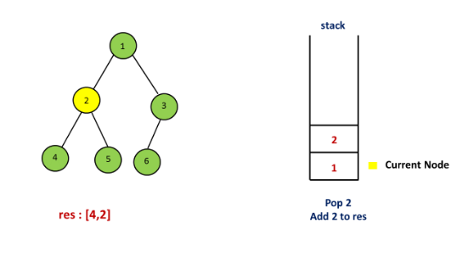

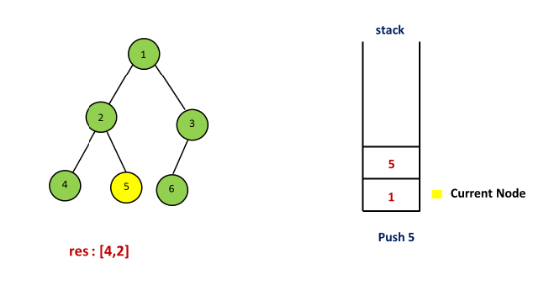

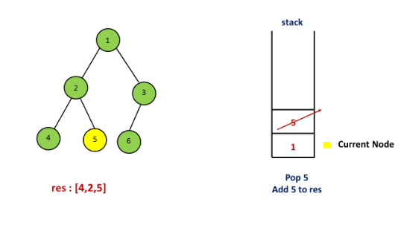

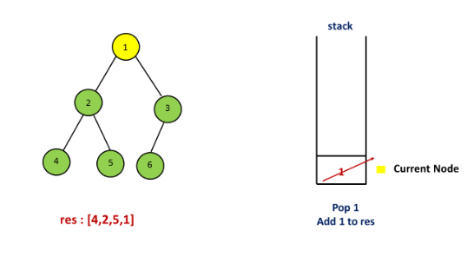

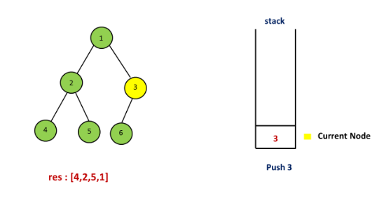

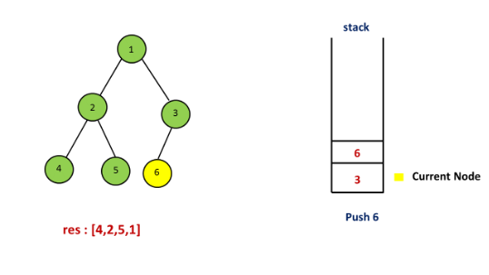

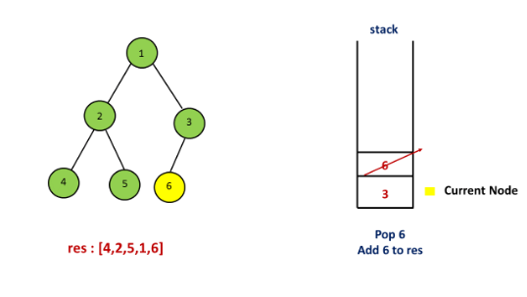

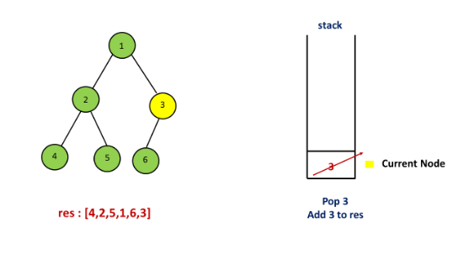

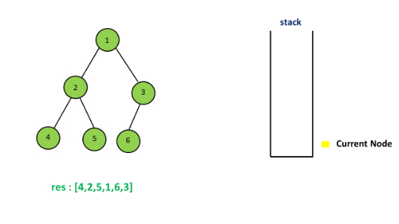

|  |
| --- |
| public class Solution {  public List < Integer > inorderTraversal(TreeNode root) {  List < Integer > res = new ArrayList < > ();  Stack < TreeNode > stack = new Stack < > ();  TreeNode curr = root;  while (curr != null || !stack.isEmpty()) {  while (curr != null) {  stack.push(curr);  curr = curr.left;  }  curr = stack.pop();  res.add(curr.val);  curr = curr.right;  }  return res;  }  } |

**Complexity Analysis**

* Time complexity : *O*(*n*).
* Space complexity : *O*(*n*).

#### **Approach 3: Morris Traversal**

In this method, we have to use a new data structure-Threaded Binary Tree, and the strategy is as follows:

Step 1: Initialize current as root

Step 2: While current is not NULL,

If current does not have left child

a. Add current’s value

b. Go to the right, i.e., current = current.right

Else

a. In current's left subtree, make current the right child of the rightmost node

b. Go to this left child, i.e., current = current.left

For example:

1

/ \

2 3

/ \ /

4 5 6

First, 1 is the root, so initialize 1 as current, 1 has left child which is 2, the current's left subtree is:

2

/ \

4 5

So in this subtree, the rightmost node is 5, then make the current(1) as the right child of 5. Set current = cuurent.left (current = 2). The tree now looks like:  
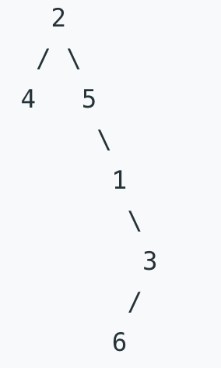

For current 2, which has left child 4, we can continue with the same process as we did above

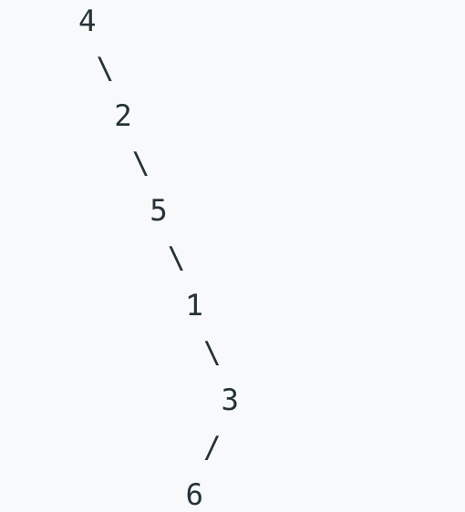  
then add 4 because it has no left child, then add 2, 5, 1, 3 one by one, for node 3 which has left child 6, do the same as above. Finally, the inorder taversal is [4,2,5,1,6,3].

For more details, please check [Threaded binary tree](https://en.wikipedia.org/wiki/Threaded_binary_tree) and [Explaination of Morris Method](https://stackoverflow.com/questions/5502916/explain-morris-inorder-tree-traversal-without-using-stacks-or-recursion)

|  |
| --- |
| class Solution {  public List < Integer > inorderTraversal(TreeNode root) {  List < Integer > res = new ArrayList < > ();  TreeNode curr = root;  TreeNode pre;  while (curr != null) {  if (curr.left == null) {  res.add(curr.val);  curr = curr.right; // move to next right node  } else { // has a left subtree  pre = curr.left;  while (pre.right != null) { // find rightmost  pre = pre.right;  }  pre.right = curr; // put cur after the pre node  TreeNode temp = curr; // store cur node  curr = curr.left; // move cur to the top of the new tree  temp.left = null; // original cur left be null, avoid infinite loops  }  }  return res;  }  } |

**Complexity Analysis**

* Time complexity : *O*(*n*). To prove that the time complexity is *O*(*n*), the biggest problem lies in finding the time complexity of finding the predecessor nodes of all the nodes in the binary tree. Intuitively, the complexity is *O*(*n*log*n*), because to find the predecessor node for a single node related to the height of the tree. But in fact, finding the predecessor nodes for all nodes only needs *O*(*n*) time. Because a binary Tree with *n* nodes has *n*−1 edges, the whole processing for each edges up to 2 times, one is to locate a node, and the other is to find the predecessor node. So the complexity is *O*(*n*).
* Space complexity : *O*(*n*). Arraylist of size *n* is used.

## Conclusion

In previous chapters, we have introduced two data structures: Queue and Stack.

### **1. Queue**

Queue is a FIFO data structure: the first element will be processed first. There are two important operations: enqueue and dequeue. We can use a dynamic array with two pointers to implement a queue.

We can use a queue to implement Breadth-first Search (BFS).

There are also some important extensions of the queue. For example,

* Dequeue
* Priority Queue

We will introduce these structures in later cards.

### **2. Stack**

Stack is a LIFO data structure: the last element will be processed first. There are two important operations: push and pop. The implementation of stack is quite simple. A dynamic array will be enough to implement a stack.

We use stack when LIFO principle is satisfied. Depth-first Search (DFS) is an important applications of stack.

### **3. Summary**

To summarize, you should be able to understand and compare the following concepts:

* FIFO and LIFO;
* Queue and Stack;
* BFS and DFS.

The best way to be comfortable with this topic is to practice. We provide some more exercise for you in this chapter.

**Implement Queue using Stacks**

Implement a first in first out (FIFO) queue using only two stacks. The implemented queue should support all the functions of a normal queue (push, peek, pop, and empty).

Implement the MyQueue class:

* void push(int x) Pushes element x to the back of the queue.
* int pop() Removes the element from the front of the queue and returns it.
* int peek() Returns the element at the front of the queue.
* boolean empty() Returns true if the queue is empty, false otherwise.

**Notes:**

* You must use **only** standard operations of a stack, which means only push to top, peek/pop from top, size, and is empty operations are valid.
* Depending on your language, the stack may not be supported natively. You may simulate a stack using a list or deque (double-ended queue) as long as you use only a stack's standard operations.

**Follow-up:** Can you implement the queue such that each operation is [**amortized**](https://en.wikipedia.org/wiki/Amortized_analysis) O(1) time complexity? In other words, performing n operations will take overall O(n) time even if one of those operations may take longer.

**Example 1:**

**Input**

["MyQueue", "push", "push", "peek", "pop", "empty"]

[[], [1], [2], [], [], []]

**Output**

[null, null, null, 1, 1, false]

**Explanation**

MyQueue myQueue = new MyQueue();

myQueue.push(1); // queue is: [1]

myQueue.push(2); // queue is: [1, 2] (leftmost is front of the queue)

myQueue.peek(); // return 1

myQueue.pop(); // return 1, queue is [2]

myQueue.empty(); // return false

**Constraints:**

* 1 <= x <= 9
* At most 100 calls will be made to push, pop, peek, and empty.
* All the calls to pop and peek are valid.

## Summary

This article is for beginners. It introduces the following ideas: Queue, Stack.

## Solution

Queue is **FIFO** (first in - first out) data structure, in which the elements are inserted from one side - rear and removed from the other - front. The most intuitive way to implement it is with linked lists, but this article will introduce another approach using stacks. Stack is **LIFO** (last in - first out) data structure, in which elements are added and removed from the same end, called top. To satisfy **FIFO** property of a queue we need to keep two stacks. They serve to reverse arrival order of the elements and one of them store the queue elements in their final order.

#### **Approach #1 (Two Stacks) Push - O(n) per operation, Pop - O(1) per operation.**

**Algorithm**

**Push**

A queue is FIFO (first-in-first-out) but a stack is LIFO (last-in-first-out). This means the newest element must be pushed to the bottom of the stack. To do so we first transfer all s1 elements to auxiliary stack s2. Then the newly arrived element is pushed on top of s2 and all its elements are popped and pushed to s1.

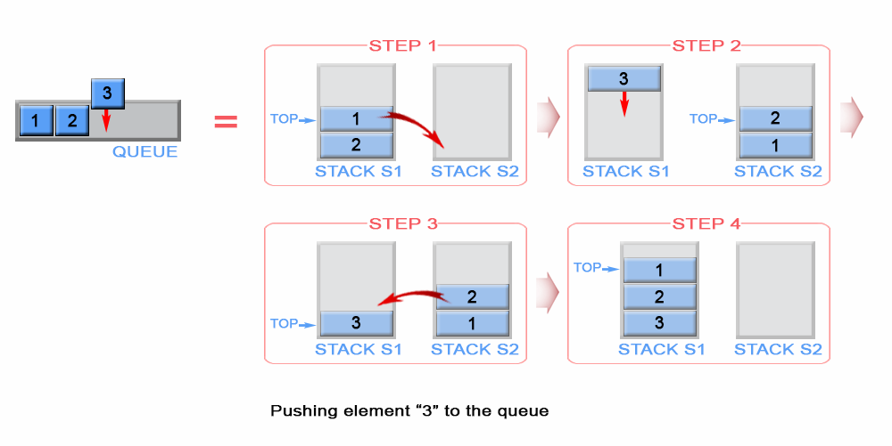

Figure 1. Push an element in queue

|  |
| --- |
| private int front;  public void push(int x) {  if (s1.empty())  front = x;  while (!s1.isEmpty())  s2.push(s1.pop());  s2.push(x);  while (!s2.isEmpty())  s1.push(s2.pop());  } |

**Complexity Analysis**

* Time complexity : *O*(*n*).

Each element, with the exception of the newly arrived, is pushed and popped twice. The last inserted element is popped and pushed once. Therefore this gives 4*n*+2 operations where *n* is the queue size. The push and pop operations have *O*(1) time complexity.

* Space complexity : *O*(*n*). We need additional memory to store the queue elements

**Pop**

The algorithm pops an element from the stack s1, because s1 stores always on its top the first inserted element in the queue. The front element of the queue is kept as front.

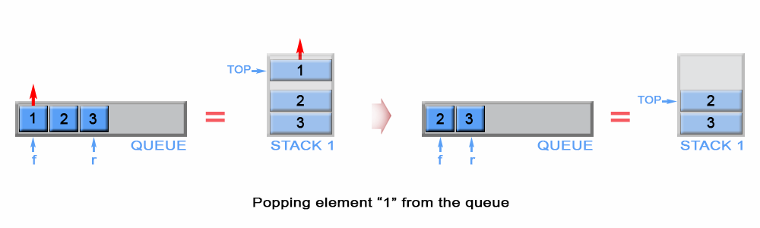

*Figure 2. Pop an element from queue*

|  |
| --- |
| // Removes the element from the front of queue.  public void pop() {  s1.pop();  if (!s1.empty())  front = s1.peek();  } |

**Complexity Analysis**

* Time complexity : *O*(1).
* Space complexity : *O*(1).

**Empty**

Stack s1 contains all stack elements, so the algorithm checks s1 size to return if the queue is empty.

|  |
| --- |
| // Return whether the queue is empty.  public boolean empty() {  return s1.isEmpty();  } |

Time complexity : *O*(1).

Space complexity : *O*(1).  
  
**Peek**

The front element is kept in constant memory and is modified when we push or pop an element.

|  |
| --- |
| // Get the front element.  public int peek() {  return front;  } |

Time complexity : *O*(1). The front element has been calculated in advance and only returned in peek operation.

Space complexity : *O*(1).

#### **Approach #2 (Two Stacks) Push - O(1) per operation, Pop - Amortized O(1) per operation.**

**Algorithm**

**Push**

The newly arrived element is always added on top of stack s1 and the first element is kept as front queue element

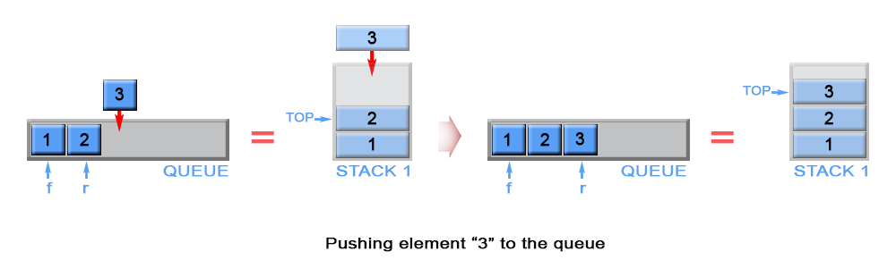

Figure 3. Push an element in queue

|  |
| --- |
| private Stack<Integer> s1 = new Stack<>();  private Stack<Integer> s2 = new Stack<>();  // Push element x to the back of queue.  public void push(int x) {  if (s1.empty())  front = x;  s1.push(x);  } |

**Complexity Analysis**

* Time complexity : *O*(1).

Аppending an element to a stack is an O(1) operation.

* Space complexity : *O*(*n*). We need additional memory to store the queue elements

**Pop**

We have to remove element in front of the queue. This is the first inserted element in the stack s1 and it is positioned at the bottom of the stack because of stack's LIFO (last in - first out) policy. To remove the bottom element from s1, we have to pop all elements from s1 and to push them on to an additional stack s2, which helps us to store the elements of s1 in reversed order. This way the bottom element of s1 will be positioned on top of s2 and we can simply pop it from stack s2. Once s2 is empty, the algorithm transfer data from s1 to s2 again.

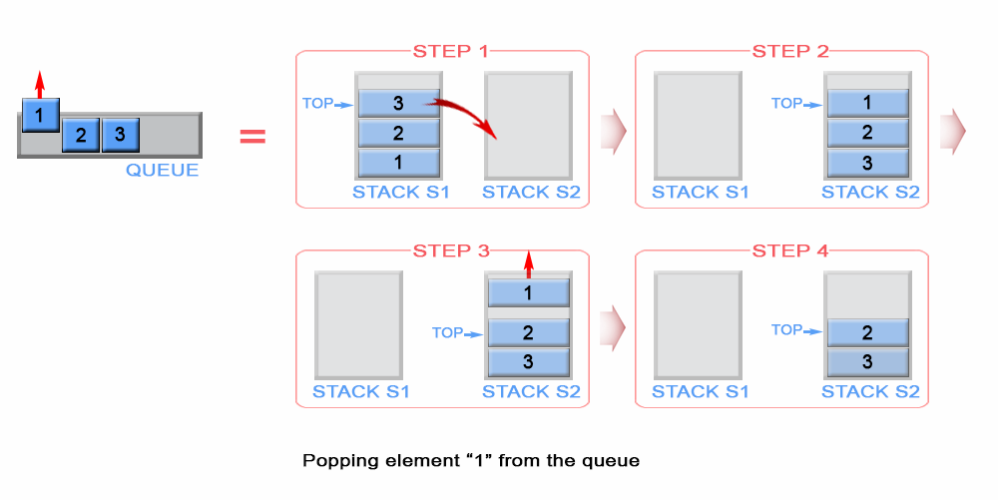

*Figure 4. Pop an element from stack*

|  |
| --- |
| // Removes the element from in front of queue.  public void pop() {  if (s2.isEmpty()) {  while (!s1.isEmpty())  s2.push(s1.pop());  }  s2.pop();  } |

**Complexity Analysis**

* Time complexity: Amortized *O*(1), Worst-case *O*(*n*).

In the worst case scenario when stack s2 is empty, the algorithm pops *n* elements from stack s1 and pushes *n* elements to s2, where *n* is the queue size. This gives 2*n* operations, which is *O*(*n*). But when stack s2 is not empty the algorithm has *O*(1) time complexity. So what does it mean by Amortized *O*(1)? Please see the next section on Amortized Analysis for more information.

* Space complexity : *O*(1).

**Amortized Analysis**

Amortized analysis gives the average performance (over time) of each operation in the worst case. The basic idea is that a worst case operation can alter the state in such a way that the worst case cannot occur again for a long time, thus amortizing its cost.

Consider this example where we start with an empty queue with the following sequence of operations applied:

*push*1​,*push*2​,…,*pushn*​,*pop*1​,*pop*2​…,*popn*​

The worst case time complexity of a single pop operation is *O*(*n*). Since we have *n* pop operations, using the worst-case per operation analysis gives us a total of O(n2) time.

However, in a sequence of operations the worst case does not occur often in each operation - some operations may be cheap, some may be expensive. Therefore, a traditional worst-case per operation analysis can give overly pessimistic bound. For example, in a dynamic array only some inserts take a linear time, though others - a constant time.

In the example above, the number of times pop operation can be called is limited by the number of push operations before it. Although a single pop operation could be expensive, it is expensive only once per n times (queue size), when s2 is empty and there is a need for data transfer between s1 and s2. Hence the total time complexity of the sequence is : n (for push operations) + 2*n (for first pop operation) + n - 1 ( for pop operations) which is *O*(2∗*n*).This gives *O*(2*n*/2*n*) = *O*(1) average time per operation.

**Empty**

Both stacks s1 and s2 contain all stack elements, so the algorithm checks s1 and s2 size to return if the queue is empty.

|  |
| --- |
| // Return whether the queue is empty.  public boolean empty() {  return s1.isEmpty() && s2.isEmpty();  } |

Time complexity : *O*(1).

Space complexity : *O*(1).

**Peek**

The front element is kept in constant memory and is modified when we push an element. When s2 is not empty, front element is positioned on the top of s2

|  |
| --- |
| // Get the front element.  public int peek() {  if (!s2.isEmpty()) {  return s2.peek();  }  return front;  } |

Time complexity : *O*(1).

The front element was either previously calculated or returned as a top element of stack s2. Therefore complexity is *O*(1)

Space complexity : *O*(1).

**Implement Stack using Queues**

Implement a last in first out (LIFO) stack using only two queues. The implemented stack should support all the functions of a normal queue (push, top, pop, and empty).

Implement the MyStack class:

* void push(int x) Pushes element x to the top of the stack.
* int pop() Removes the element on the top of the stack and returns it.
* int top() Returns the element on the top of the stack.
* boolean empty() Returns true if the stack is empty, false otherwise.

**Notes:**

* You must use **only** standard operations of a queue, which means only push to back, peek/pop from front, size, and is empty operations are valid.
* Depending on your language, the queue may not be supported natively. You may simulate a queue using a list or deque (double-ended queue), as long as you use only a queue's standard operations.

**Example 1:**

**Input**

["MyStack", "push", "push", "top", "pop", "empty"]

[[], [1], [2], [], [], []]

**Output**

[null, null, null, 2, 2, false]

**Explanation**

MyStack myStack = new MyStack();

myStack.push(1);

myStack.push(2);

myStack.top(); // return 2

myStack.pop(); // return 2

myStack.empty(); // return False

**Constraints:**

* 1 <= x <= 9
* At most 100 calls will be made to push, pop, top, and empty.
* All the calls to pop and top are valid.

**Follow-up:** Can you implement the stack such that each operation is [**amortized**](https://en.wikipedia.org/wiki/Amortized_analysis) O(1) time complexity? In other words, performing n operations will take overall O(n) time even if one of those operations may take longer. You can use more than two queues.

## Summary

This article is for beginners. It introduces the following ideas: Stack, Queue.

## Solution

#### **Approach #1 (Two Queues, push - O(1), pop O(n) )**

**Intuition**

Stack is **LIFO** (last in - first out) data structure, in which elements are added and removed from the same end, called top. In general stack is implemented using array or linked list, but in the current article we will review a different approach for implementing stack using queues. In contrast queue is **FIFO** (first in - first out) data structure, in which elements are added only from the one side - rear and removed from the other - front. In order to implement stack using queues, we need to maintain two queues q1 and q2. Also we will keep top stack element in a constant memory.

**Algorithm**

**Push**

The new element is always added to the rear of queue q1 and it is kept as top stack element

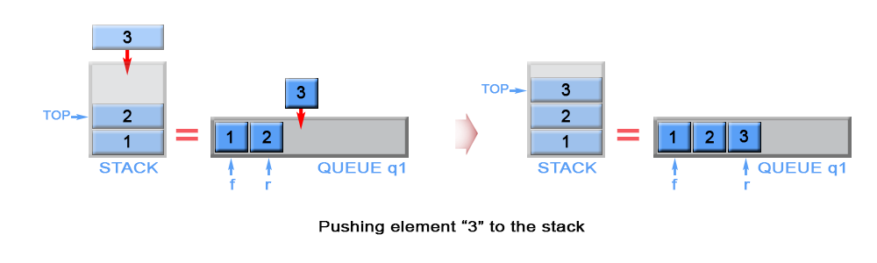

Figure 1. Push an element in stack

|  |
| --- |
| private Queue<Integer> q1 = new LinkedList<>();  private Queue<Integer> q2 = new LinkedList<>();  private int top;  // Push element x onto stack.  public void push(int x) {  q1.add(x);  top = x;  } |

**Complexity Analysis**

* Time complexity : *O*(1). Queue is implemented as linked list and add operation has *O*(1) time complexity.
* Space complexity : *O*(1)

**Pop**

We need to remove the element from the top of the stack. This is the last inserted element in q1. Because queue is FIFO (first in - first out) data structure, the last inserted element could be removed only after all elements, except it, have been removed. For this reason we need to maintain additional queue q2, which will serve as a temporary storage to enqueue the removed elements from q1. The last inserted element in q2 is kept as top. Then the algorithm removes the last element in q1. We swap q1 with q2 to avoid copying all elements from q2 to q1.

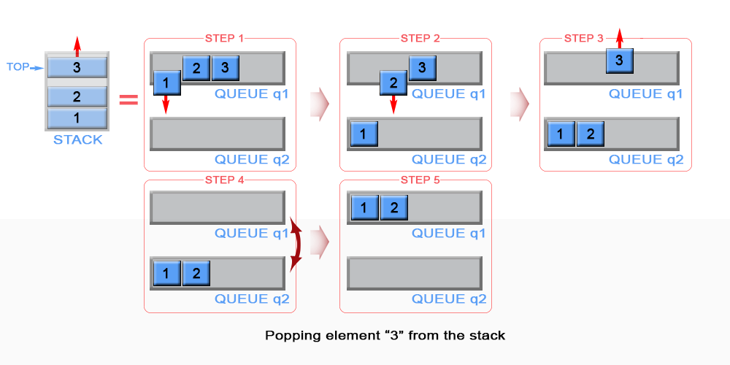

Figure 2. Pop an element from stack

|  |
| --- |
| // Removes the element on top of the stack.  public void pop() {  while (q1.size() > 1) {  top = q1.remove();  q2.add(top);  }  q1.remove();  Queue<Integer> temp = q1;  q1 = q2;  q2 = temp;  } |

**Complexity Analysis**

* Time complexity : *O*(*n*). The algorithm dequeues n elements from q1 and enqueues *n*−1 elements to q2, where *n* is the stack size. This gives 2*n*−1 operations.
* Space complexity : *O*(1).

#### **Approach #2 (Two Queues, push - O(n), pop O(1) )**

**Algorithm**

**Push**

The algorithm inserts each new element to queue q2 and keep it as the top element. In case queue q1 is not empty (there are elements in the stack), we remove all elements from q1 and add them to q2. In this way the new inserted element (top element in the stack) will be always positioned at the front of q2. We swap q1 with q2 to avoid copying all elements from q2 to q1.

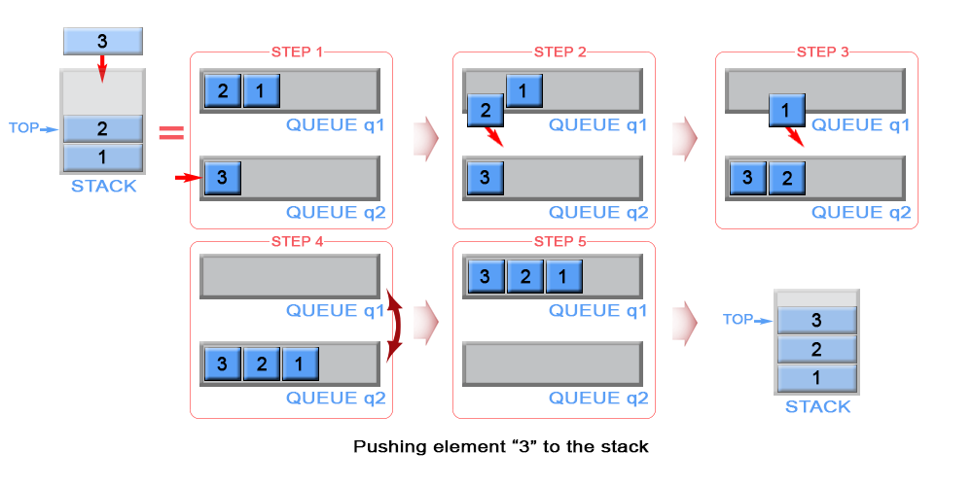

Figure 3. Push an element in stack

|  |
| --- |
| public void push(int x) {  q2.add(x);  top = x;  while (!q1.isEmpty()) {  q2.add(q1.remove());  }  Queue<Integer> temp = q1;  q1 = q2;  q2 = temp;  } |

**Complexity Analysis**

* Time complexity : *O*(*n*). The algorithm removes n elements from q1 and inserts *n*+1 elements to q2, where n is the stack size. This gives 2*n*+1 operations. The operations add and remove in linked lists has *O*(1) complexity.
* Space complexity : *O*(1).

**Pop**

The algorithm dequeues an element from queue q1 and keeps front element of q1 as top.

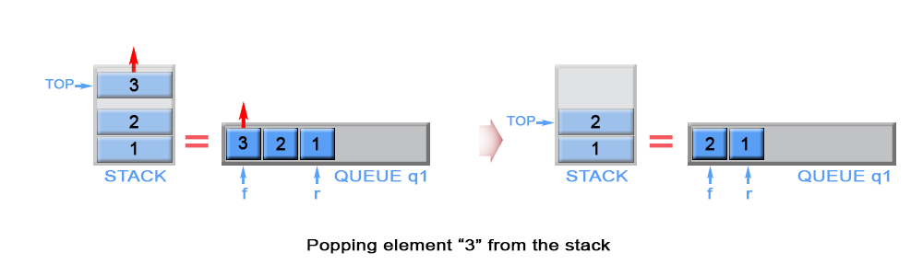

Figure 4. Pop an element from stack

|  |
| --- |
| // Removes the element on top of the stack.  public void pop() {  q1.remove();  if (!q1.isEmpty()) {  top = q1.peek();  }  } |

**Complexity Analysis**

* Time complexity : *O*(1).
* Space complexity : *O*(1).

In both approaches empty and top operations have the same implementation.

**Empty**

Queue q1 always contains all stack elements, so the algorithm checks q1 size to return if the stack is empty.

|  |
| --- |
| // Return whether the stack is empty.  public boolean empty() {  return q1.isEmpty();  } |

Time complexity : *O*(1).

Space complexity : *O*(1).

**Top**

The top element is kept in constant memory and is modified each time when we push or pop an element.

|  |
| --- |
| // Get the top element.  public int top() {  return top;  } |

Time complexity : *O*(1). The top element has been calculated in advance and only returned in top operation.

Space complexity : *O*(1).

#### **Approach #3 (One Queue, push - O(n), pop O(1) )**

The mentioned above two approaches have one weakness, they use two queues. This could be optimized as we use only one queue, instead of two.

**Algorithm**

**Push**

When we push an element into a queue, it will be stored at back of the queue due to queue's properties. But we need to implement a stack, where last inserted element should be in the front of the queue, not at the back. To achieve this we can invert the order of queue elements when pushing a new element.

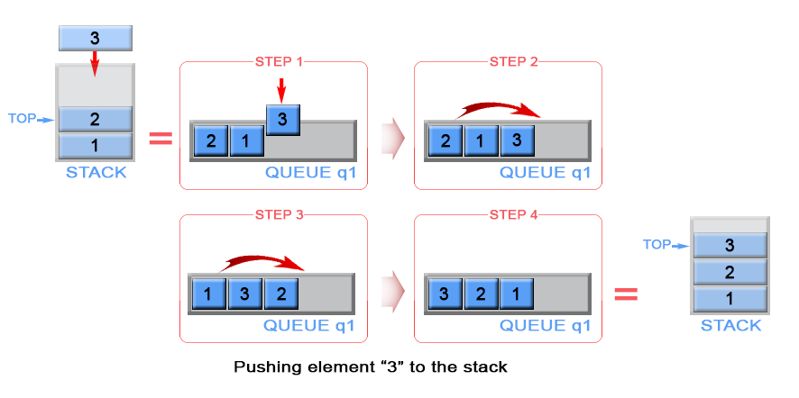

Figure 5. Push an element in stack

|  |
| --- |
| private LinkedList<Integer> q1 = new LinkedList<>();  // Push element x onto stack.  public void push(int x) {  q1.add(x);  int sz = q1.size();  while (sz > 1) {  q1.add(q1.remove());  sz--;  }  } |

**Complexity Analysis**

* Time complexity : *O*(*n*). The algorithm removes n elements and inserts *n*+1 elements to q1 , where n is the stack size. This gives 2*n*+1 operations. The operations add and remove in linked lists has *O*(1) complexity.
* Space complexity : *O*(1).

**Pop**

The last inserted element is always stored at the front of q1 and we can pop it for constant time.

|  |
| --- |
| // Removes the element on top of the stack.  public void pop() {  q1.remove();  } |

**Complexity Analysis**

* Time complexity : *O*(1).
* Space complexity : *O*(1).

**Empty**

Queue q1 contains all stack elements, so the algorithm checks if q1 is empty.

|  |
| --- |
| // Return whether the stack is empty.  public boolean empty() {  return q1.isEmpty();  } |

Time complexity : *O*(1).

Space complexity : *O*(1).

**Top**

The top element is always positioned at the front of q1. Algorithm return it.

|  |
| --- |
| // Get the top element.  public int top() {  return q1.peek();  } |

Time complexity : *O*(1).

Space complexity : *O*(1).

**Decode String**

Given an encoded string, return its decoded string.

The encoding rule is: k[encoded_string], where the encoded_string inside the square brackets is being repeated exactly k times. Note that k is guaranteed to be a positive integer.

You may assume that the input string is always valid; No extra white spaces, square brackets are well-formed, etc.

Furthermore, you may assume that the original data does not contain any digits and that digits are only for those repeat numbers, k. For example, there won't be input like 3a or 2[4].

**Example 1:**

**Input:** s = "3[a]2[bc]"

**Output:** "aaabcbc"

**Example 2:**

**Input:** s = "3[a2[c]]"

**Output:** "accaccacc"

**Example 3:**

**Input:** s = "2[abc]3[cd]ef"

**Output:** "abcabccdcdcdef"

**Example 4:**

**Input:** s = "abc3[cd]xyz"

**Output:** "abccdcdcdxyz"

**Constraints:**

* 1 <= s.length <= 30
* s consists of lowercase English letters, digits, and square brackets '[]'.
* s is guaranteed to be **a valid** input.
* All the integers in s are in the range [1, 300].

## Solution

#### **Overview**

We are given string s*s* in a particular form k[string] and we have to decode it as string repeated k times . For example,2[b] is decoded as bb.

The problem seems straightforward at first glance. But the trick here is that there can be nested encoded strings like k[string k[string]]. For example, string s =3[a2[c]]. In such cases, we must decode the innermost string and continue in an outward direction until the entire string is decoded.

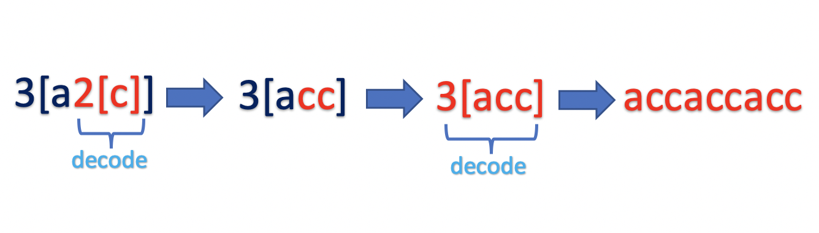

If you have solved similar problem such as [Evaluate Polish Notation](https://leetcode.com/problems/evaluate-reverse-polish-notation/) or [Simplify Path](https://leetcode.com/problems/simplify-path/) , it is clear that [Stack Data Structure](https://en.wikipedia.org/wiki/Stack_(abstract_data_type)) is best suited to implement such problems. We could implement a stack data structure or recursively build the solution by using an internal call stack. Let's understand both approaches in detail.

#### **Approach 1: Using Stack**

**Intuition**

We have to decode the result in a particular pattern. We know that the input is always valid. The pattern begins with a number k, followed by opening braces [, followed by string. Post that, there could be one of the following cases :

1. There is another nested pattern k[string k[string]]
2. There is a closing bracket k[string]

Since we have to start decoding the innermost pattern first, continue iterating over the string s, pushing each character to the stack until it is not a closing bracket ]. Once we encounter the closing bracket ], we must start decoding the pattern.

As we know that stack follows the Last In First Out (LIFO) Principle, the top of the stack would have the data we must decode.

**Algorithm**

The input can contain an alphabet (a-z), digit (0-9), opening braces [ or closing braces ]. Start traversing string s and process each character based on the following rules:

Case 1) Current character is not a closing bracket ].

Push the current character to stack.

Case 2) Current character is a closing bracket ].

Start decoding the last traversed string by popping the string decodedString and number k from the top of the stack.

* Pop from the stack while the next character is not an opening bracket [ and append each character (a-z) to the decodedString.
* Pop opening bracket [ from the stack.
* Pop from the stack while the next character is a digit (0-9) and build the number k.

Now that we have k and decodedString , decode the pattern k[decodedString] by pushing the decodedString to stack k times.

Once the entire string is traversed, pop the result from stack and return.

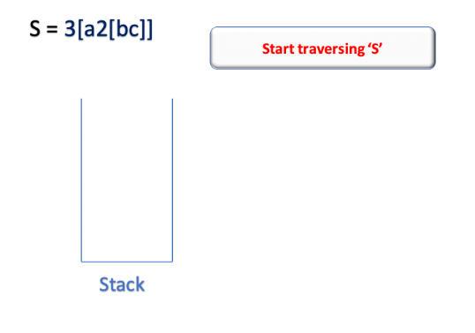

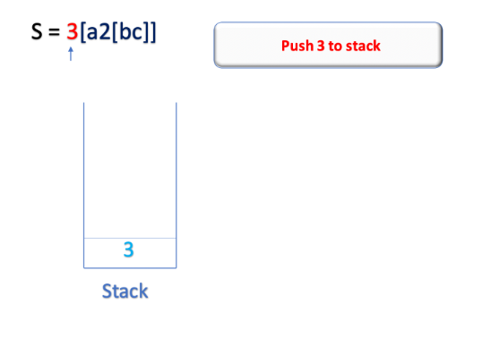

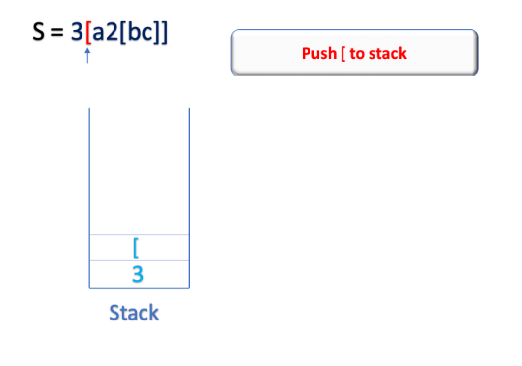

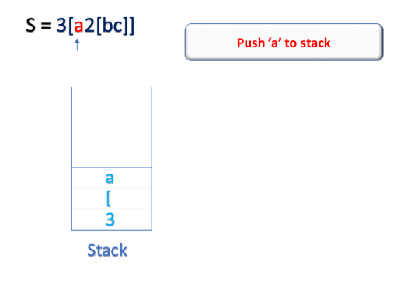

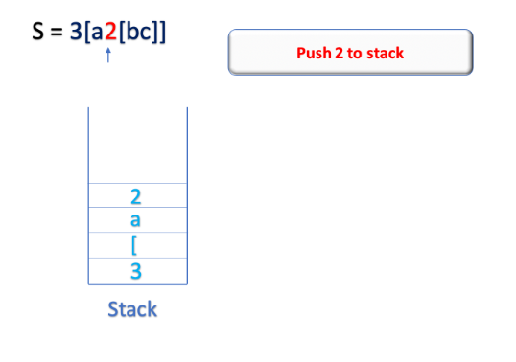

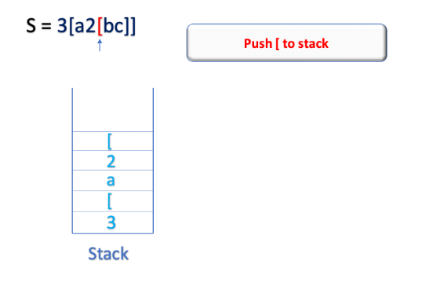

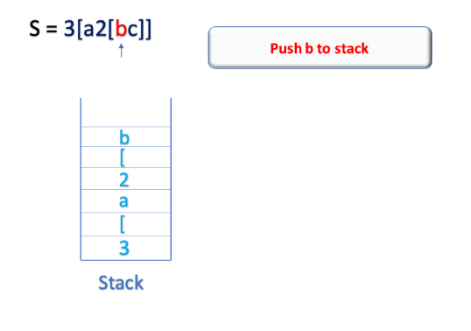

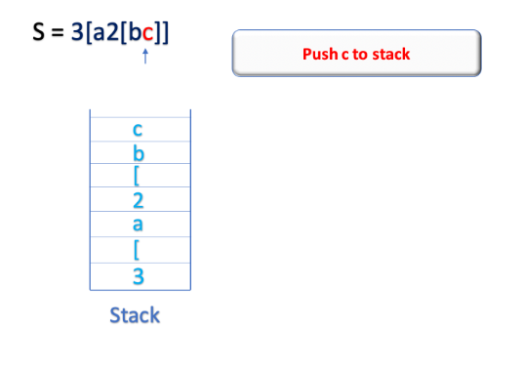

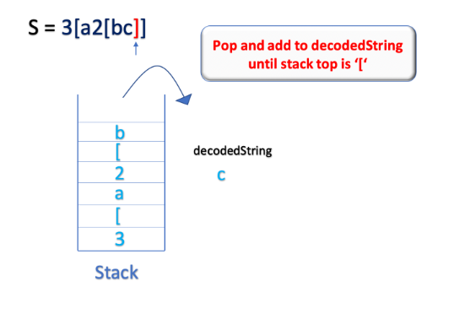

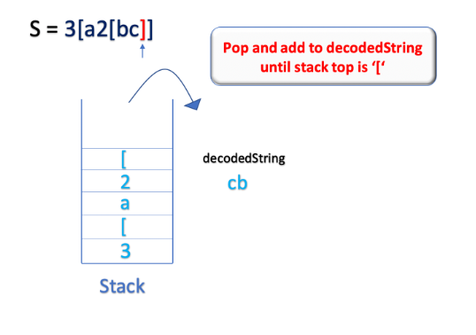

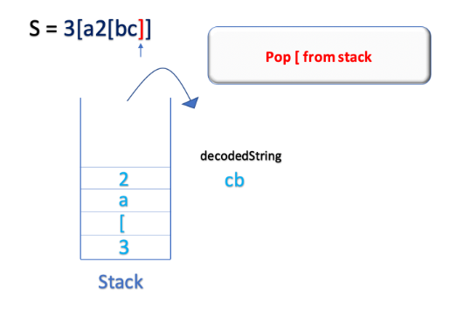

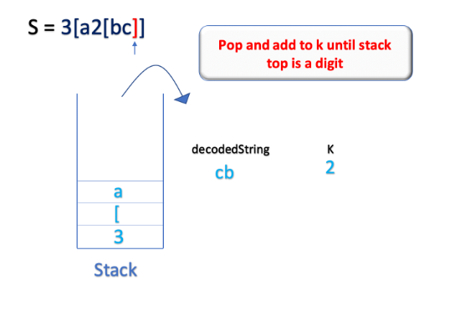

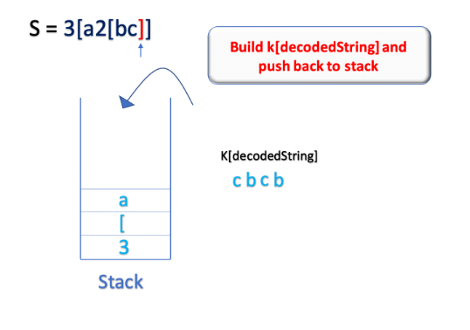

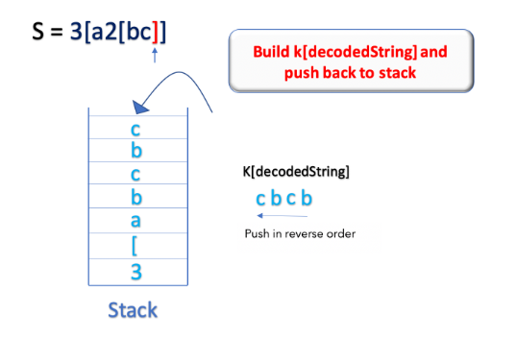

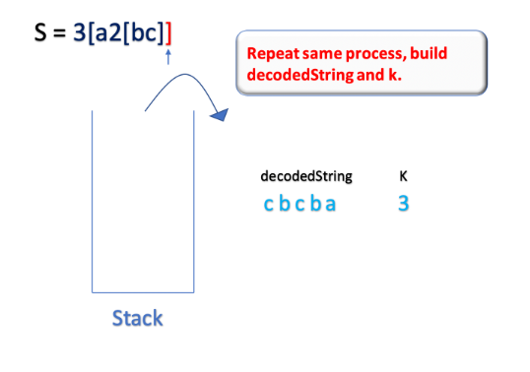

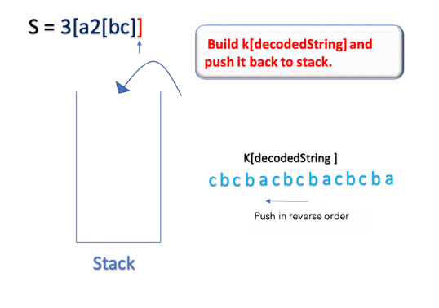

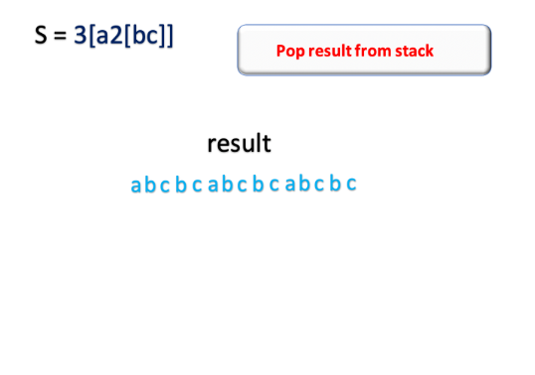

**Implementation**

|  |
| --- |
| class Solution {  public String decodeString(String s) {  Stack<Character> stack = new Stack<>();  for (int i = 0; i < s.length(); i++) {  if (s.charAt(i) == ']') {  List<Character> decodedString = new ArrayList<>();  // get the encoded string  while (stack.peek() != '[') {  decodedString.add(stack.pop());  }  // pop [ from the stack  stack.pop();  int base = 1;  int k = 0;  // get the number k  while (!stack.isEmpty() && Character.isDigit(stack.peek())) {  k = k + (stack.pop() - '0') * base;  base *= 10;  }  // decode k[decodedString], by pushing decodedString k times into stack  while (k != 0) {  for (int j = decodedString.size() - 1; j >= 0; j--) {  stack.push(decodedString.get(j));  }  k--;  }  }  // push the current character to stack  else {  stack.push(s.charAt(i));  }  }  // get the result from stack  char[] result = new char[stack.size()];  for (int i = result.length - 1; i >= 0; i--) {  result[i] = stack.pop();  }  return new String(result);  }  } |

**Complexity Analysis**

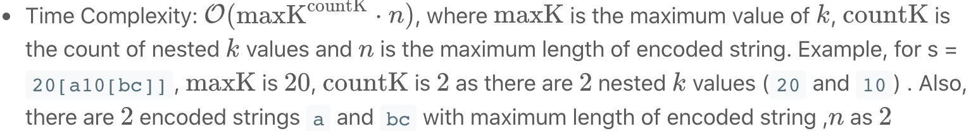

The worst case scenario would be when there are multiple nested patterns. Let's assume that all the *k* values (maxK) are 10 and all encoded string(*n*) are of size 2.

For, s = 10[ab10[cd]]10[ef], time complexity would be roughly equivalent to 10∗cd∗10∗ab+10∗2=102∗2.

Hence, for an encoded pattern of form maxK[nmaxK[n]], the time complexity to decode the pattern can be given as, O(maxKcountK  * *n*).

* Space Complexity:  O(maxKcountK  * *n*). where  maxK is the maximum value of *k*,  countK is the count of nested *k* values and *n* is the maximum length of encoded string.

The maximum stack size would be equivalent to the sum of all the decoded strings in the form  maxK[nmaxK[n]]

#### **Approach 2: Using 2 Stack**

**Intuition**

In the previous approach, we used a single character stack to store the digits(0-9) as well as letters (a-z). We could instead maintain 2 separate stacks.

* countStack: The stack would store all the integer k.
* stringStack: The stack would store all the decoded strings.

Also, instead of pushing the decoded string to the stack character by character, we could improve our algorithm by appending all the characters into the string first and then push the entire string into the stringStack. Let's look at the algorithm in detail.

**Algorithm**

Iterate over the string s and process each character as follows:

Case 1) If the current character is a digit (0-9), append it to the number k.

Case 2) If the current character is a letter (a-z), append it to the currentString.

Case 3) If current character is a opening bracket [, push k and currentString intocountStack and stringStack respectively.

Case 4) Closing bracket ]: We must begin the decoding process,

* We must decode the currentString. Pop currentK from the countStack and decode the pattern currentK[currentString]
* As the stringStack contains the previously decoded string, pop the decodedString from the stringStack. Update the decodedString = decodedString + currentK[currentString]

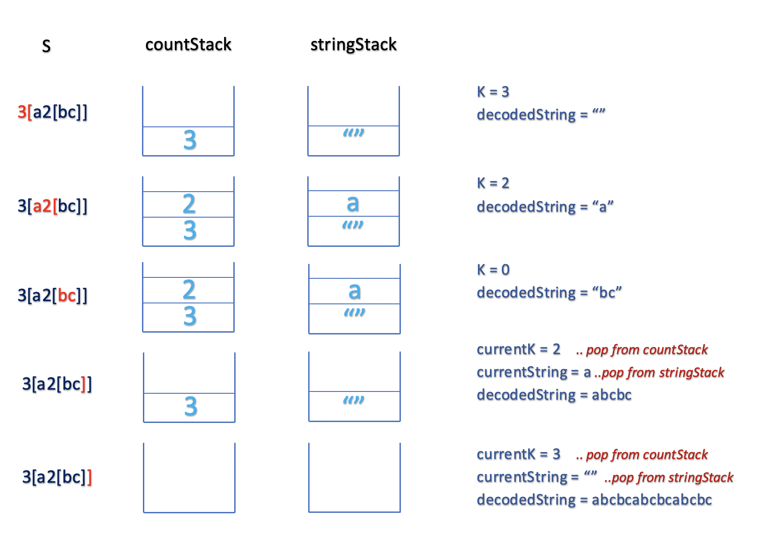

**Implementation**

|  |
| --- |
| class Solution {  String decodeString(String s) {  Stack<Integer> countStack = new Stack<>();  Stack<StringBuilder> stringStack = new Stack<>();  StringBuilder currentString = new StringBuilder();  int k = 0;  for (char ch : s.toCharArray()) {  if (Character.isDigit(ch)) {  k = k * 10 + ch - '0';  } else if (ch == '[') {  // push the number k to countStack  countStack.push(k);  // push the currentString to stringStack  stringStack.push(currentString);  // reset currentString and k  currentString = new StringBuilder();  k = 0;  } else if (ch == ']') {  StringBuilder decodedString = stringStack.pop();  // decode currentK[currentString] by appending currentString k times  for (int currentK = countStack.pop(); currentK > 0; currentK--) {  decodedString.append(currentString);  }  currentString = decodedString;  } else {  currentString.append(ch);  }  }  return currentString.toString();  }  } |

**Complexity Analysis**

Assume, *n* is the length of the string s*s*.

* Time Complexity:  O(maxK⋅*n*), where maxK is the maximum value of *k* and *n* is the length of a given string *s*. We traverse a string of size *n* and iterate *k* times to decode each pattern of form k[string]. This gives us worst case time complexity as O(maxK⋅*n*).
* Space Complexity:  O(*m*+*n*), where *m* is the number of letters(a-z) and *n* is the number of digits(0-9) in string *s*. In worst case, the maximum size of  stringStack and  countStack could be *m* and *n* respectively.

#### **Approach 3: Using Recursion**

**Intuition**

In the previous approach, we implemented an external stack to keep the track of each character traversed. Ideally, a stack is required when we have nested encoded string in the form k[string k[string]].

Using this intuition, we could start by building k and string and recursively decode for each nested substring. The recursion uses an internal call stack to store the previous state. Let's understand the algorithm in detail.

**Algorithm**

* Build result while next character is letter (a-z) and build the number k while next character is a digit (0-9) by iterating over string s.
* Ignore the next [ character and recursively find the nested decodedString.
* Decode the current pattern k[decodedString] and append it to the result.
* Return the current result.

The above steps are repeated recursively for each pattern until the entire string s is traversed.

Base Condition: We must define a base condition that must be satisfied to backtrack from the recursive call. In this case, we would backtrack and return the result when we have traversed the string s or the next character is ] and there is no nested substring.

Thanks to [@bluedawnstar](https://leetcode.com/bluedawnstar/) for suggesting the solution.

**Implementation**

|  |
| --- |
| class Solution {  int index = 0;  String decodeString(String s) {  StringBuilder result = new StringBuilder();  while (index < s.length() && s.charAt(index) != ']') {  if (!Character.isDigit(s.charAt(index)))  result.append(s.charAt(index++));  else {  int k = 0;  // build k while next character is a digit  while (index < s.length() && Character.isDigit(s.charAt(index)))  k = k * 10 + s.charAt(index++) - '0';  // ignore the opening bracket '['  index++;  String decodedString = decodeString(s);  // ignore the closing bracket ']'  index++;  // build k[decodedString] and append to the result  while (k-- > 0)  result.append(decodedString);  }  }  return new String(result);  }  } |

**Complexity Analysis**

Assume, *n* is the length of the string *s*.

* Time Complexity: O(maxK⋅*n*) as in Approach 2
* Space Complexity: O(*n*). This is the space used to store the internal call stack used for recursion. As we are recursively decoding each nested pattern, the maximum depth of recursive call stack would not be more than *n*

**Flood Fill**

An image is represented by a 2-D array of integers, each integer representing the pixel value of the image (from 0 to 65535).

Given a coordinate (sr, sc) representing the starting pixel (row and column) of the flood fill, and a pixel value newColor, "flood fill" the image.

To perform a "flood fill", consider the starting pixel, plus any pixels connected 4-directionally to the starting pixel of the same color as the starting pixel, plus any pixels connected 4-directionally to those pixels (also with the same color as the starting pixel), and so on. Replace the color of all of the aforementioned pixels with the newColor.

At the end, return the modified image.

**Example 1:**

**Input:**

image = [[1,1,1],[1,1,0],[1,0,1]]

sr = 1, sc = 1, newColor = 2

**Output:** [[2,2,2],[2,2,0],[2,0,1]]

**Explanation:**

From the center of the image (with position (sr, sc) = (1, 1)), all pixels connected

by a path of the same color as the starting pixel are colored with the new color.

Note the bottom corner is not colored 2, because it is not 4-directionally connected

to the starting pixel.

**Note:**

• The length of image and image[0] will be in the range [1, 50].

• The given starting pixel will satisfy 0 <= sr < image.length and 0 <= sc < image[0].length.

• The value of each color in image[i][j] and newColor will be an integer in [0, 65535].

Hint #1

Write a recursive function that paints the pixel if it's the correct color, then recurses on neighboring pixels.

#### **Approach #1: Depth-First Search [Accepted]**

**Intuition**

We perform the algorithm explained in the problem description: paint the starting pixels, plus adjacent pixels of the same color, and so on.

**Algorithm**

Say color is the color of the starting pixel. Let's floodfill the starting pixel: we change the color of that pixel to the new color, then check the 4 neighboring pixels to make sure they are valid pixels of the same color, and of the valid ones, we floodfill those, and so on.

We can use a function dfs to perform a floodfill on a target pixel.

|  |
| --- |
| class Solution {  public int[][] floodFill(int[][] image, int sr, int sc, int newColor) {  int color = image[sr][sc];  if (color != newColor) dfs(image, sr, sc, color, newColor);  return image;  }  public void dfs(int[][] image, int r, int c, int color, int newColor) {  if (image[r][c] == color) {  image[r][c] = newColor;  if (r >= 1) dfs(image, r-1, c, color, newColor);  if (c >= 1) dfs(image, r, c-1, color, newColor);  if (r+1 < image.length) dfs(image, r+1, c, color, newColor);  if (c+1 < image[0].length) dfs(image, r, c+1, color, newColor);  }  }  } |

**Complexity Analysis**

* Time Complexity: *O*(*N*), where *N* is the number of pixels in the image. We might process every pixel.
* Space Complexity: *O*(*N*), the size of the implicit call stack when calling dfs.

**01 Matrix**

Given a matrix consists of 0 and 1, find the distance of the nearest 0 for each cell.

The distance between two adjacent cells is 1.

**Example 1:**

**Input:**

[[0,0,0],

[0,1,0],

[0,0,0]]

**Output:**

[[0,0,0],

 [0,1,0],

 [0,0,0]]

**Example 2:**

**Input:**

[[0,0,0],

[0,1,0],

[1,1,1]]

**Output:**

[[0,0,0],

[0,1,0],

[1,2,1]]

**Note:**

1. The number of elements of the given matrix will not exceed 10,000.
2. There are at least one 0 in the given matrix.
3. The cells are adjacent in only four directions: up, down, left and right.

## Solution

#### **Approach #1 Brute force [Time Limit Exceeded]**

**Intuition**

Do what the question says.

**Algorithm**

* Initialize dist[i][j]=INT_MAX for all {i,j} cells.
* Iterate over the matrix.
  + If cell is 0, dist[i][j]=0,
  + Else, for each 1 cell,
    - Iterate over the entire matrix
    - If the cell is 0, calculate its distance from current cell as abs(k-i)+abs(l-j).
    - If the distance is smaller than the current distance, update it.

|  |
| --- |
| vector<vector<int> > updateMatrix(vector<vector<int> >& matrix)  {  int rows = matrix.size();  if (rows == 0)  return matrix;  int cols = matrix[0].size();  vector<vector<int> > dist(rows, vector<int>(cols, INT_MAX));  for (int i = 0; i < rows; i++) {  for (int j = 0; j < cols; j++) {  if (matrix[i][j] == 0)  dist[i][j] = 0;  else {  for (int k = 0; k < rows; k++)  for (int l = 0; l < cols; l++)  if (matrix[k][l] == 0) {  int dist_01 = abs(k - i) + abs(l - j);  dist[i][j] = min(dist[i][j], abs(k - i) + abs(l - j));  }  }  }  }  return dist;  } |

**Complexity Analysis**

* Time complexity: *O*((*r*⋅*c*)2). Iterating over the entire matrix for each 1 in the matrix.
* Space complexity: *O*(*r*⋅*c*). No extra space required than the vector<vector<int> > dist

#### **Approach #2 Using BFS [Accepted]**

**Intuition**

A better brute force: Looking over the entire matrix appears wasteful and hence, we can use Breadth First Search(BFS) to limit the search to the nearest 0 found for each 1. As soon as a 0 appears during the BFS, we know that the 0 is nearest, and hence, we move to the next 1.

Think again: But, in this approach, we will only be able to update the distance of one 1 using one BFS, which could in fact, result in slightly higher complexity than the Approach #1 brute force. But hey,this could be optimised if we start the BFS from 0s and thereby, updating the distances of all the 1s in the path.

**Algorithm**

* For our BFS routine, we keep a queue, q to maintain the queue of cells to be examined next.
* We start by adding all the cells with 0s to q.
* Intially, distance for each 0 cell is 0 and distance for each 1 is INT_MAX, which is updated during the BFS.
* Pop the cell from queue, and examine its neighbours. If the new calculated distance for neighbour {i,j} is smaller, we add {i,j} to q and update dist[i][j].

|  |
| --- |
| vector<vector<int> > updateMatrix(vector<vector<int> >& matrix)  {  int rows = matrix.size();  if (rows == 0)  return matrix;  int cols = matrix[0].size();  vector<vector<int> > dist(rows, vector<int>(cols, INT_MAX));  queue<pair<int, int> > q;  for (int i = 0; i < rows; i++)  for (int j = 0; j < cols; j++)  if (matrix[i][j] == 0) {  dist[i][j] = 0;  q.push({ i, j }); //Put all 0s in the queue.  }  int dir[4][2] = { { -1, 0 }, { 1, 0 }, { 0, -1 }, { 0, 1 } };  while (!q.empty()) {  pair<int, int> curr = q.front();  q.pop();  for (int i = 0; i < 4; i++) {  int new_r = curr.first + dir[i][0], new_c = curr.second + dir[i][1];  if (new_r >= 0 && new_c >= 0 && new_r < rows && new_c < cols) {  if (dist[new_r][new_c] > dist[curr.first][curr.second] + 1) {  dist[new_r][new_c] = dist[curr.first][curr.second] + 1;  q.push({ new_r, new_c });  }  }  }  }  return dist;  } |

**Complexity analysis**

* Time complexity: *O*(*r*⋅*c*).
  + Since, the new cells are added to the queue only if their current distance is greater than the calculated distance, cells are not likely to be added multiple times.
* Space complexity: *O*(*r*⋅*c*). Additional *O*(*r*⋅*c*) for queue than in Approach #1

#### **Approach #3 DP Approach [Accepted]**

**Intuition**

The distance of a cell from 0 can be calculated if we know the nearest distance for all the neighbours, in which case the distance is minimum distance of any neightbour + 1. And, instantly, the word come to mind DP!!  
For each 1, the minimum path to 0 can be in any direction. So, we need to check all the 4 direction. In one iteration from top to bottom, we can check left and top directions, and we need another iteration from bottom to top to check for right and bottom direction.

**Algorithm**

* Iterate the matrix from top to bottom-left to right:
  + Update **dist[*i*][*j*]=min(dist[*i*][*j*],min(dist[*i*][*j*−1],dist[*i*−1][*j*])+1)** i.e., minimum of the current dist and distance from top or left neighbour +1, that would have been already calculated previously in the current iteration.
* Now, we need to do the back iteration in the similar manner: from bottom to top-right to left:
  + Update **dist[*i*][*j*]=min(dist[*i*][*j*],min(dist[*i*][*j*+1],dist[*i*+1][*j*])+1)** i.e. minimum of current dist and distances calculated from bottom and right neighbours, that would be already available in current iteration.

|  |
| --- |
| vector<vector<int> > updateMatrix(vector<vector<int> >& matrix)  {  int rows = matrix.size();  if (rows == 0)  return matrix;  int cols = matrix[0].size();  vector<vector<int> > dist(rows, vector<int>(cols, INT_MAX - 100000));  //First pass: check for left and top  for (int i = 0; i < rows; i++) {  for (int j = 0; j < cols; j++) {  if (matrix[i][j] == 0)  dist[i][j] = 0;  else {  if (i > 0)  dist[i][j] = min(dist[i][j], dist[i - 1][j] + 1);  if (j > 0)  dist[i][j] = min(dist[i][j], dist[i][j - 1] + 1);  }  }  }  //Second pass: check for bottom and right  for (int i = rows - 1; i >= 0; i--) {  for (int j = cols - 1; j >= 0; j--) {  if (i < rows - 1)  dist[i][j] = min(dist[i][j], dist[i + 1][j] + 1);  if (j < cols - 1)  dist[i][j] = min(dist[i][j], dist[i][j + 1] + 1);  }  }  return dist;  } |

**Complexity analysis**

* Time complexity: *O*(*r*⋅*c*). 2 passes of *r*⋅*c* each
* Space complexity: *O*(*r*⋅*c*). No additional space required than dist vector<vector<int> >

**Keys and Rooms**

There are N rooms and you start in room 0.  Each room has a distinct number in 0, 1, 2, ..., N-1, and each room may have some keys to access the next room.

Formally, each room i has a list of keys rooms[i], and each key rooms[i][j] is an integer in [0, 1, ..., N-1] where N = rooms.length.  A key rooms[i][j] = v opens the room with number v.

Initially, all the rooms start locked (except for room 0).

You can walk back and forth between rooms freely.

Return true if and only if you can enter every room.

**Example 1:**

**Input:** [[1],[2],[3],[]]

**Output:** true

**Explanation:**

We start in room 0, and pick up key 1.

We then go to room 1, and pick up key 2.

We then go to room 2, and pick up key 3.

We then go to room 3. Since we were able to go to every room, we return true.

**Example 2:**

**Input:** [[1,3],[3,0,1],[2],[0]]

**Output:** false

**Explanation:** We can't enter the room with number 2.

**Note:**

1. 1 <= rooms.length <= 1000
2. 0 <= rooms[i].length <= 1000
3. The number of keys in all rooms combined is at most 3000.

#### **Approach #1: Depth-First Search [Accepted]**

**Intuition and Algorithm**

When visiting a room for the first time, look at all the keys in that room. For any key that hasn't been used yet, add it to the todo list (stack) for it to be used.

See the comments of the code for more details.

|  |
| --- |
| class Solution {  public boolean canVisitAllRooms(List<List<Integer>> rooms) {  boolean[] seen = new boolean[rooms.size()];  seen[0] = true;  Stack<Integer> stack = new Stack();  stack.push(0);  //At the beginning, we have a todo list "stack" of keys to use.  //'seen' represents at some point we have entered this room.  while (!stack.isEmpty()) { // While we have keys...  int node = stack.pop(); // Get the next key 'node'  for (int nei: rooms.get(node)) // For every key in room # 'node'...  if (!seen[nei]) { // ...that hasn't been used yet  seen[nei] = true; // mark that we've entered the room  stack.push(nei); // add the key to the todo list  }  }  for (boolean v: seen) // if any room hasn't been visited, return false  if (!v) return false;  return true;  }  } |

**Complexity Analysis**

* Time Complexity: *O*(*N*+*E*), where *N* is the number of rooms, and *E* is the total number of keys.
* Space Complexity: *O*(*N*) in additional space complexity, to store stack and seen.